**Installer**

# Table of Contents

Table of Contents 2

Analysis 4

The Problem Area 4

A computational Approach: 4

Thinking Abstractly & Visualisation 4

Thinking Ahead 5

Thinking Procedurally & Decomposition 5

Thinking Logically 6

Thinking Concurrently 6

The Stakeholders: 6

Interview: 6

What functionality is needed? 7

What are the visual requirements? 7

What should the user interface be like to use? 7

The interview script: 7

A review of the interview: 9

Similar Solutions: 9

Essential Features: 9

Limitations: 10

Requirements (hardware and software) 10

Research 11

Research into Cydia 11

Features I will take from Cydia: 14

Features I will not be taking from Cydia: 14

Research into App Store 15

Features I will take from App Store: 17

Features I will not be taking from App Store: 17

Research into PIP 17

Features I will take from PIP: 18

Features I will not be taking from PIP: 18

Success Criteria 19

Design 21

Decomposition 21

Algorithms 22

Flowcharts 24

Database Design 60

UI Design 61

Variables Table 65

Development 69

Version 1 69

Version 2 72

Version 3 73

Version 4 78

Version 5 82

Final Repository Design 83

Version 6 87

Version 7 90

The User Tested GUI Iterations 94

Iteration 1 94

Iteration 2 109

Iteration 3 126

User Acceptance Testing 133

Evaluation 135

Were the success criteria met? 135

Maintenance 137

Limitations 138

# Analysis

## The Problem Area

Application and package distribution in general on macOS is an area completely controlled and limited by apple. They have one solution which you can use and it is heavily restricted in what is allowed onto their store. This means users are missing out on a lot of useful applications and packages and do not have the freedom to choose where they get their apps from as well as not having the freedom to make any advanced changes to macOS.

On macOS there is a functioning App Store, however what is accepted onto that app store is limited and there is only one source of apps being apples own server. With this solution the users are limited by apple in that they cannot find apps from multiple sources and they are also restricted to apps that apple reviews and decides they would like to host. Another issue with the App Store is that the process for uploading your app to the store is a long and costly one, as well as the fact that only Applications can be uploaded and there is no support for any other type of file.

On iOS (the mobile operating system) there exists a solution to get around these problems, a process called ‘Jailbreaking’ by which a user can bypass the measures put into place by Apple and install an alternative store called ‘Cydia’. Cydia allows the user to install packages that can be hosted by anybody for free as long as they follow the repository format guide. Cydia also allows installation of system packages or modifications(Tweaks).

However there are three main issues I want to tackle regarding this solution, the first is that ‘Cydia’ is only available on iOS and no similar solution yet exists for macOS users. And the second issue is the security risk that comes with the freedom of ‘Cydia’ on iOS, in order to install the third party app with the privileges to write system files and applications to the system the security of the device needs to first be compromised as well as the warranty voided. iOS has tough restrictions that do not allow the installation of third party software or the modification of the system software/operating system. Lastly, Cydia contains features that are simply not necessary for a system such as this and so my solution will cut down on these features that would use up memory without much meaning behind them.

Through my solution, macOS users will have access to a third party package manager/store that allows access to applications or modifications (I will collectively refer to these as packages from now on) created and hosted by anybody that wants to do so. Not only that, but the hosting of these packages will be free of charge apart from the cost of hosting a website or server with the repository, although there are free web hosting solutions such as github pages. Finally, my solution will not by default require the deactivation or circumvention of security measures that come with macOS, although for more powerful packages there will be the option of the user disabling the system integrity protection (SIP) themselves.

## A computational Approach:

### Thinking Abstractly & Visualisation

* My solution will provide the user with a nice user interface like the normal macOS AppStore, and will be only marginally more difficult to use. Tabs will be clear and simple while providing the wider variety of packages and management options that come with the product.
* I will make use of abstraction to remove any unnecessary data and functions from my program in order to save space and to become as memory efficient as possible.
* For example my program will not need to know the date and time at which a package was installed and so it can be left out of the program saving both space and memory.
* Without using abstraction my program could use too much memory and then end up slowing down other programs/processes on the system. The Installer will in some cases be pulling large amounts of data from the hosted repositories and so minimising this data is a necessary step in developing this solution.

### Thinking Ahead

The user should not have to input much except from repo url’s on the gui version as all of the possible choices are displayed as buttons.

This removes the need for checks on the inputs for those parts, however there might still need to be a fallback for if the data in the repo is not valid.

If for example, the data type is valid but the actual data in the repo has been entered wrong by the maintainer, it will cause issues later on if downloading a package.

Need to be sure that in such a case, the program can recognise this issue and prevent issues.

The downloader function will be the most important part of the program, as it is the most likely to fail. To solve this, making sure that the downloader code follows all the guidelines and that there are checks on if there is actually a file to download in the first place will remove any errors.

### Thinking Procedurally & Decomposition

* The program will be broken down into various sections or functions in order to make it easier to understand and simpler to both maintain and to work on initially/test initially.
* Using decomposition I will break the problem down into smaller sub-problems so that it is simpler.
* By doing this the risk of compromising the entirety of the code with a mistake is minimalised as each function is isolated from the rest and also the testing of the program will become much easier along with commenting becoming much simpler as each section can be briefly described too to help quickly locate the target code for maintenance.
* The program will need to be split into many parts as it is quite a complex program however, through breaking it down it becomes simpler.
* The program will need to have four main parts: displaying the data, downloading data, installing data, and removing data. Inside of these four main sections comes further breaking down however these are the main things that the program must do.
* Some of the smaller problems inside of these key parts of the program would be:
* The program will need a variety of data in order to function, however this will be handled in
* the background apart from the user adding a repository source to access packages.
* The program will load in a repository by storing the added repositories to a flat-file and at launch it will check the url’s for a json file that is used to identify and index the repositories.
* The program will load in from the json files the location and information of all packages stored in the related repository, and will use that data to install/update the packages.
* Some information such as package version and package name will be saved from the json file to a local database along with the local file path of the installed package and the repository it was downloaded from.
* The local database will allow the program to view the list of installed packages and know where the packages are located for removal as well as to check the version against the version hosted on the repositories to check for updates.
* At launch the program will go through the installed packages in the local database and check the system versions against the version hosted by the repository it was downloaded from.
* If the version number on the repository does not match the local installed package then the updated file will be downloaded and installed from the repository.
* After organising these into their respective parts then the program will be easy to maintain and finding the specific functions inside of the code that are responsible for key functions will become extremely efficient.
* I will use the eel module for the UI, it allows me to code a ui for python script in web script such as html, css, javascript

### Thinking Logically

* The program will mostly consist of one or another type decisions for the user to make. The package data will be displayed for the user and the user will then make the decision for which tab of the application they would like to use, this can be changed at any time as the menu bar will always be visible.
* The user will then be presented with choices to make depending on the tab that they have chosen, if they choose the sources tab then they will be able to make the decisions to either add a url to the sources list or remove a url from the list. If they go into the download or remove tabs then they will be able to make the decision to choose a package from the list to download or remove, and if there are updates available then they can make the decision to install the new version of the package or to ignore the update this time around.

### Thinking Concurrently

* In my program, since the backend is going to be in python, code will not be running at the same time but rather right after the last code that has been run.
* Variables with useful information to be used across the functions at different stages and times will be stored at once as globals, this one move will remove the need for further inputs at other times.

## The Stakeholders:

I have found a user of similar solutions on other operating systems, who is interested in having that solution on macOS. They are a university student in France and I have conducted interviews and talked through the project with them over social media apps.  
  
This user, having already found use for the similar solution on iOS, will be able to quickly adapt to the new system and know how to work the repo system and package management systems well already.

This user knows that the solution will be useful to them as it is already being used on a mobile operating system, and a solution for a desktop operating system would allow for much greater control and changes as well as more complex packages for the user.

## Interview:

In order to find out what the target audience would want from the system I conducted an interview with the stakeholder asking about the core features and how they should be implemented.

I prepared a series of questions for each main element of the system to get an in-depth view of the user requirements.

The main elements are functionality, visuals and ease-of-use.

The questions were as follows:

### What functionality is needed?

* How complex should the system be considering the user base?
* Should this system follow the iOS package managers repository standard? (an example was given)
* Should the user see any errors, even if they are automatically fixed?
* After which similar system should the update function take after? (examples given)

### What are the visual requirements?

* Should the UI match the system apps?
* What style would you like to see?
* Do you want the background to be any specific way?

### What should the user interface be like to use?

* Should the interface have descriptions for everything?
* Should the system give instructions on file related errors or automatically correct them?
* Should any important files be hidden from the user?
* How should a user search for a new package?

### The interview script:

What functionality is needed?

How complex should the system be considering the user base?

The system should be as simple as possible, especially with younger people now using these solutions as they will not know what to do otherwise.

Should this system follow the iOS package managers repository standard? (an example was given)

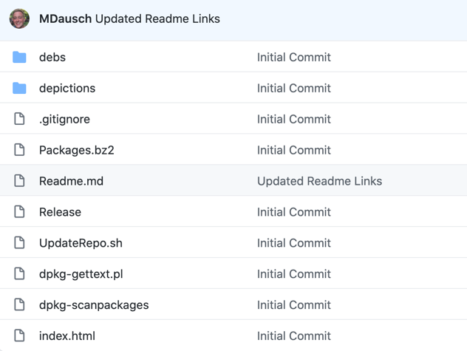example of a Cydia repository.

No, I’ve always been against how complicated the repo system is for Cydia. There’re too many files.

Should the user see any errors, even if they are automatically fixed?

In my opinion, it is always good to let the user know when an issue occurs. This way they know what it is and if it keeps happening then they will know what the problem is from these alerts.

After which similar system should the update function take after? (examples given)

I prefer the way the App Store updates, with there just being one button to update anything that needs an update. It’s easier and requires less from the user.

What are the visual requirements?

Should the UI match the system apps?

It could look nice if it matched the system apps, but I prefer more modern looking UI’s. And it would be fitting for it to stand out and look different since it would be an alternative to Apple’s own app.

What style would you like to see?

It should be clean but also stand out, I like the way Cydia looks with it being simple and just having all of the parts in a row for you to pick from when you open it.

Do you want the background to be any specific way?

Probably just a plain background would be nice since it keeps things simple and clean.

What should the user interface be like to use?

It should feel fast and look clean and simple.

Should the interface have descriptions for everything?

No, the app should be straightforward but without having the explain everything to the user, since that gets annoying really fast.

Should the system give instructions on file related errors or automatically correct them?

It’s always good when an app does the annoying things for you, especially for people that wouldn’t know how to fix the issues.

Should any important files be hidden from the user?

Definitely, lots of problems could be avoided by not even giving the user a chance to break the files.

How should a user search for a new package?

If it’s a new system that developers will have to bring their software over to then nobody will know what is there and what isn’t. Searching for things you don’t know about is impossible so maybe there should be a grid or some sort of a display showing all of the available things.

### A review of the interview:

* The solution should be straightforward and easy to use
* The solution should have a clean but modern looking GUI
* The solution should display available packages in some way
* The solution should install all available updates at once
* The solution should hide important files from the user to protect them
* The solution should automatically detect and fix file issues
* The solution should alert the user of any problems
* The solution should have a simple repository system

## Similar Solutions:

There is a similar solution on the mobile operating system iOS, called 'Cydia', this mobile solution allows the downloading and management of system packages and modifications just as my product will allow you to do on macOS. However unlike my product, it does not work on macOS and also requires the user to void their warranty by modifying the system software through a process called 'Jailbreaking', whereas my product will function without the need to do any of that, however some advanced modifications will require the SIP (System Integrity Protection) on macOS to be disabled by the user.

Another similar solution is the official App Store. This solution does support macOS like my solution, however unlike my solution it does not allow you to install apps from multiple sources. Furthermore, Apple heavily restricts what can make it onto the store, and also the only thing that can be downloaded from the App Store is applications. Whereas my solution will offer software of any kind, and with the user in full control of what makes it into their store through the repository system.

A final similar solution to take note of is PIP, a command line package manager for macOS which like my solution does support the installation of software packages and not just applications. However, PIP does not have a user interface and does not allow you to browse packages or manage repositories. And this is where my solution will improve over this current one which appears at the top of the ranks of macOS package managers.

## Essential Features:

My solution should be simple and straightforward to use and should be documented well, so that any maintenance that is needed or updating of the code goes smoothly.

It should be able to download, install and remove packages without issues and be able to recognise and notify the user if something does go wrong with these processes.

The solution should recognise when necessary files are missing or deleted, and should auto repair as much as possible while letting the user know what has taken place.

The solution should make sure that a default repository/source is added at all times, so that the user is not stuck without any sources and to make sure that any necessary/important packages related to this solution are available at all times. If the default source is missing from the installed sources it should be added back at each start of the program.

The solution should be able to correctly find and install updates to packages, despite the packages being installed from across multiple different repos/sources without issue.

The solution should correctly update the local packages database, making sure that any data is correct and that if a package is no longer installed that the data is removed from this database also.

Finally the solution should have a simple way for the user to add a new repository/source of packages should they want to. And let the user remove any unused or redundant repos if they want to.

## Limitations:

For lack of experience in this area, the solution will not have the most memory efficient approach to checking for updates across multiple repositories. The only solution I am currently capable of with my knowledge of coding would be to cycle through every installed repo and then pull the installed package information for any packages installed from that repo, check the version number against the one for that package on its repo and then if there is an update install the new package file and update the database. This will use a lot of memory and so while I would like to have the program check for any package updates at start of the program, this is not feasible as the user would notice significant slowing down of the system during every start. Instead, checking for updates will have to be a separate part of the application that the user themselves has to go and start.

## Requirements (hardware and software)

The solution requirements should be as flexible as possible, the solution should work across the greatest amount of hardware and software as possible.

Any version of macOS that supports running python3 code will be able to run this program, also this program should run fine on other systems such as Windows and Linux, however these are not the target systems and so support for them in the code will not be added.

As far as hardware, the solution will run on any hardware that is capable of running a modern version of macOS.

A processor of i3 or higher, any intel integrated graphics card (as comes with macbooks) or a graphics card released within the last 10 years will be good enough hardware to run this program without any noticeable slow downs.

In order for the solution to run smoothly at all times, especially during the updating function, it is recommended that the user have at least 8GB of RAM. However it will run on less if necessary, unless there are too many repos and installed packages in which case the program could use up too much memory and be forcibly closed by the system.

# Research

## Research into Cydia

‘Cydia’ is a package manager for the iOS mobile operating system, it allows you to install/remove/update and manage tweaks and apps on the device and is not limited to only one source of these tweaks/apps. This package manager makes use of a repository system, allowing anyone to copy the correct file structure onto their server and host tweaks/apps of their own, and users of ‘Cydia’ can then import their servers as a ‘source’ and download those tweaks and apps from across multiple servers through one solution.

‘Cydia’ has five main functions, the ability to download packages, the ability to remove them, the ability to check for and install updates for packages across multiple ‘sources’, the ability to have multiple servers added as ‘sources’ for the packages, and the installed packages data management.

A user can add servers that host packages by url and can choose one of them from a list of all added ‘sources’ to browse the packages of. They can then choose to install a package that they choose. The user can also view a list of all of the installed packages and choose one to remove. Finally the user can run a check for any package updates, which will compare the package versions of those which are installed to their counterparts hosted on the servers and installs any available updates.

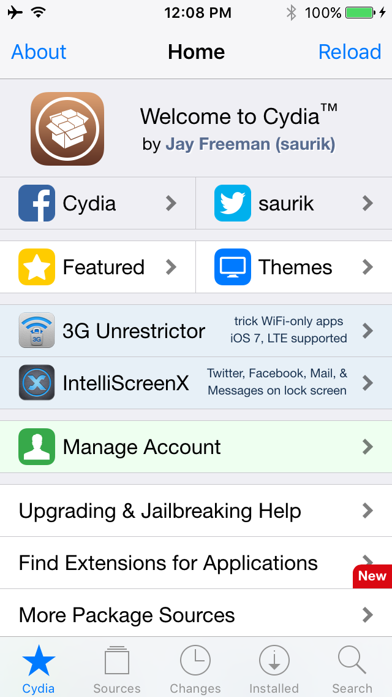

A list of useful resources and information for new users

There is an application page for viewing a list of added repositories, you can also click on one of them to go into that repo and view the packages hosted on it

There is an application page that will list any new packages added to a repo after it was added to Cydia

Cydia supports searching by package name for a package across the repos

There is a application page for viewing a list of all installed packages

Cydia supports having an account, and has store features such as buying packages

Cydia supports sharing links to packages with other Cydia users

A button to access the actions such as download, remove, update etc

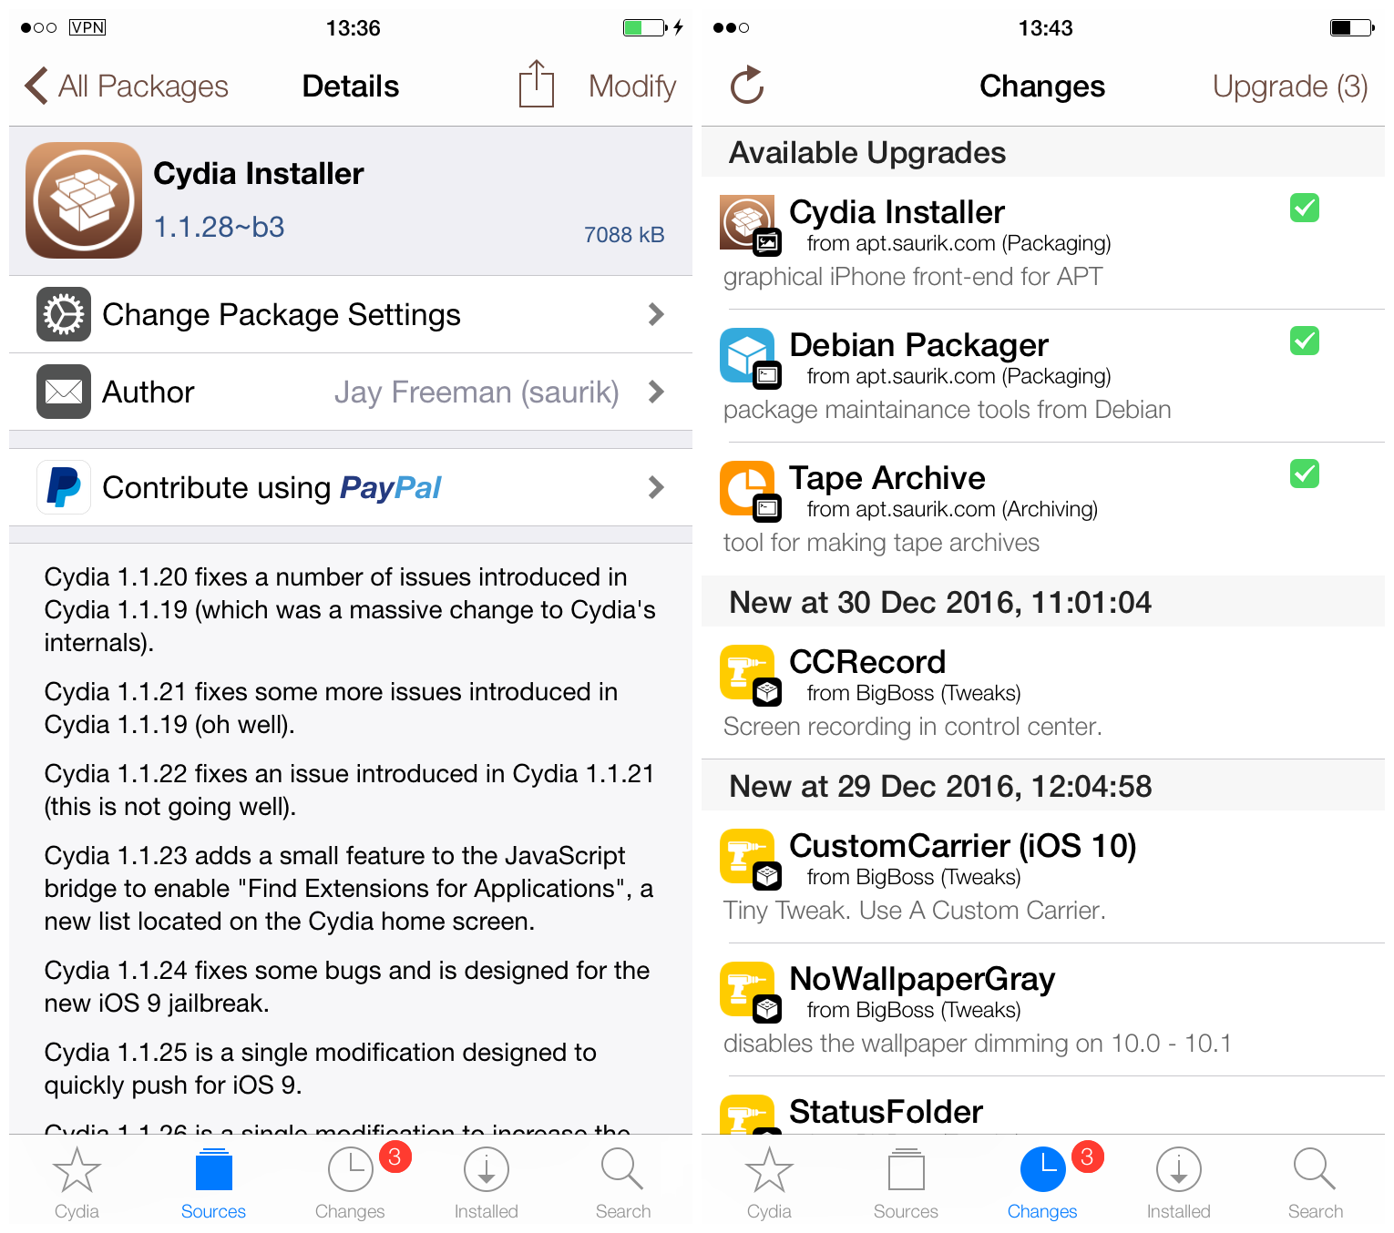

If an update is available Cydia will prompt the user to ‘upgrade’ them

When a package is selected you are brought to a screen showing a brief description of the package

This is an example of how Cydia shows and lists packages on each application tab

Cydia supports donating to package creators through paypal links

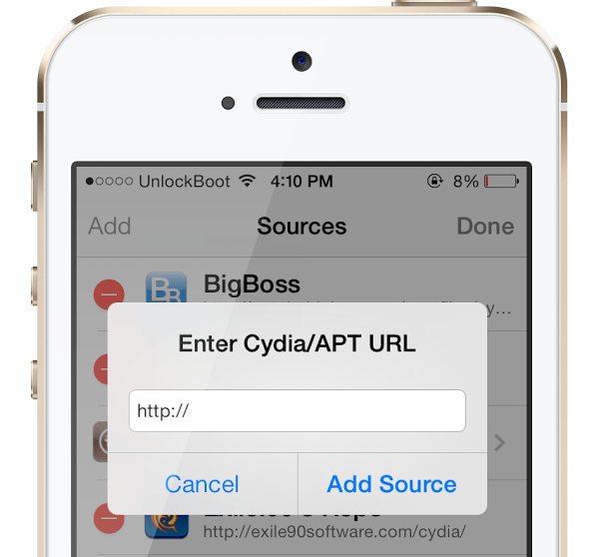

You add a repo/source to Cydia by pasting in the url

### Features I will take from Cydia:

* **The clean design/background**
* **The ability to view all installed packages**
* **Adding a repo by url**
* **Choosing a repo to open and view packages**

### Features I will not be taking from Cydia:

* **Searching for a package by name (due to time constraints)**
* **Donations (due to time constraints)**
* **Package description pages (due to time constraints)**
* **Accounts/Purchases system (due to time constraints)**
* **Sharing from the app (due to time constraints)**
* **Useful information links (due to time constraints)**
* **Prompts for available updates (due to time constraints) although an update button will be present to check for/install any updates**

## Research into App Store

**The App Store is Apple’s solution to software distribution. It is a closed-source system that heavily restricts what can make it into the store. It is the only major solution for software distribution on macOS and is tied to the users ‘AppleID’. Due to this, it offers a purchase and rating system which is tied to users’ accounts. The App Store offers apps only from its own source and apps are only able to be hosted there after passing many tests and only if they follow the strict rules Apple imposes. Also the App Store, as its name implies, is only a solution for applications and not anything else, it also restricts what those applications are able to do meaning you cannot download any significant software packages from this solution.**

**The App Store has four main features being the ability to download apps, the ability to search for apps, the ability to purchase apps through the account system and lastly it has the ability to update apps. Updates are done either with all the available updates happening at once or with one app at a time. Downloading an app is possible but there is no way to remove an app from within the App Store. Searching for apps is possible and would have been much easier to implement in this system than it would be in Cydia because it has only one source to search through. And the payment system and the existence of accounts is similar to Cydia however this account is tied to the actual hardware as it is the same company making both the App Store and the MacBook’s.**

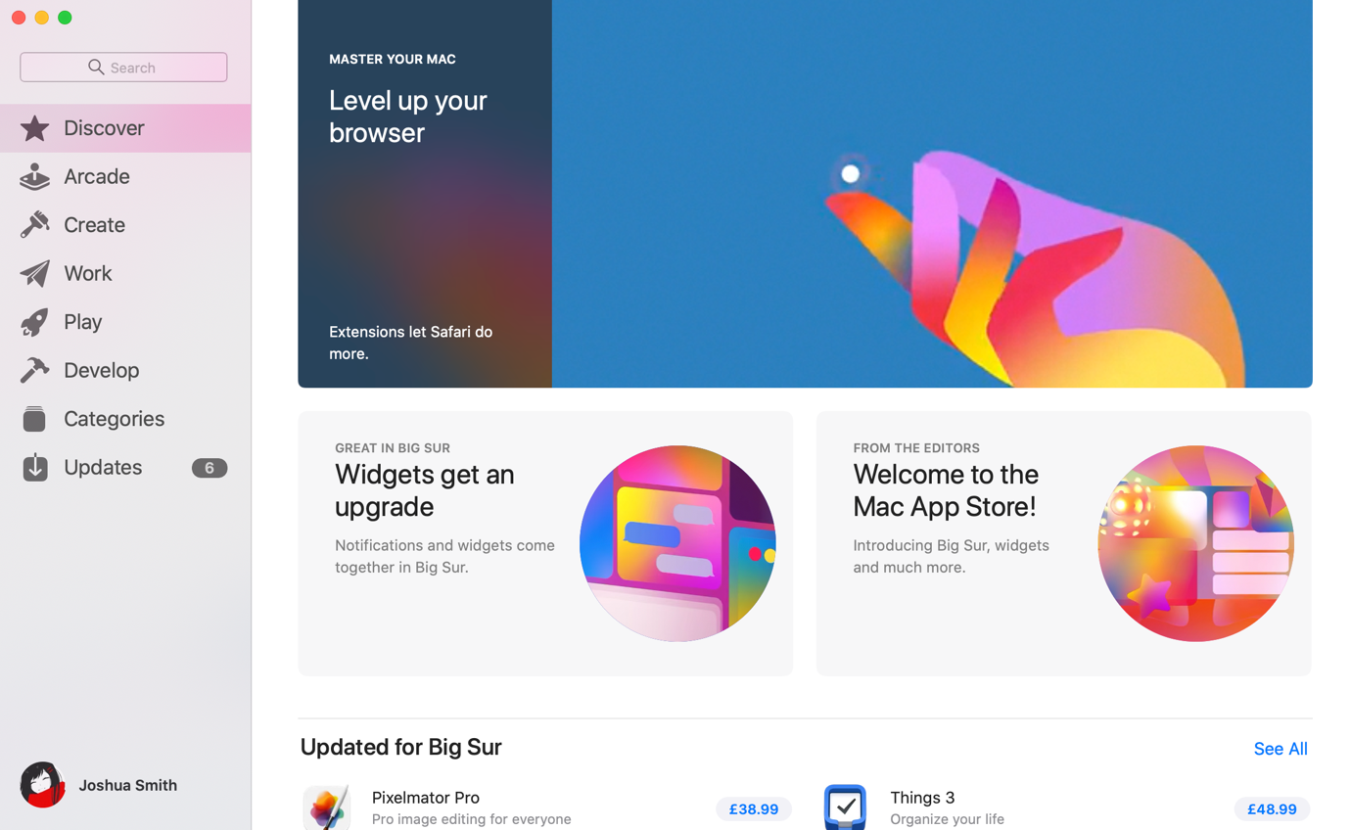

Can search for apps by name

Supports an account/payment system

Shows off newly updated apps that aren’t installed

Many categories you can go into

From list of apps you can update one on its own

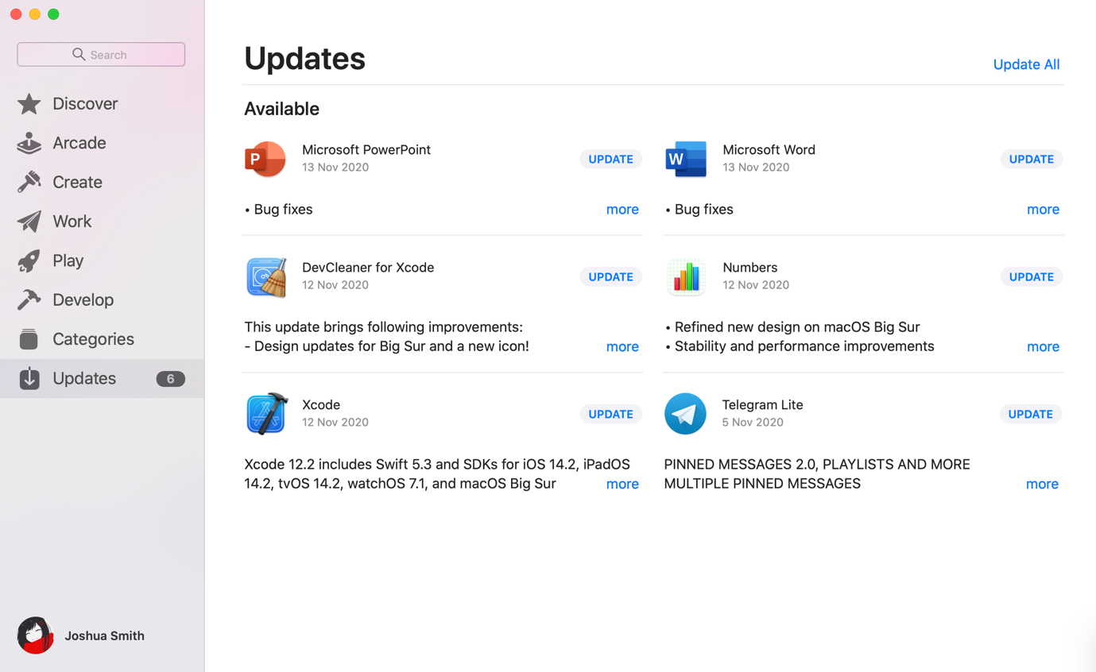

Button to update every app that needs an update

### Features I will take from App Store:

* **Ability to update all of the apps with a single button press**

### Features I will not be taking from App Store:

* **Categories for apps**
* **Account/Payment system**
* **Ability to individually update apps**
* **Searching for apps by name**
* **Showing off new/popular apps**
* **Using a single source that is kept private and heavily moderated**

## Research into PIP

**PIP is another third-party software package manager, it allows you to install, update and remove software packages from its huge repository and is not limited to applications like the App Store. PIP is a command line application though, so the user does need to know the commands and the different arguments to give for installing or updating different types of software packages. PIP is closer to Cydia than the App Store as it offers more than just applications, however unlike both of the other solutions it does not have a graphical user interface or the ability to search for applications in any way.**

**The three main features of PIP are installing, removing and updating. It is a very simple solution and manages to provide much more control over software installations. However, it is not a tool for a normal MacBook user as it is command line only and therefore requires some command line knowledge that most people do not have.**

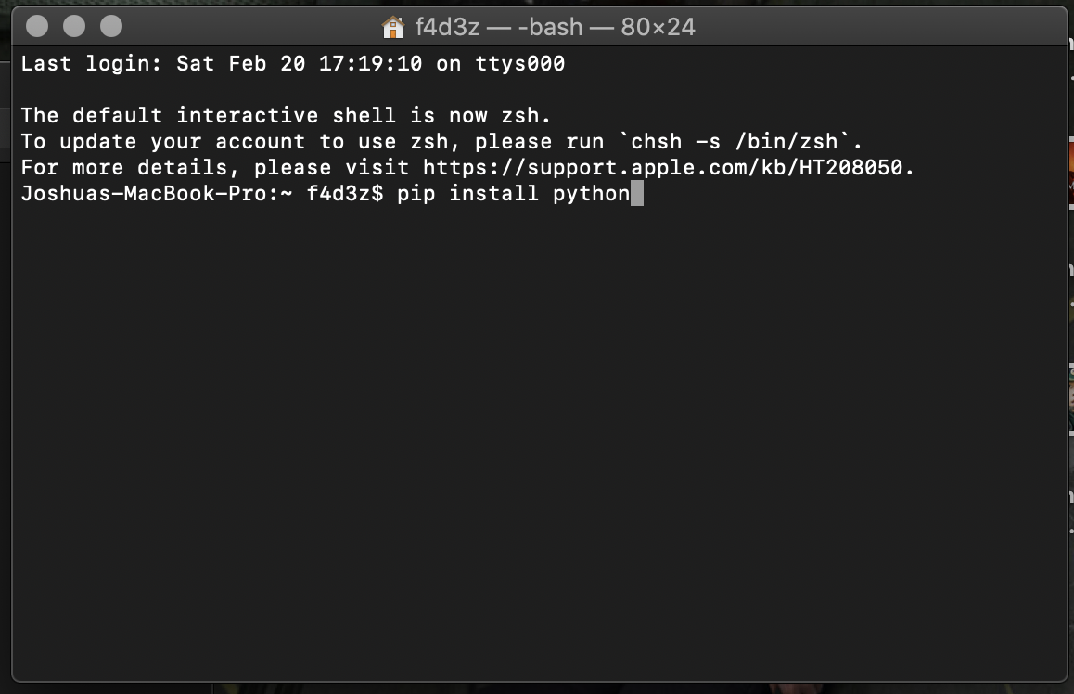

User is not able to view/add/remove sources

Can install powerful software packages not just apps

No UI as it is inside the terminal app

User must know the commands and type them out in full

Runs inside of the terminal

### Features I will take from PIP:

* **Ability to install software packages as well as apps**

### Features I will not be taking from PIP:

* **Running inside of the terminal**
* **Making the user memorise and use commands**
* **Restricting sources**

# Success Criteria

|  |  |  |  |
| --- | --- | --- | --- |
| No. | Requirement | Justification | Reference |
| 1. | The solution should be able to self-repair any missing files or dependencies such as the local database, or the default repository. | On other solutions, if there are any important files missing from the system, the solution will simply stop working. By running a check for the few essential files my solution has, and repairing them if necessary, this can become an advantage of my system over the other. | Cydia/PIP/AppStore all fail to function if there are missing files that they depend on. With no function to self-check or repair any missing files they will just remain broken unless fully reinstalled. |
| 2. | The solution should run without error, completing a chosen task. | If the solution was the crash or give an error during use, the user would stop using the solution. | Basic software requirements/expectations. |
| 3. | The solution should not take long to complete a task, the user should not have to wait for too long. | If the solution takes too long to complete a task, then the users would have no reason to use it anymore. | Basic software requirements/expectations. |
| 4. | The solution should have a clean but modern looking GUI | In order for the solution to be pleasant to use it must look nice for the user. | Interview with stakeholder. |
| 5. | The solution should be straightforward and easy to use | If a solution is difficult to use then a user will look elsewhere or even do things manually rather than use a tool that confuses them or makes things unnecessarily hard. | Interview with stakeholder. |
| 6. | The solution should display available packages in some way | In order to choose a package to install/Remove/Update the solution needs to be able to display lists of packages to the user. | Interview with stakeholder. |
| 7. | The solution should have a working repository system | In order to install apps from various servers, the solution needs to be able to work with packages and information from multiple sources at once. | Interview with stakeholder. |
| 8. | The solution should alert the user of any problems | Should there be any problems, the user needs to be told about them in order to verify that they have been fixed or to report the errors. | Interview with stakeholder. |
| 9. | The solution should hide important files from the user to protect them | If any of the files are modified incorrectly then the solution will stop working. In order to prevent this the files should be stored out of sight of the users. | Interview with stakeholder. |
| 10. | The solution should install all available updates at once | A simple update button that takes care of all of the available updates is much easier for a user than having to go into each package and install updates individually. | Interview with stakeholder. |
| 11. | The solution should open windows properly and without delay | When launching the main interface, or when showing a pop-up message, the solution should successfully open those windows seemingly instantly. | Basic software requirements/expectations. |
| 12. | The solution should be able to perform tasks in any order and repeatedly without error | When providing the user with choices on which actions they can take, the solution cannot then be unable to complete any certain task at any time. | Basic software requirements/expectations. |

# Design

## Decomposition

Installer

Repos tab with list of repos to go into

Package info screen with button to remove the package

Installed tab with list of installed packages and an update button

Home tab with information about the installer

If an update is available, download the new file and update the version in the local database

Check the package versions to see if an update is available

Load the package info from the repo

Load the package info from the local database

Remove the package information from the local database

Delete the package file from the system

Check the status of the repo

List the packages from the local database and let the user select one

Download the package from the repo

Store the information from the repo that is needed for download

Pull package information from the server and let the user select one

Pull repo information from repo and let the user select one

Adding repo to local repo file

s

Removing repo from local repo file

Repository

UI

Update

Remove

Download

Packages screen with list of packages in repo and button to install

Store package info to the local database

## **Algorithms**

|  |  |
| --- | --- |
| Algorithm | Purpose |
| startup | Preparations for app to run properly |
| addRepo | Adding a repo to the repo file |
| removeRepo | Removing a repo from the repo file |
| addPackage | Adding package information to the database |
| choosePackageRemove | Choosing a package from the database to remove |
| removePackage | Removing package information from the database |
| chooseRepo | Choosing a repo from the repo file to load packages from |
| choosePackageAdd | Choosing a package from the repo to download |
| checkUpdates | Checking installed package versions against the latest version on the repo |
| updatePackages | Any packages with a newer version available get overwritten with the new version |
| startDownload | Starts the downloading process for a package |
| checkStatus | Checks if a repo url points to a valid Installer repository |
| DownloadPrep | Gathers the necessary package information for downloading the file and what needs to be stored locally about the package |
| appDownload | Downloads the package to the app folder |
| tweakDownload | Downloads the package to the tweak folder |
| menu | Provides the user with an interface and allows them to choose a function of the program to be run |
| button1 | Starts download process on user click |
| data | Checks user input for repo choice |
| packages_list_step | Calls javascript function from python |
| send_packages_list | returns packages list to javascript function |
| find_id | finds id for chosen package and starts actual download function |

Flowcharts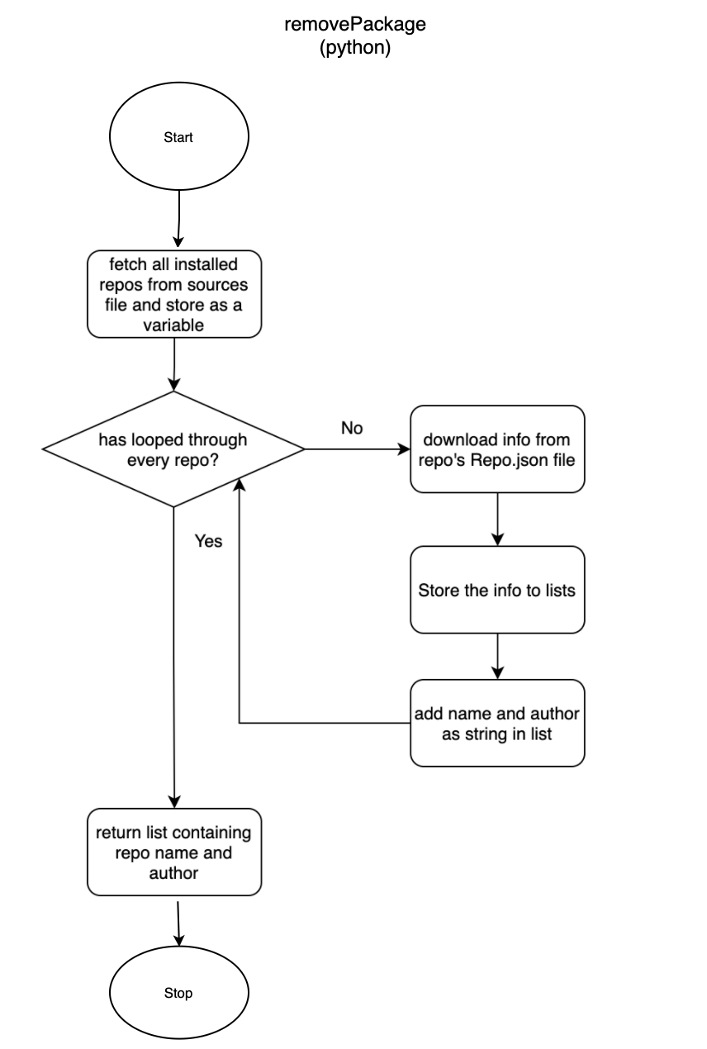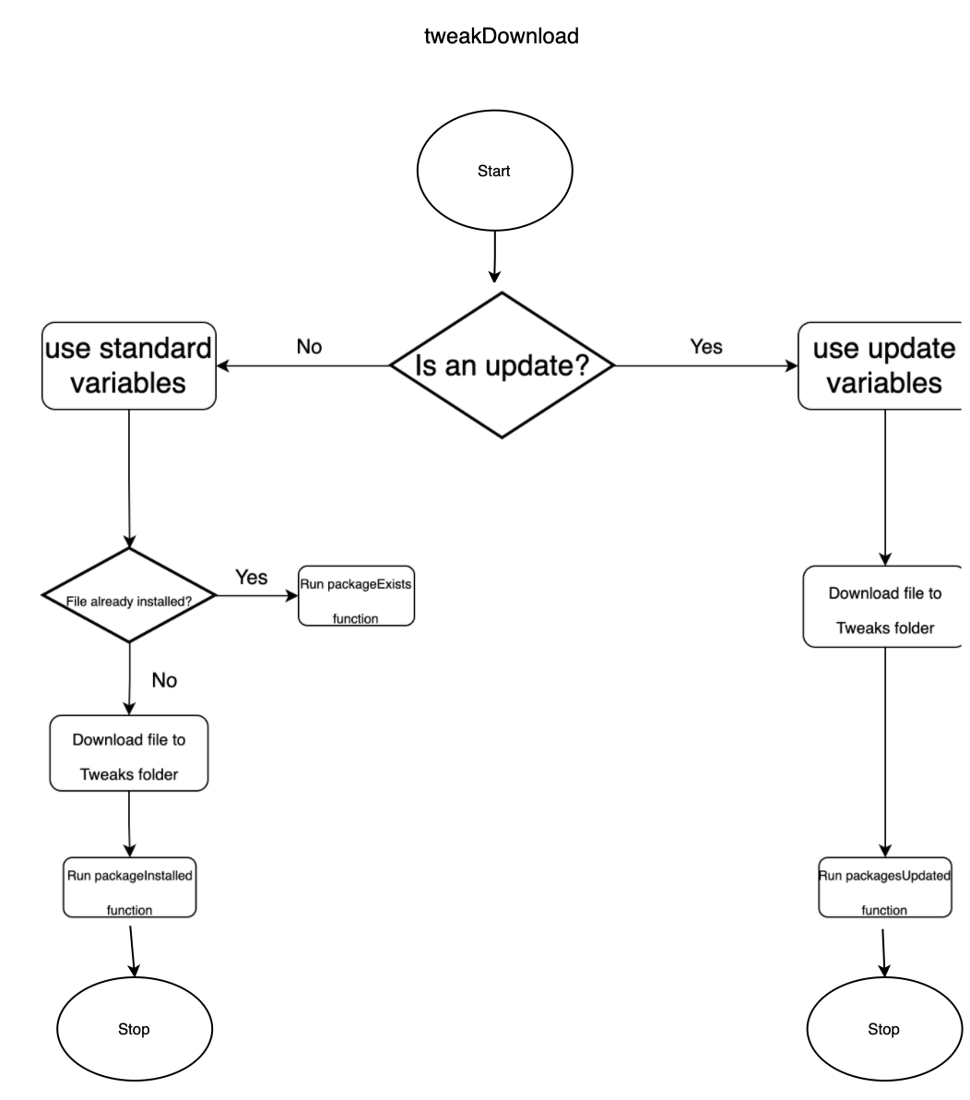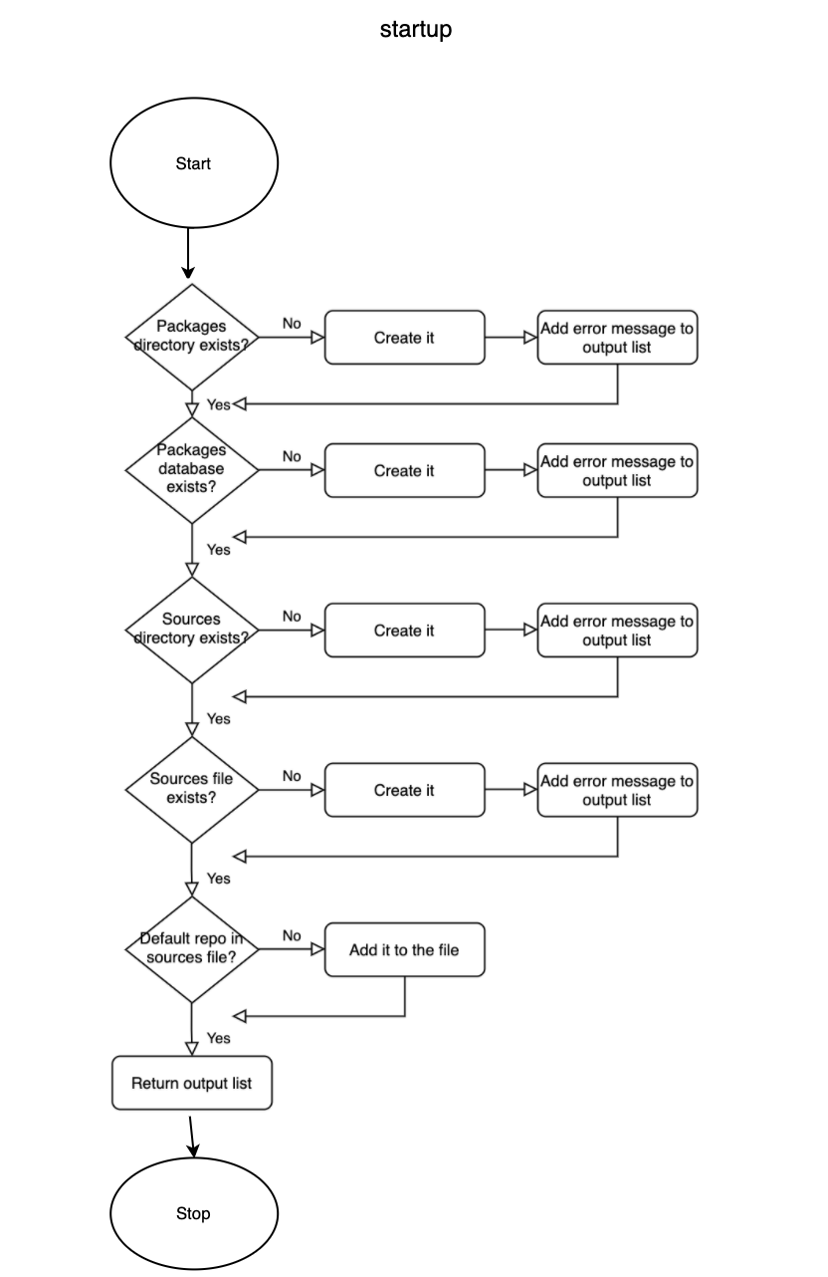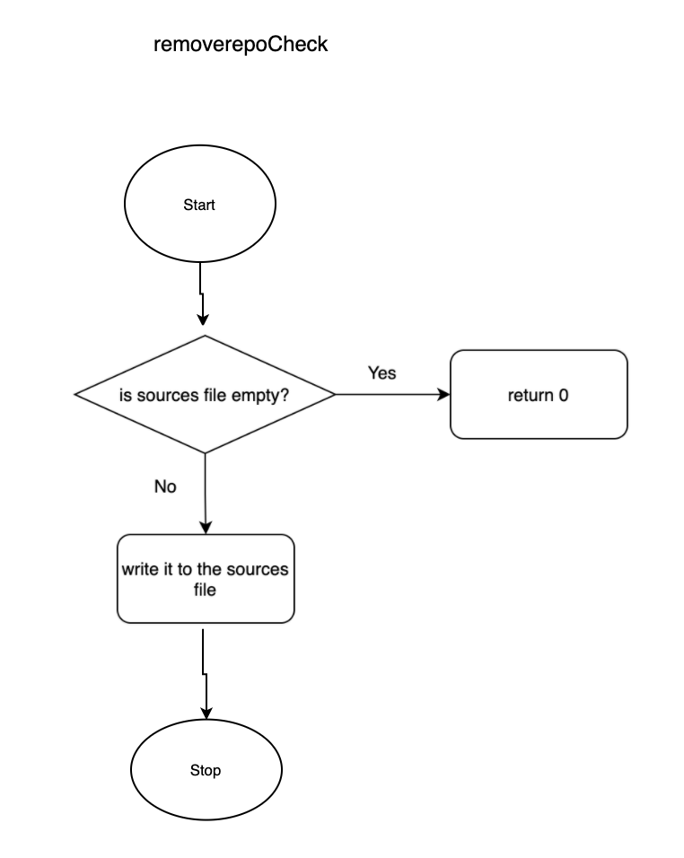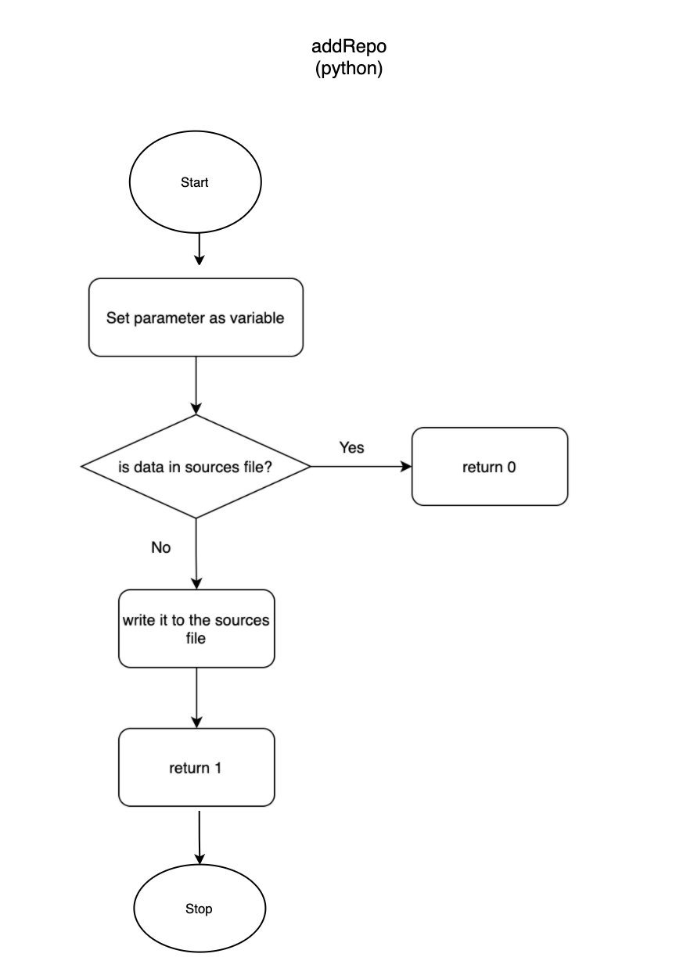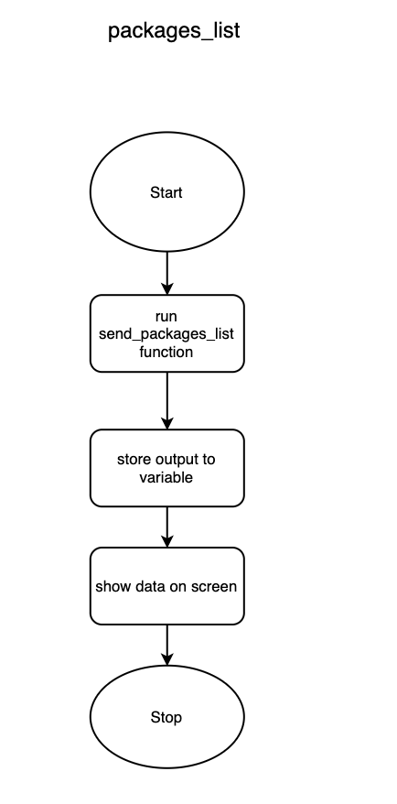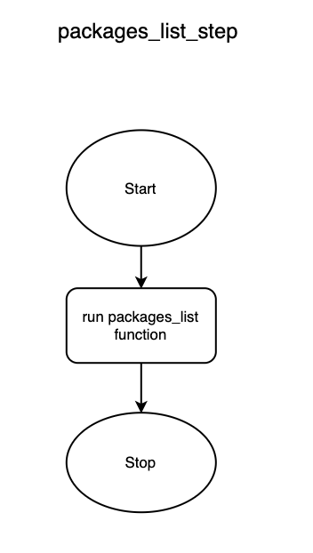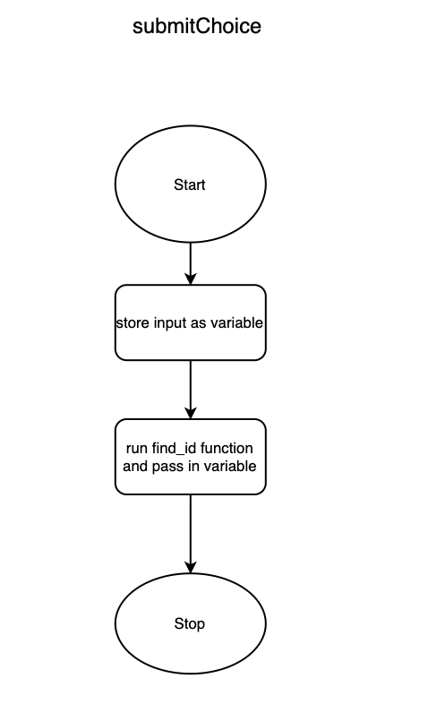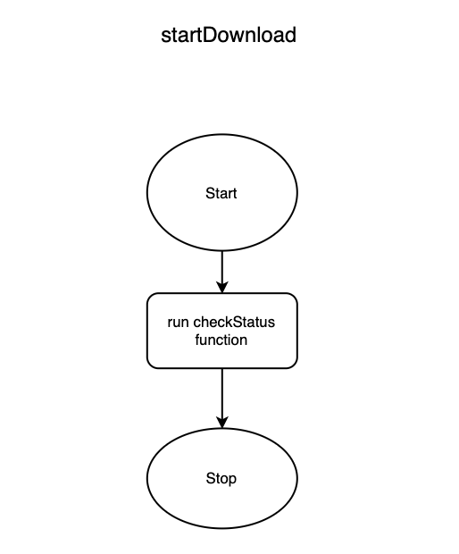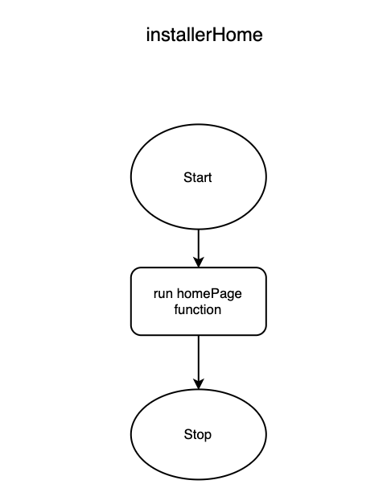

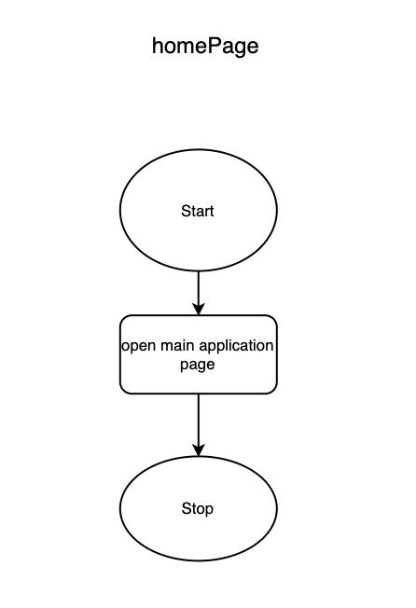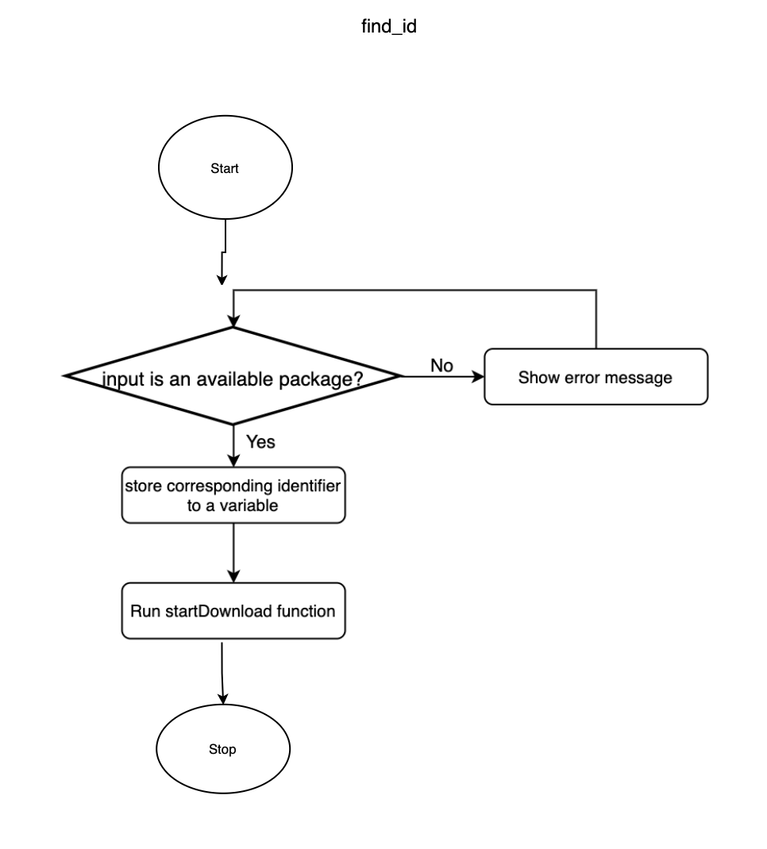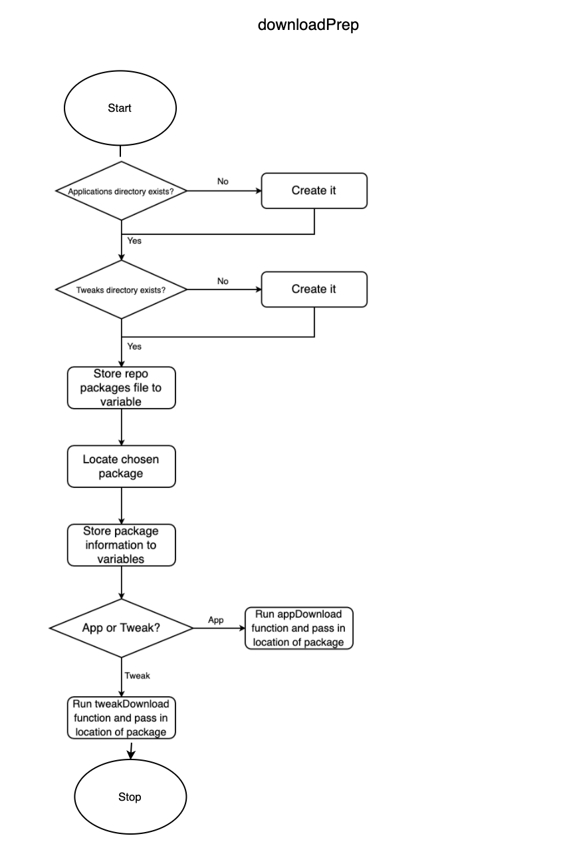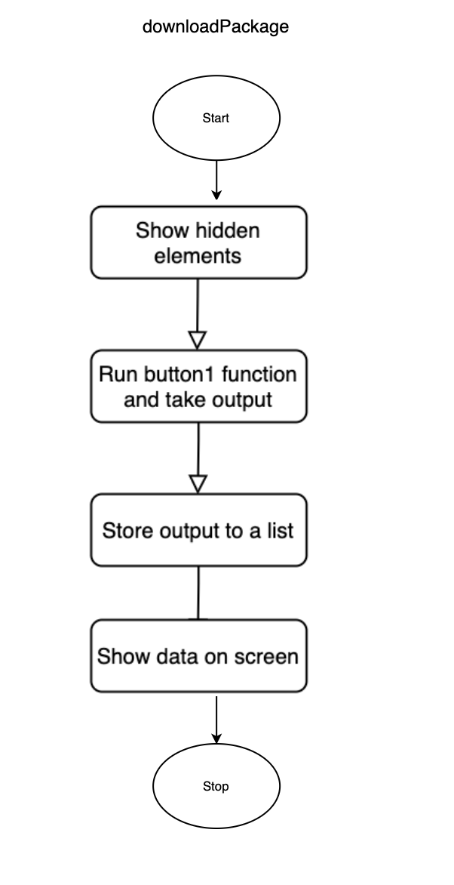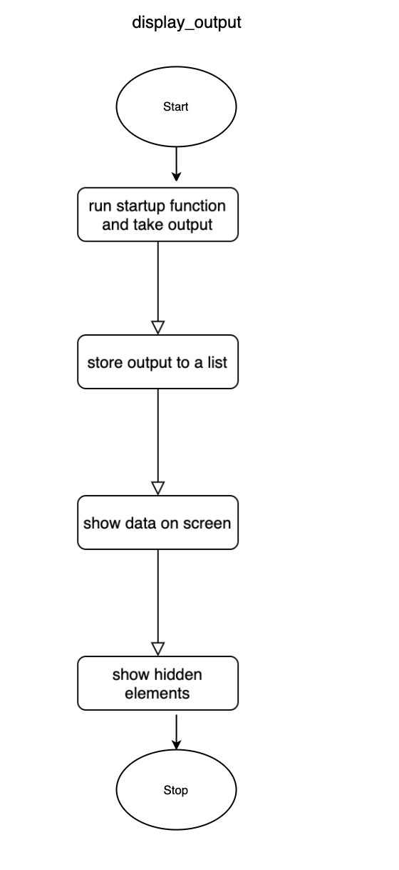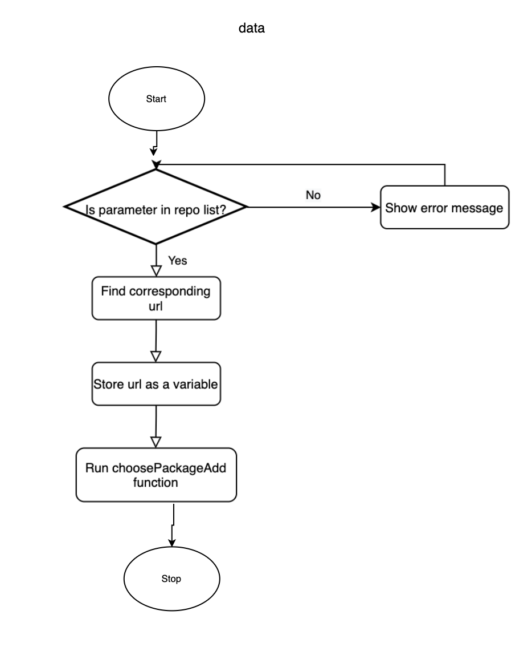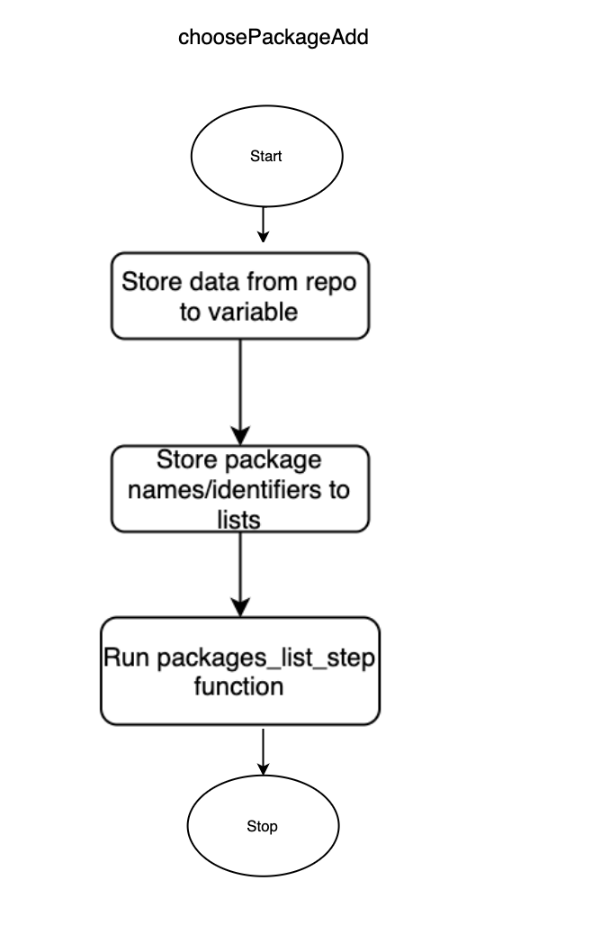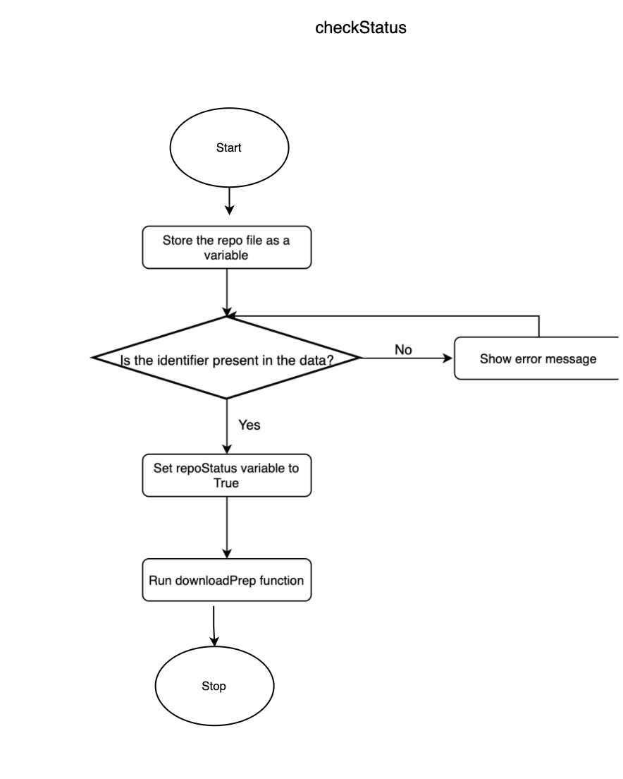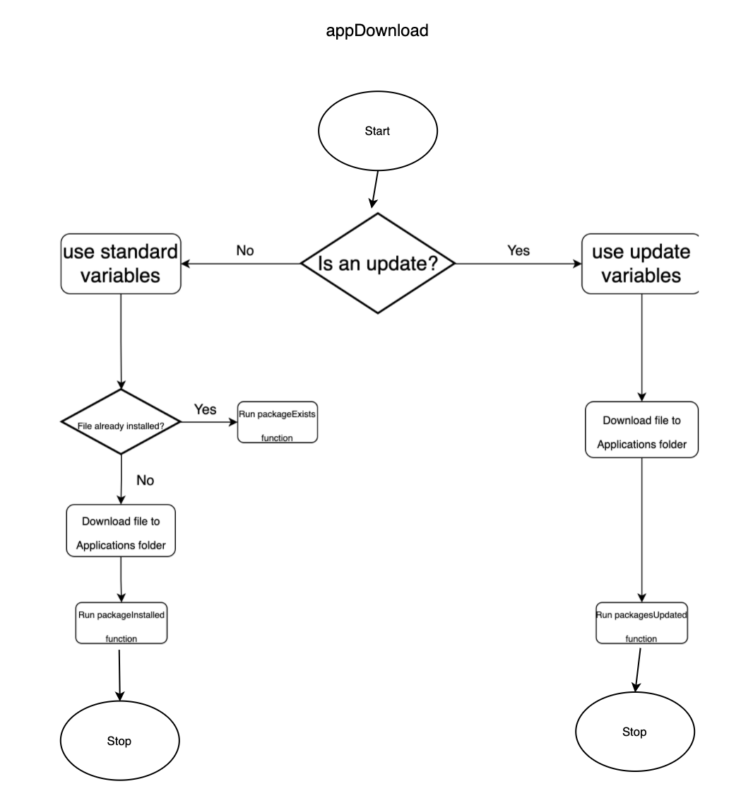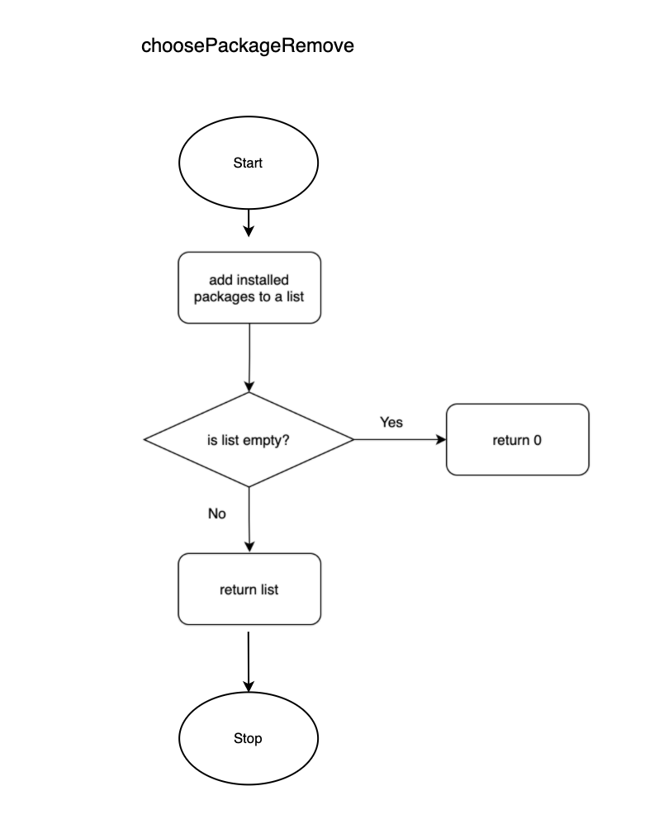

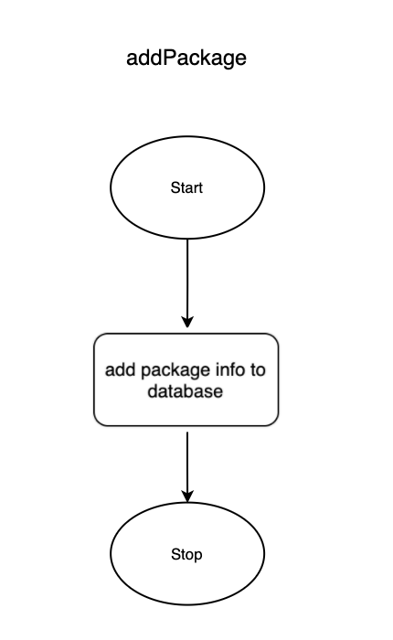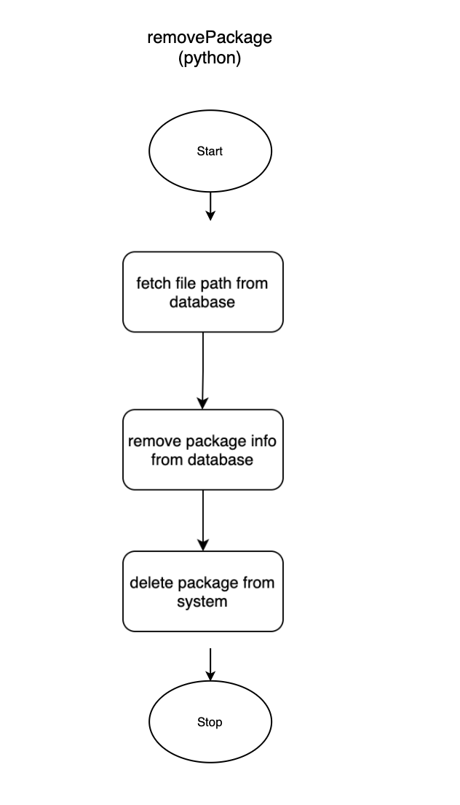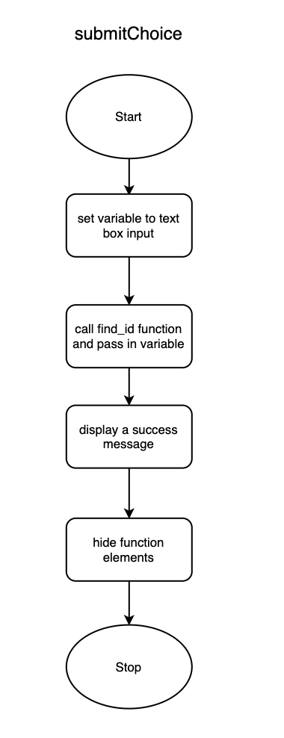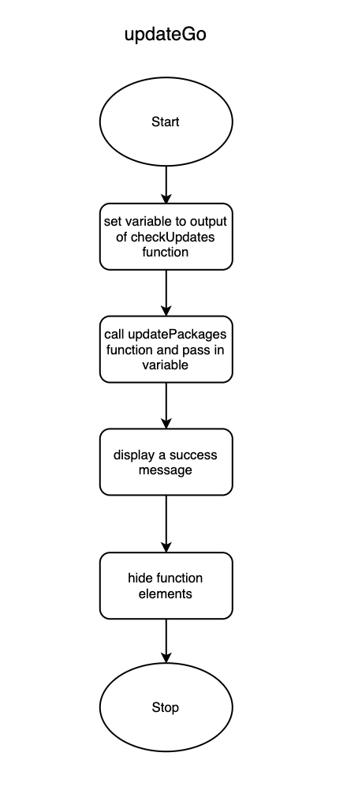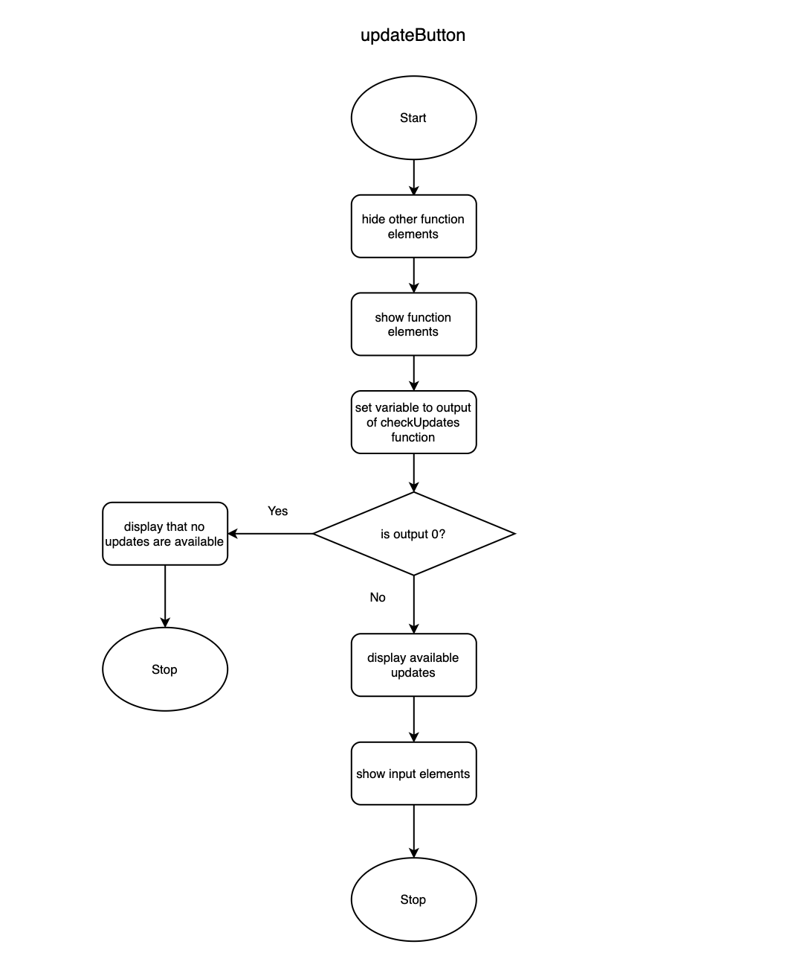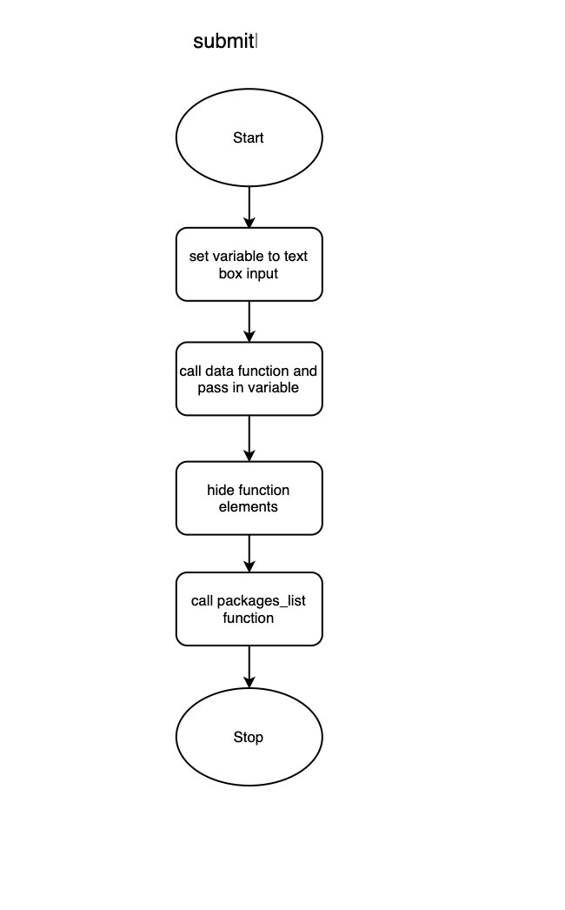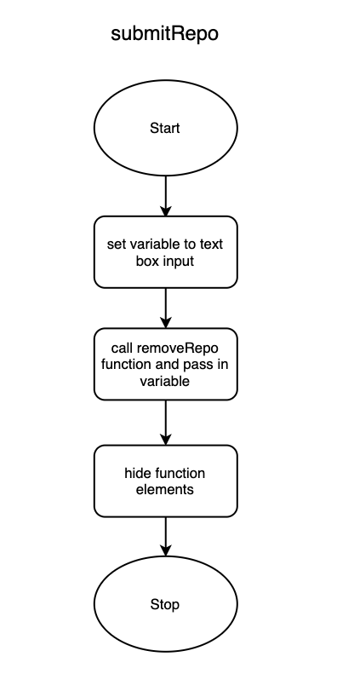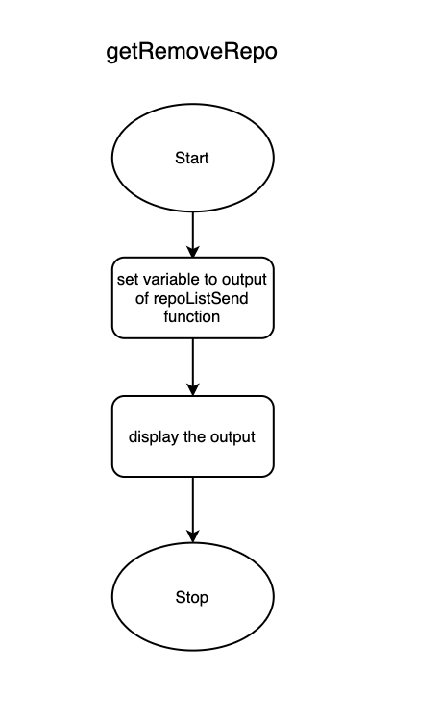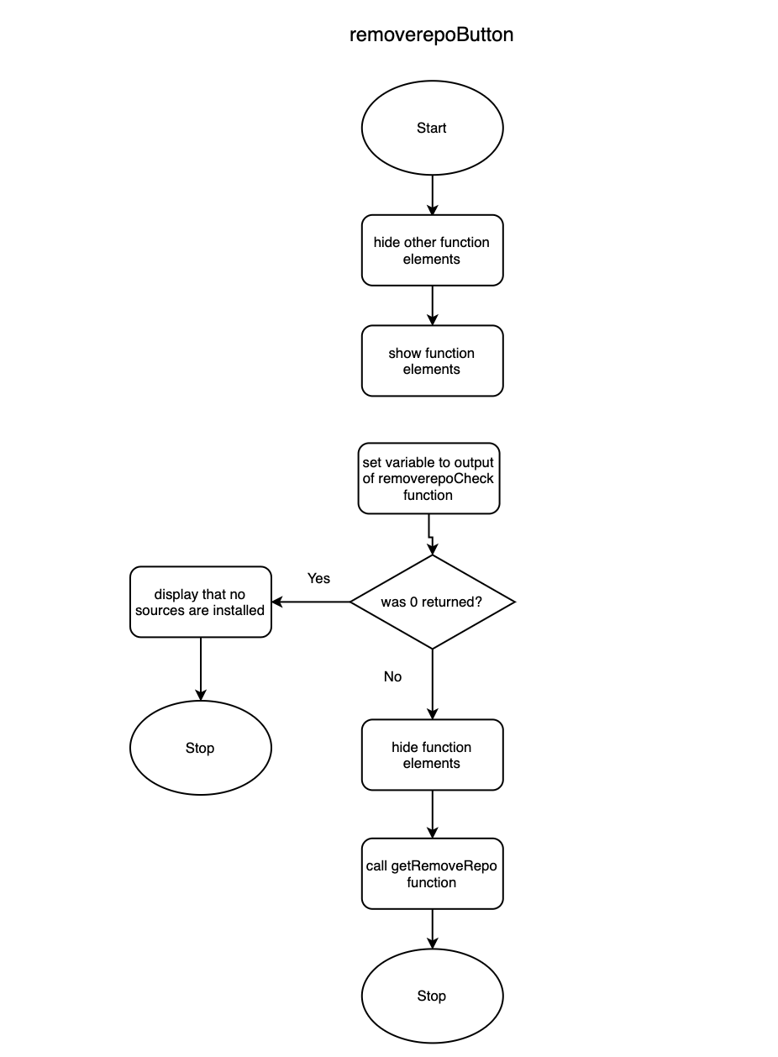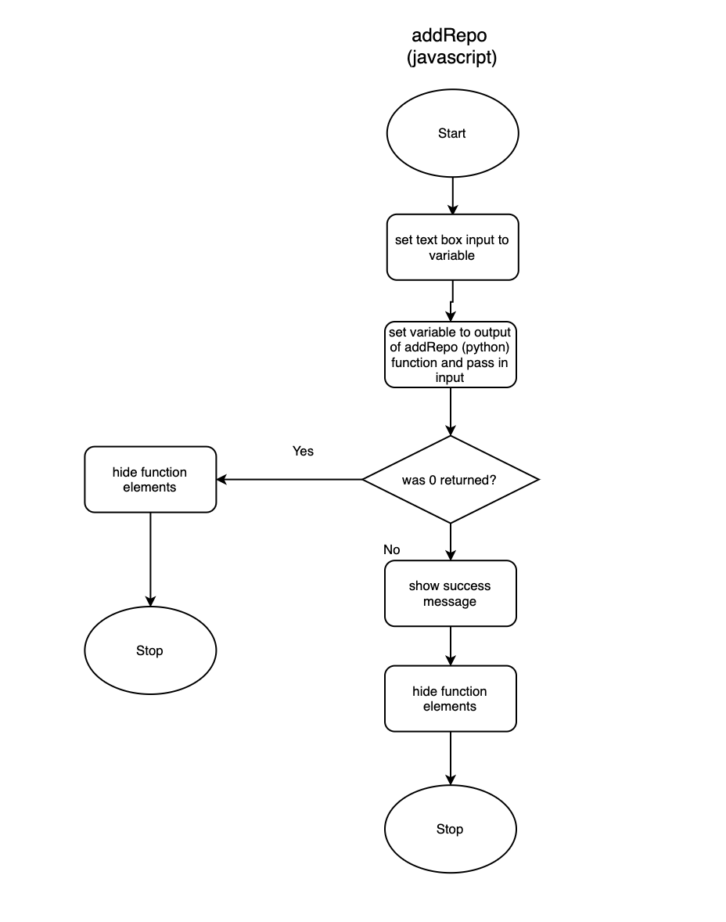

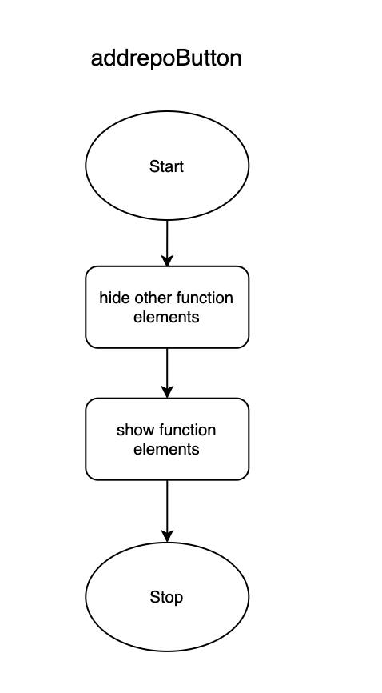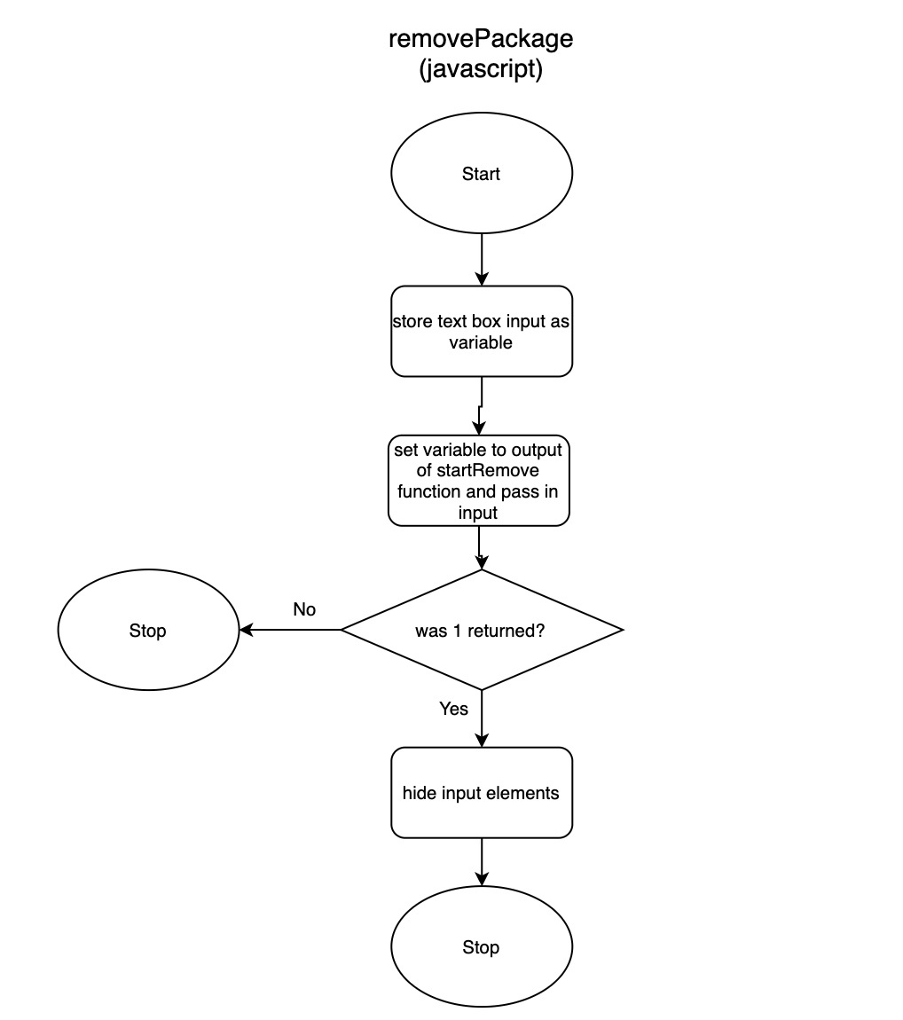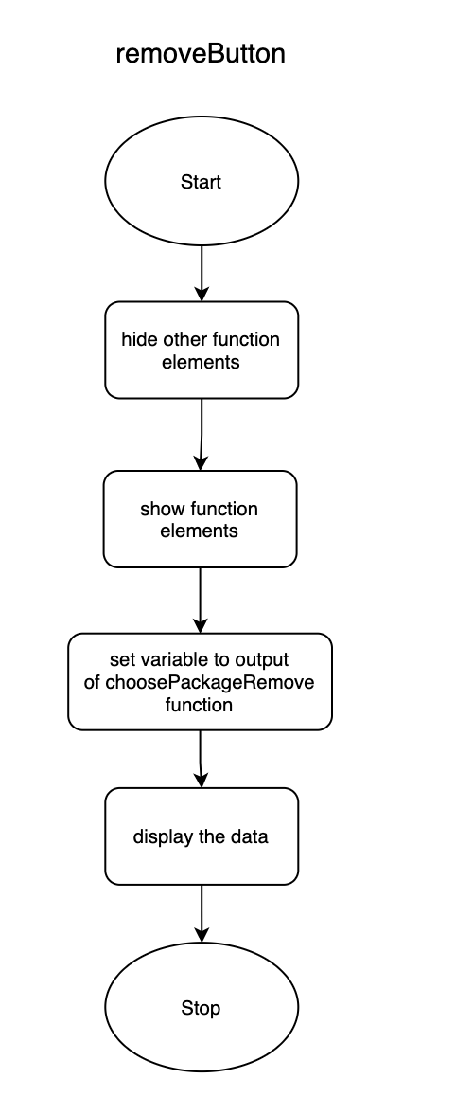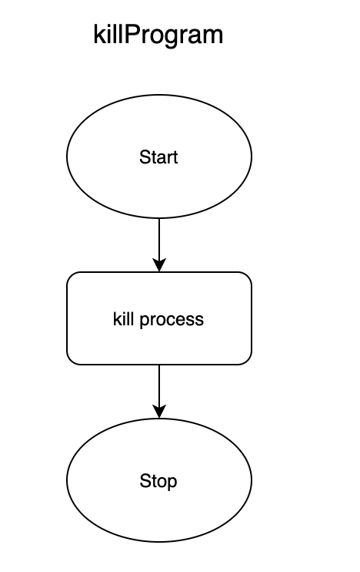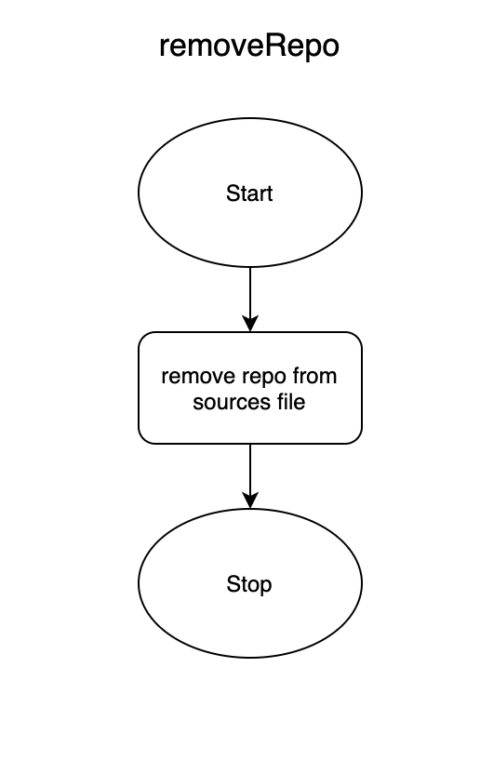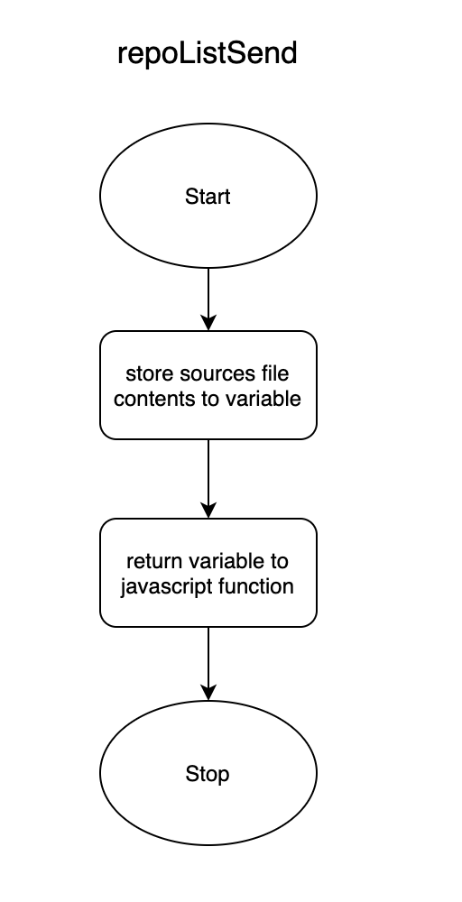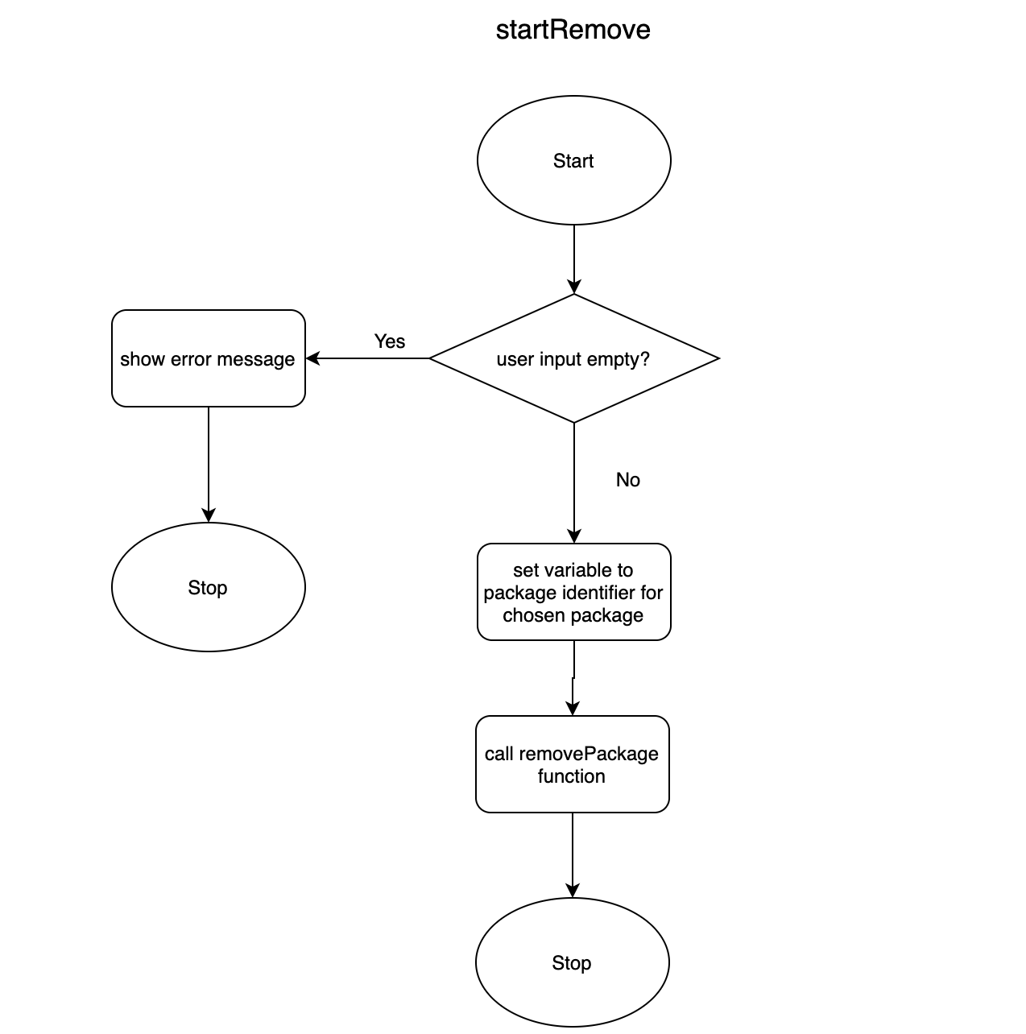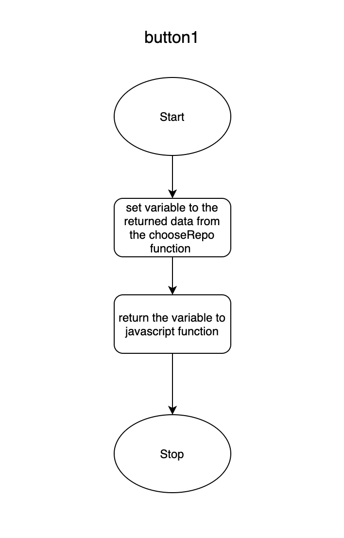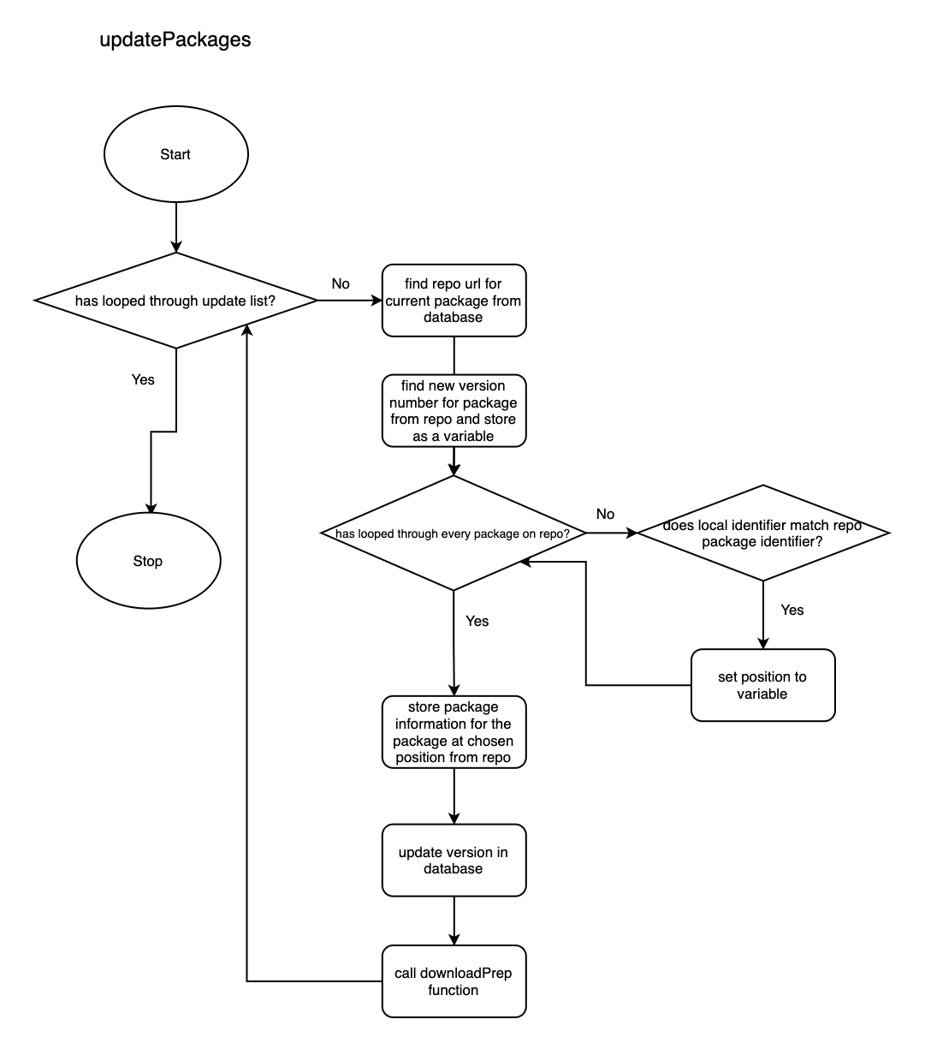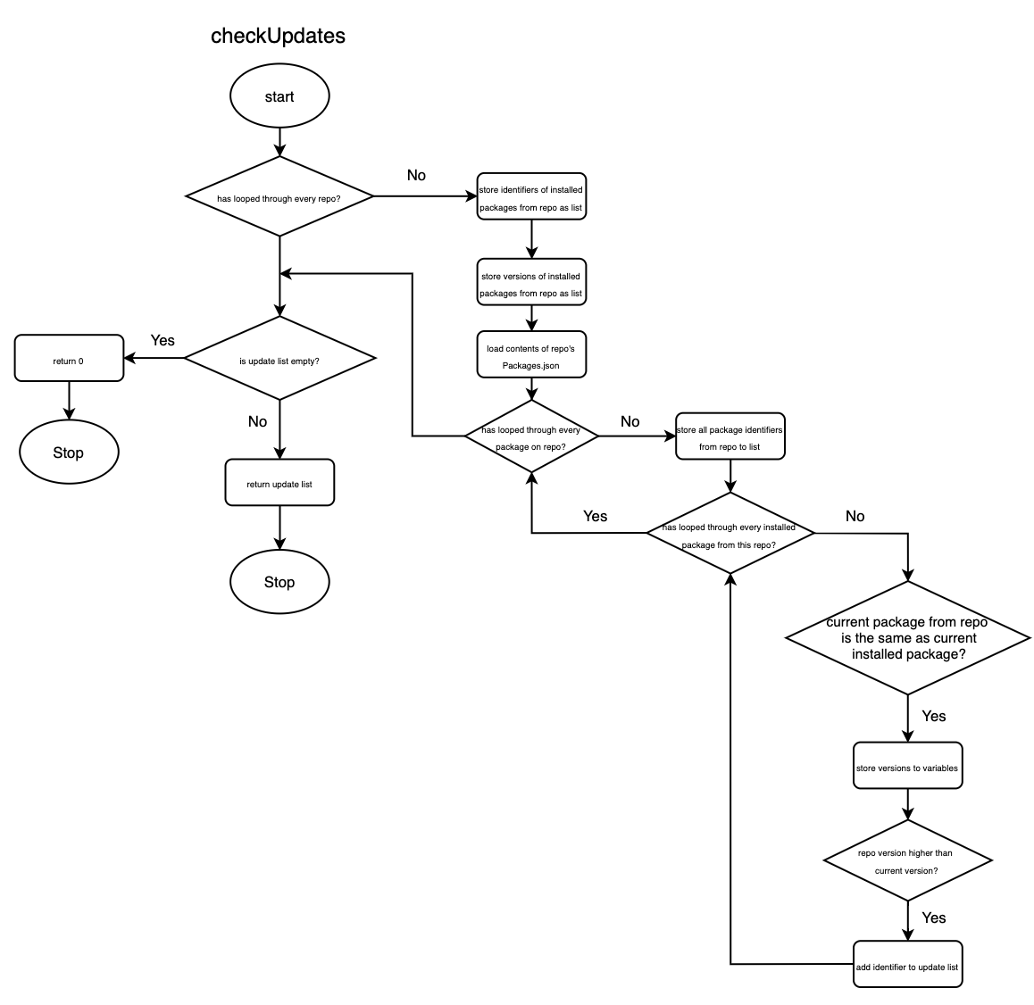

## Database Design

Tables in ‘Packages.db’

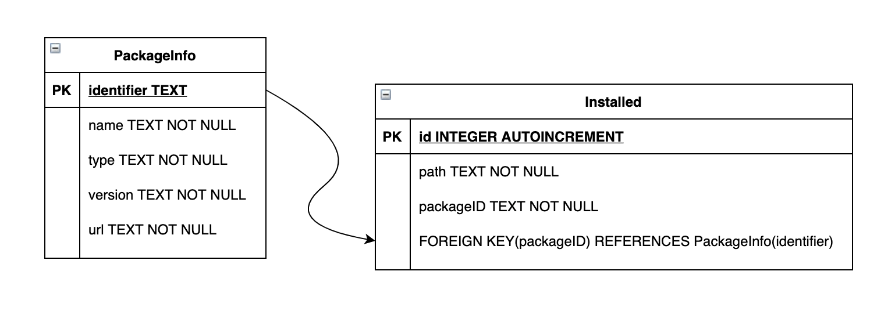

They will all grow in entries as new sources and packages are added, since the installer stores package information from the servers (sources/repositories) and stores that into the local database it will need to grow when a new package is added or shrink when a source is removed. The foreign key ‘packageID’ in the table Installed references the primary key in the table PackageInfo ‘identifier’.

## UI Design

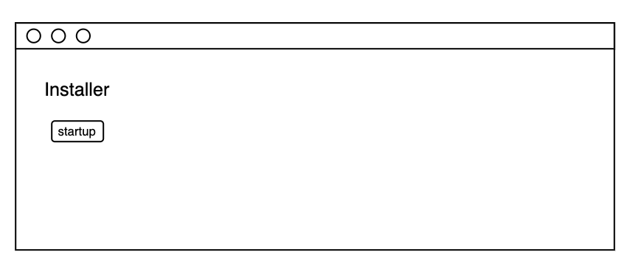

Button to run system checks before starting the main program.

**Start-up assistant to check and fix any file issues before the**

**main program starts to run.**

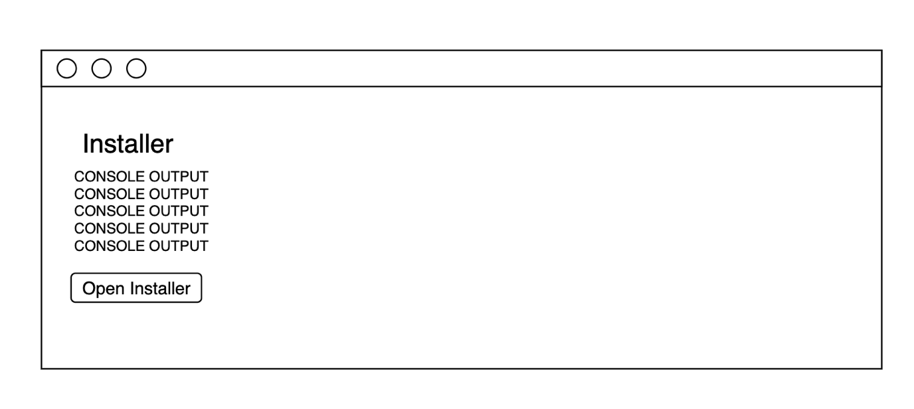

Console log displayed for the user to see.

Button to start the main program.

**Start-up assistant after checking and finding file issues,**

**It will display the console log explaining what has been**

**fixed/replaced and then it will let the user start the main**

**program.**

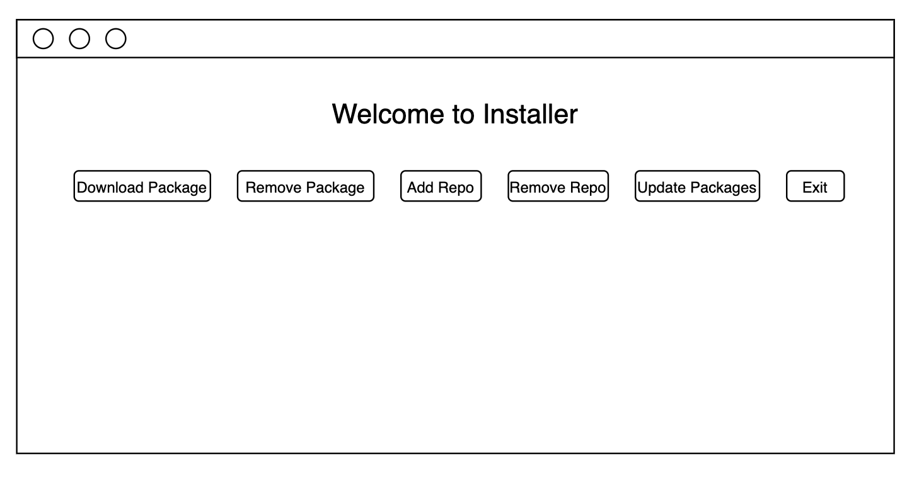

The main program window, will show all of the available functions as buttons.

**This is the main window for the solution, now the various**

**Functions can be called by pressing any of the buttons.**

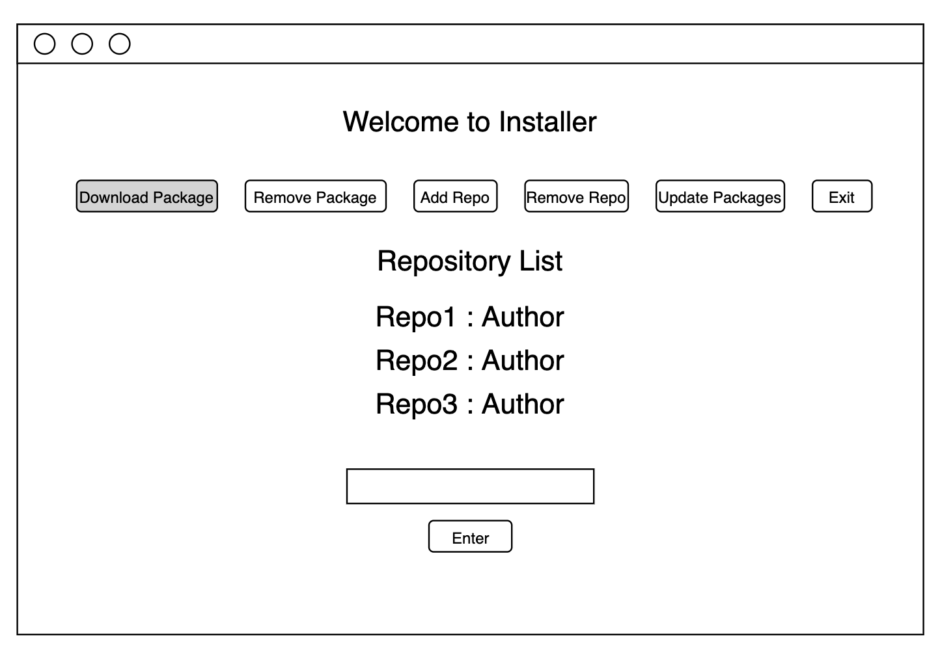

List of available repositories to choose.

Input box for users choice.

The download button has been pressed.

Button to submit the user’s choice to the program.

**This is an example of what happens when you choose a function,**

**The download button has been pressed and the process for choosing**

**A package to install has started.**

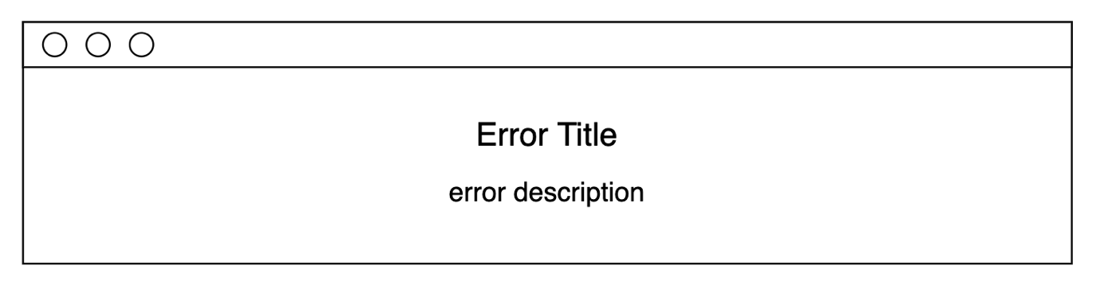

**This is an example of a pop-up window that will show when an input error occurs, such as the user entering a repo name incorrectly or choosing a package that doesn’t exist.**

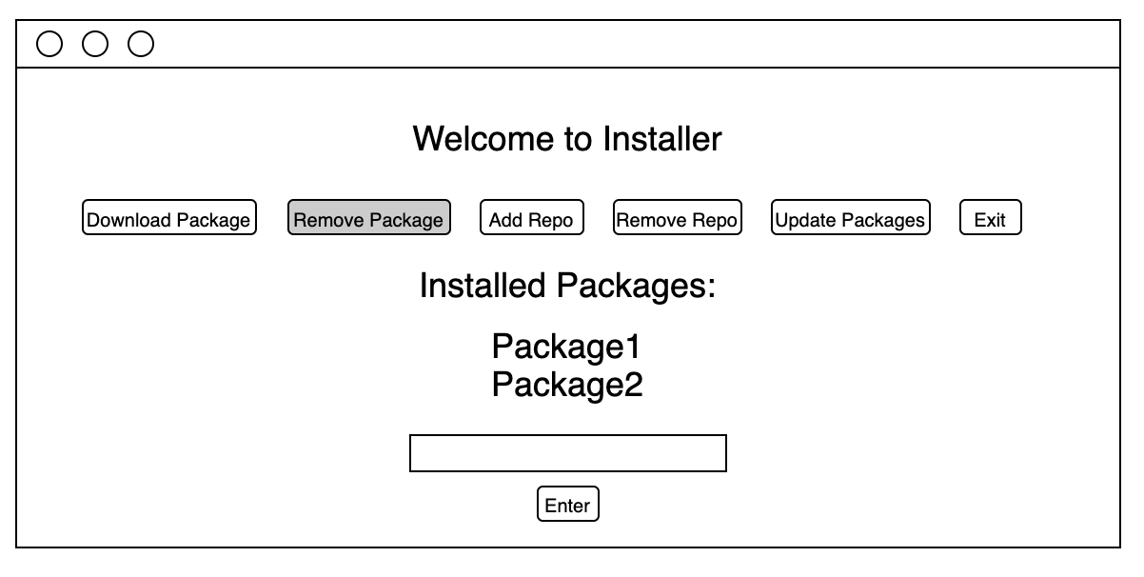

The remove button has been pressed

List of installed packages

Input elements for choosing a package to remove

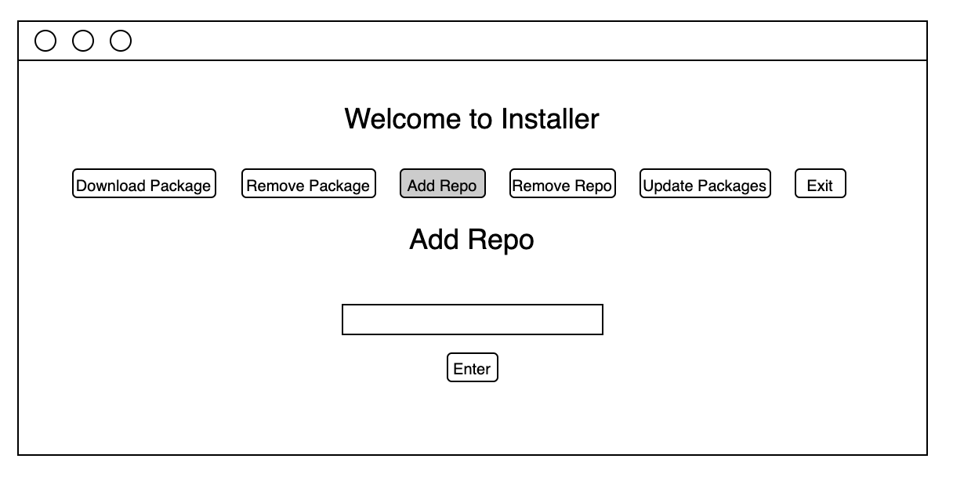

The add repo button has been pressed

Input elements for the repo url

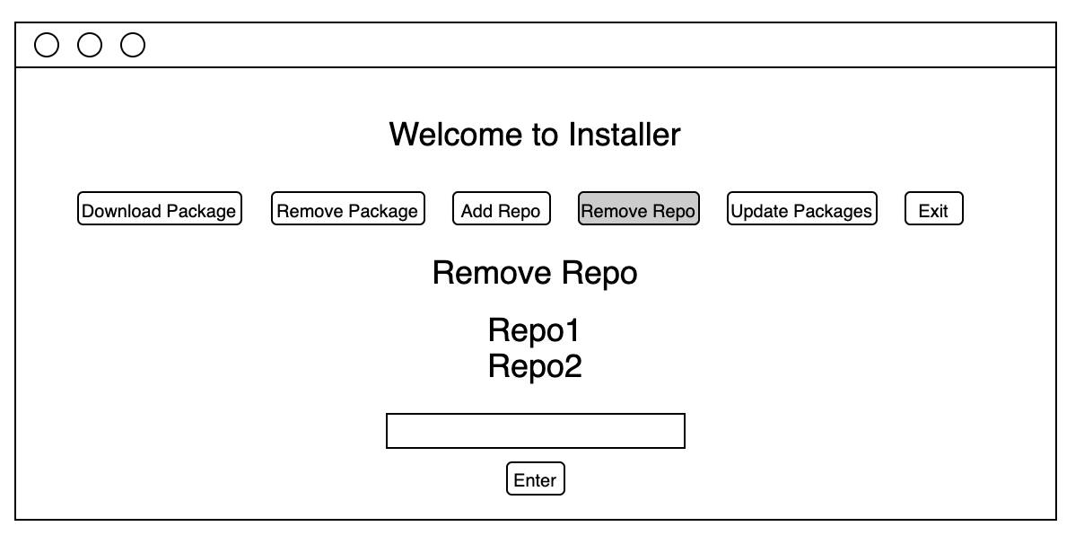

The remove repo button has been pressed

Input elements for choosing a repo to remove

List of installed repositories

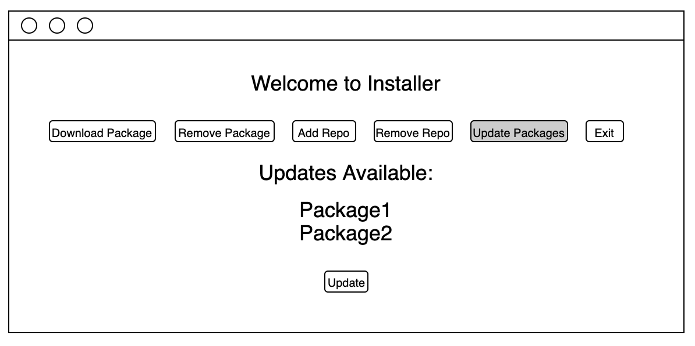

The update button has been pressed

List of all packages that have updates available to download

Button to download all available updates, and to update the local database

## Variables Table

|  |  |
| --- | --- |
| variables | description |
| **global** repoStatus | a variable used to store a Boolean that shows if the repo is a valid Installer repo |
| **global** filename | a variable to hold the file name of a package on the repo, used to build it’s local file path |
| **global** url | a variable to hold the current repo url to be worked with |
| **global** downloadType | a variable to hold the package type of the package being currently worked with |
| **global** identifier | a variable to hold the package identifier of the package being currently worked with |
| **global** version | a variable to hold the package version of the package being currently worked with |
| **global** filePath | a variable that holds the local file path for a package |
| **global** packageName | another variable used to hold the package name of the package being currently worked with, at different stages from the latter variable ‘name’ |
| **global** updateList | an array used to hold the packages that are to be updated |
| **global** choice | a variable to hold the menu input from the user |
| **global** name | a variable used to hold the package name of the package being currently worked with |
| **global** activeRepo | a variable used to hold the Boolean output from checking if a repo is valid |
| **global** updateInstall | a variable used to hold the Boolean output from checking if the install type is an update |
| url | a variable used to hold the currently active repo url |
| file | a variable used to store the file being worked on |
| data | a variable to hold the json file data or database data after it is loaded from the repo or the local db |
| check | a variable used to store data that needs to be validated |
| end | a variable used to store the length of files |
| sources | an array used to hold the installed repos loaded from the local sources text file |
| name | array used to store a package name |
| packagesFile | array used to store the location of the packages json file on the repo |
| author | array used to store package creator |
| idList | array used to store identifiers |
| update | array used to store package names of packages with updates available |
| identifiers | array used to store all identifiers |
| versions | array used to store all package versions |
| installedPackages | array used to store installed package names so that ones with updates can be added to update |
| installedVersions | array used to store installed package versions to check against repo versions |
| temp | array used to store repo package versions to check against installed versions |
| **global** repo_list | list of repos |
| **global** packages_list | list of packages |
| **global** idList | list of package ids |
| info | holds repo choice |
| input | Holds user input from text box |
| x/y/z (in javascript) | used to reference page elements |
| text | holds data to be shown on screen |
| i/x/pos | variables used for looping |

# Development

## Version 1

The aim of version 1 is to be able to download a specified file from the repo to a folder on the local system.

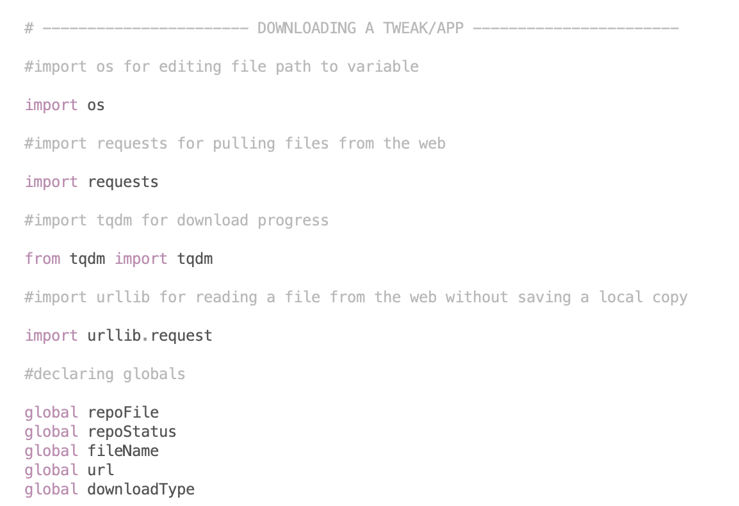

Declaring global variables

Importing necessary modules

The first part I worked on was the downloading function, as this was the centrepiece of the entire program. In order to download and install files from a web server I needed to import a few libraries first. Importing os allows me to work with local files/directories, importing requests allows me to pull a file from a url, importing tqdm allows for tracking progress of a downloading file and although not necessary it is always a nice thing to have while testing, and importing urllib.request allows the reading of file date from a url without having to save a local copy of the file.

Next, I declared all of the variables that would be needed in the downloading section. I also made the decision to have all of the variables here as global, since it makes changing them in other parts of the program easier. And there will be no issues with this since everything runs in a set order, and there is no need to use data previously stored in a variable.

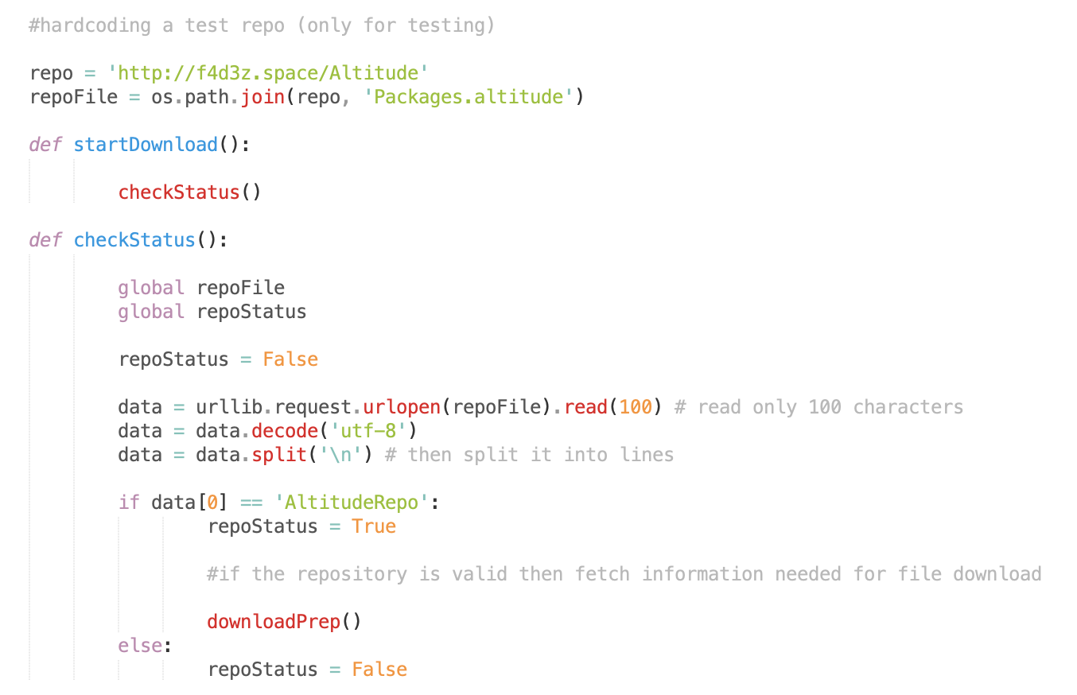

Function to check if a repo is online by reading data from a file hosted on the server

Function just to start the download process

Used a custom file ending for this version

Hardcoded the repo input for testing purposes

For testing purposes only, I now hardcoded a repo into the program so that I didn’t have to write a function for selecting an installed repo or working with that at this point. I also wrote the two first functions being startDownload and checkStatus. startDownload is a function which is responsible for starting the chain of actions for downloading a file from a repo. The first action that must be taken is always to check the status of the repo, if it is offline then there is no use in trying to go through the rest of the actions as they will just cause errors. This is where checkStatus comes in, this function attempts to load data from the repo file and also checks to make sure that the url even if it is online is a compatible repo. It loads the first piece of data in the json file, which should be the identifier “AltitudeRepo” showing that at this url, that is online since the data was downloaded, there is a valid repo. Then if this is true, then the repoStatus is set to True and the next action begins and if not then it is set to False. 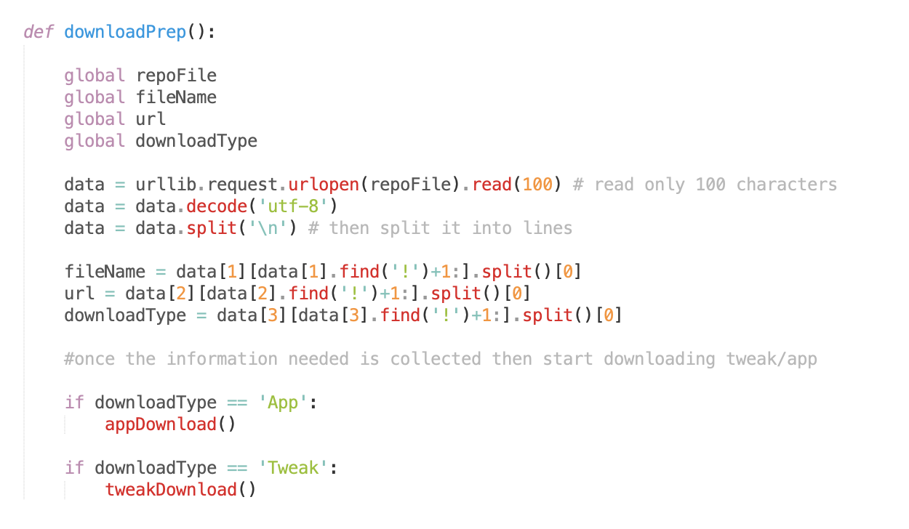

Way of reading from the repo file, since it was just a text file attempting to be an organised structure

Different functions for different package types, as they install to different locations

I then created a function that would locate and store the information about the package from the repository, and then call the functions responsible for actually downloading the file to the system. Due to making my repo file a word file and attempting to organise the data with a key “!”, the process for reading the data is messy and definitely not an ideal solution. But this version is only an attempt at getting a chosen file to download from the repo, and so as long as that works this version is a success and the rest will be cleaned up in a later version.

I used the requests module to start the file download

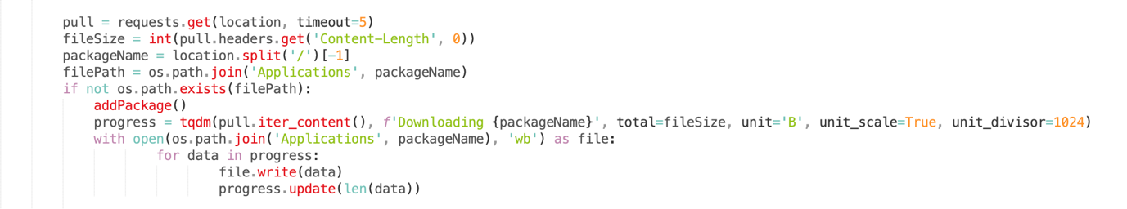

I used the tqdm module to add a downloading bar for the CLI version of the solution that I would use for testing

This section of code is the main part of this version, the code responsible for downloading a file from the repo to a specified folder on our system. The code uses the requests module to start the download. The code also takes the package name from the url and adds it to the end of the install path to create the new file path for the file to be installed to. Then the function addPackage is called which will be responsible for adding the package to a local database. TQDM is also used to add a progress bar to the command line when you run the script.

## Version 2

The aim of version 2 is to clean up the process leading up to the download functions from version 1, and to fix the repo system.

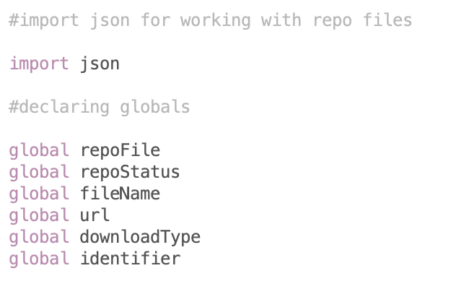

Imported the json module for working with the new repo file

Added another global as it was needed

In version 2 of the solution, my goal was to issues with the repository system that came from using a text file in place of an organised structure. To do this I decided to switch over to using json files since they are organised by identifiers which I can use to jump to specific parts of the file in an easy way.

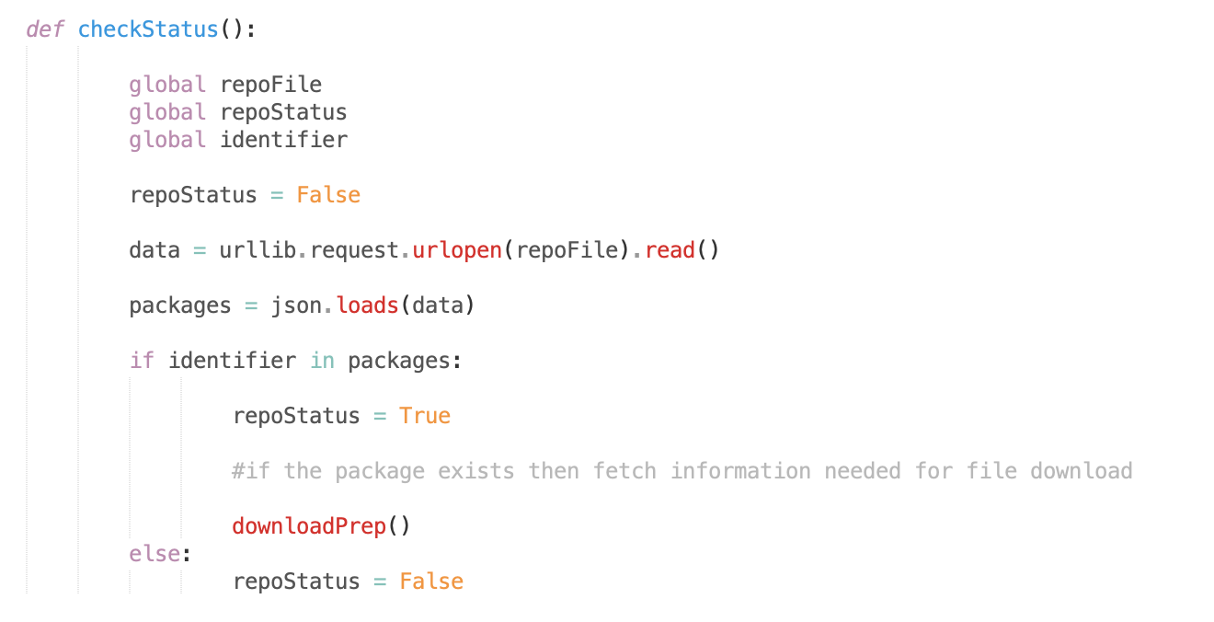

Loading data from the repo was now much easier to do

By switching to a json file for the repo, it required less lines of code to load the data so it could be checked for an identifier. We could now check if a string was in the repo file easily also, which would be useful in other parts of the solution.

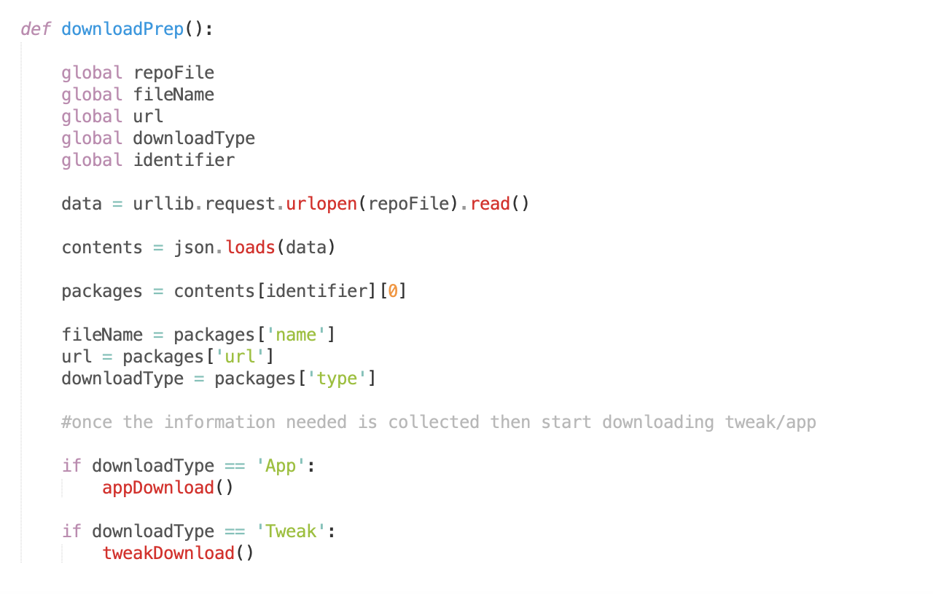

What used to be a messy way of reading data is now simple and clean

Now the process leading up to the downloading functions has been cleaned up, this was the goal of version 2 and so I moved on to version 3 after this.

## Version 3

The aim of version 3 is a fully working repo system which includes being able to add a repo to the solution, to remove one, and to store data from the repo to a local database when a file is installed.

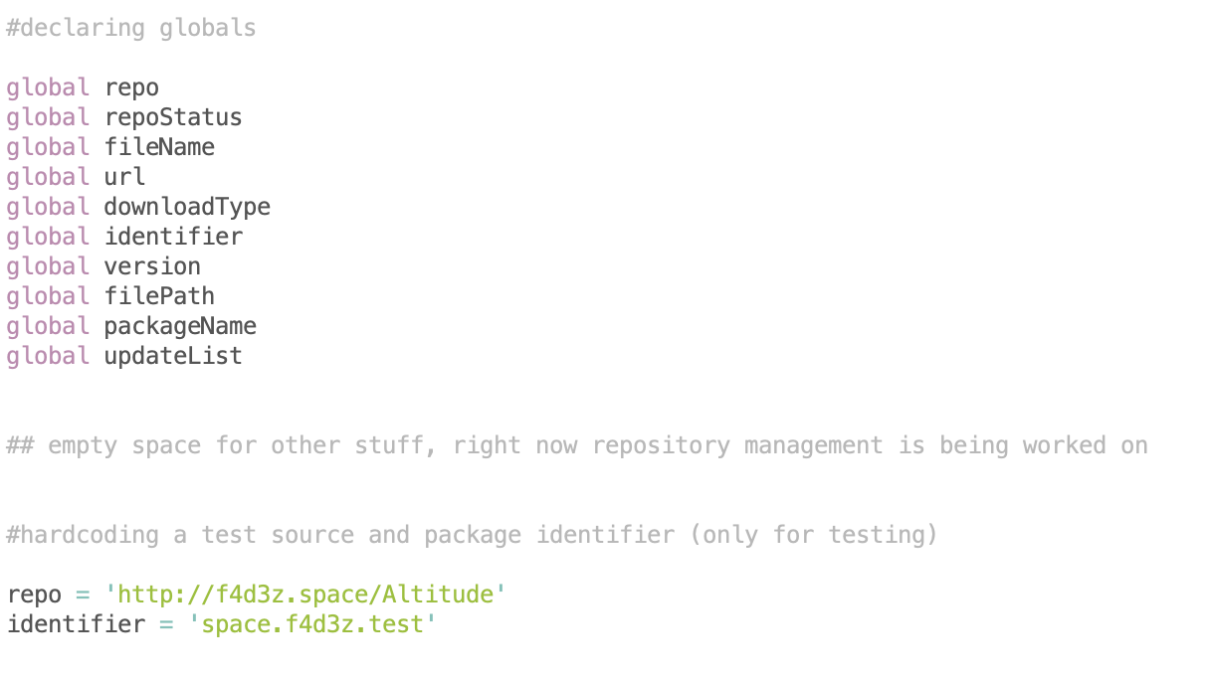

What used to be a messy way of reading data is now simple and clean

What used to be a messy way of reading data is now simple and clean

I added more global variables as they were needed for the next version. And then I hardcoded a repo url and the identifier of one of the packages on that repo. This was for testing as I do not have any user input in this version.

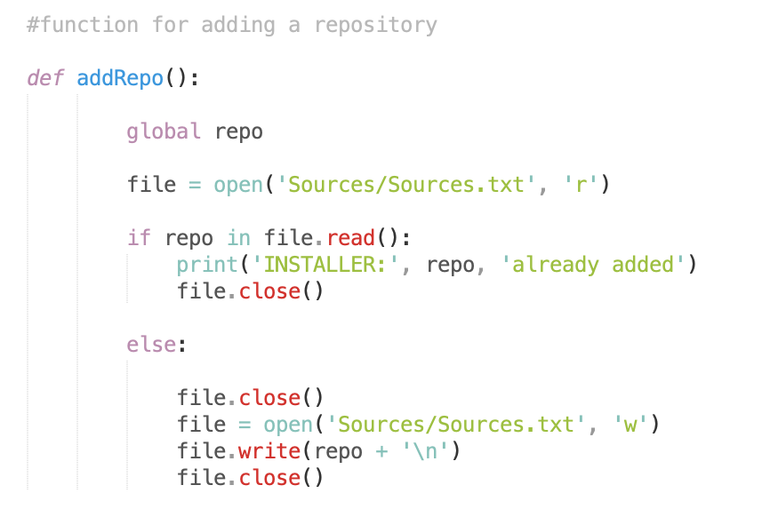

Writes the new repo to a new line in the sources file

Sources file can be a text file unlike the repo files, as it is only organised by lines

Function to add a repo to the solution

First, I added a function for importing a repo into the solution. This worked just by taking the variable “repo” which would later be set by user input, and then writing the contents of that variable to a new line in a sources file.

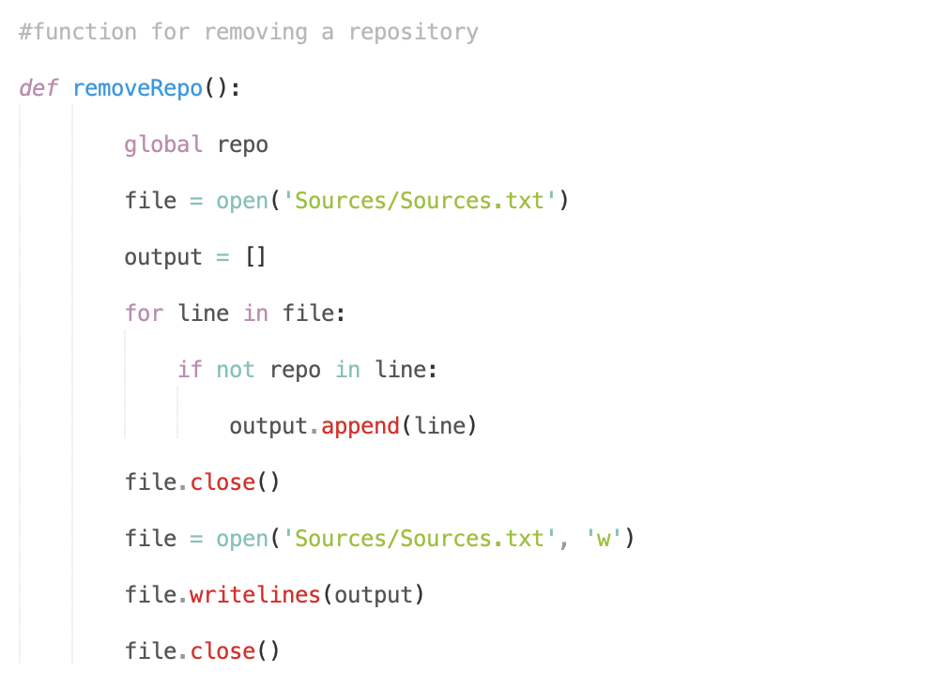

Overwrites the file with the list that contains all previous repos except the chosen one

Loads every line that doesn’t contain the chosen repo into a list

Function to remove a repo from the solution

Next, I added a function for removing a repo from the solution. This worked just by taking the variable “repo” which again would be set by user input in the future, and then loads the contents of the file into a list but excluding the chosen repo. Then the sources file is overwritten by the list, producing the same effect as removing a line from the file.

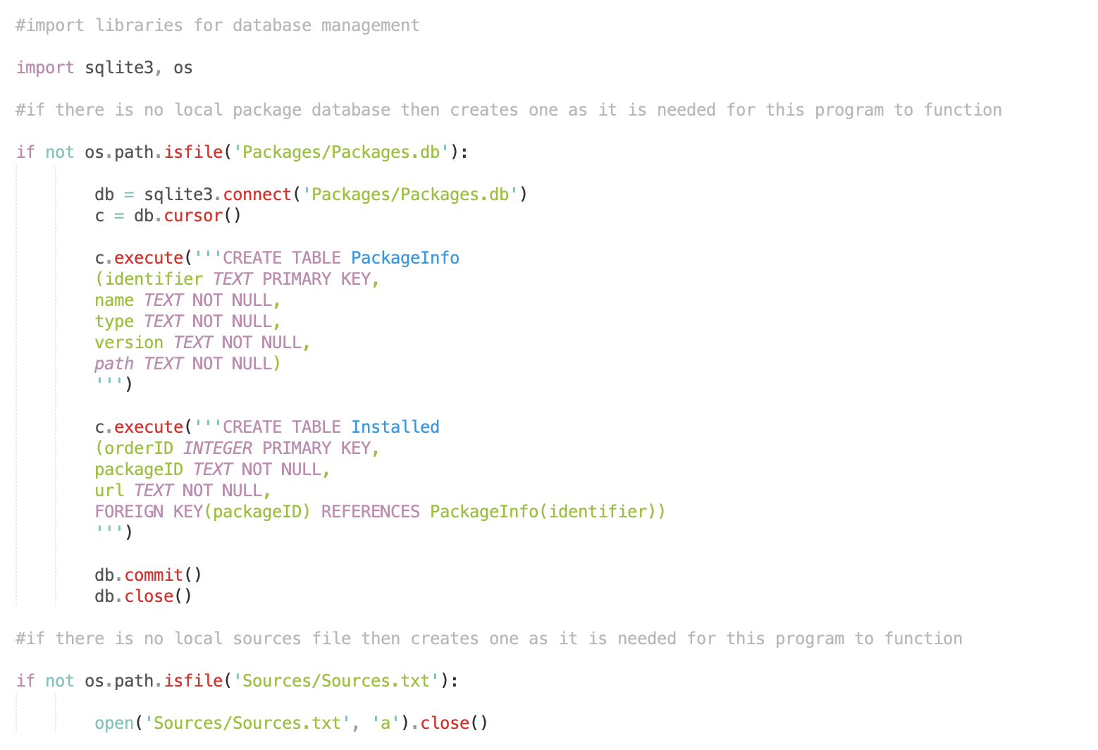

Creates the sources file if it isn’t present, as it is necessary

Table for storing where the packages were downloaded from

Table for storing all package info for installed packages

Database is created in Packages folder

Next I created the local database for storing the package information of any packages that have been downloaded to the system. The two tables included a Packages table for storing the file information, and the Installed table for storing the repo information about installed packages. This last table is necessary as it will be used later by other functions to check where a package is from, and this can be used to then check the local version against its version on the repo to see if any updates are available.

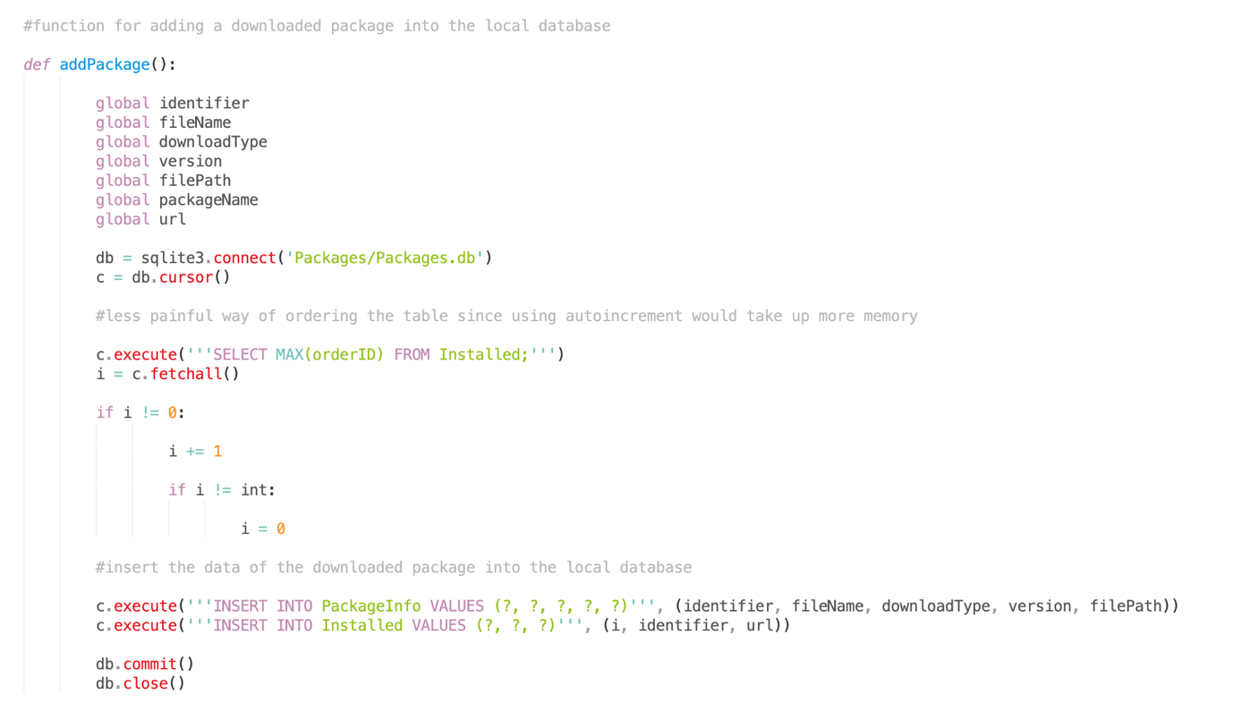

Package information from the repo is stored into the database

A way of creating a new id for every entry without using autoincrement

A function was created for adding package information into the local database. It creates a unique id as well by reading the highest id in the database and increasing it by 1.

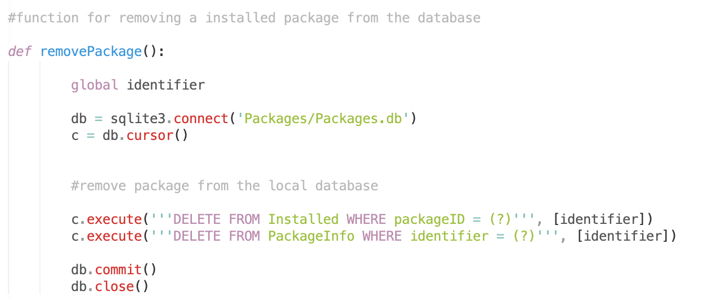

Removes all information about a specific package from both tables

A simple function was created for removing package information from the local database.

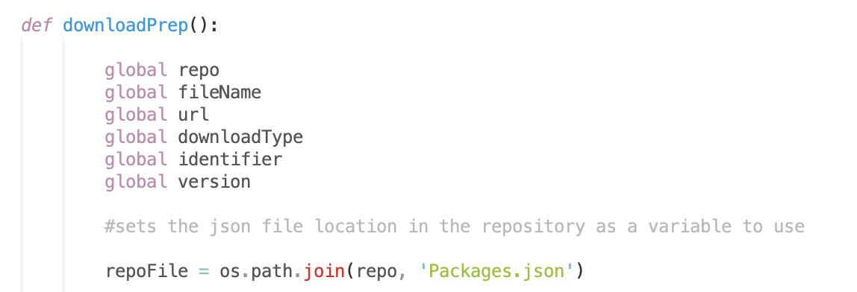

Creates the repo file location from the url

This function will be used to store the necessary information about a package as variables. Which can then be inserted into the database once the file is installed to the system.

It also creates the repo file location from the url instead of having that hardcoded like in versions 1 and 2.

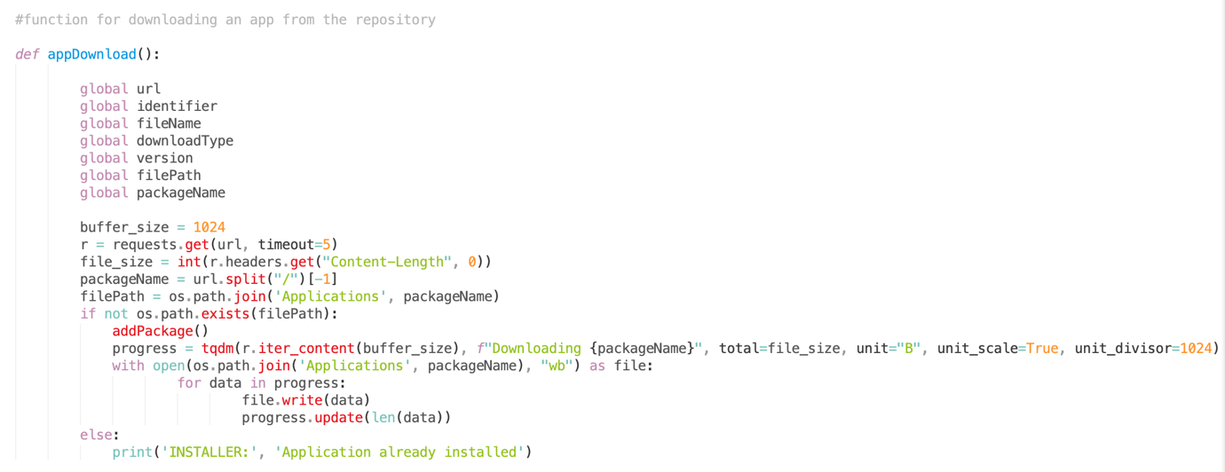

Adds a buffer to the file download

Something extra I did in version 3 was to set a buffer size for the downloads. I picked a buffer size of 1024 which is enough to download at a decent speed.

## Version 4

The aim of version 4 was to support multiple packages and repositories in the solution, and to improve upon what was already created for this purpose.

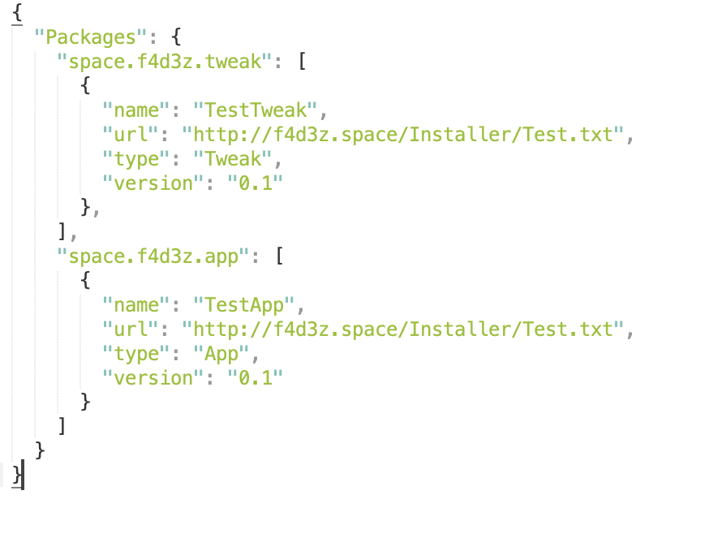

New repo layout using the package identifiers as keys

I changed the repo file layout, so that a package could be quickly jumped to if its identifier was known.

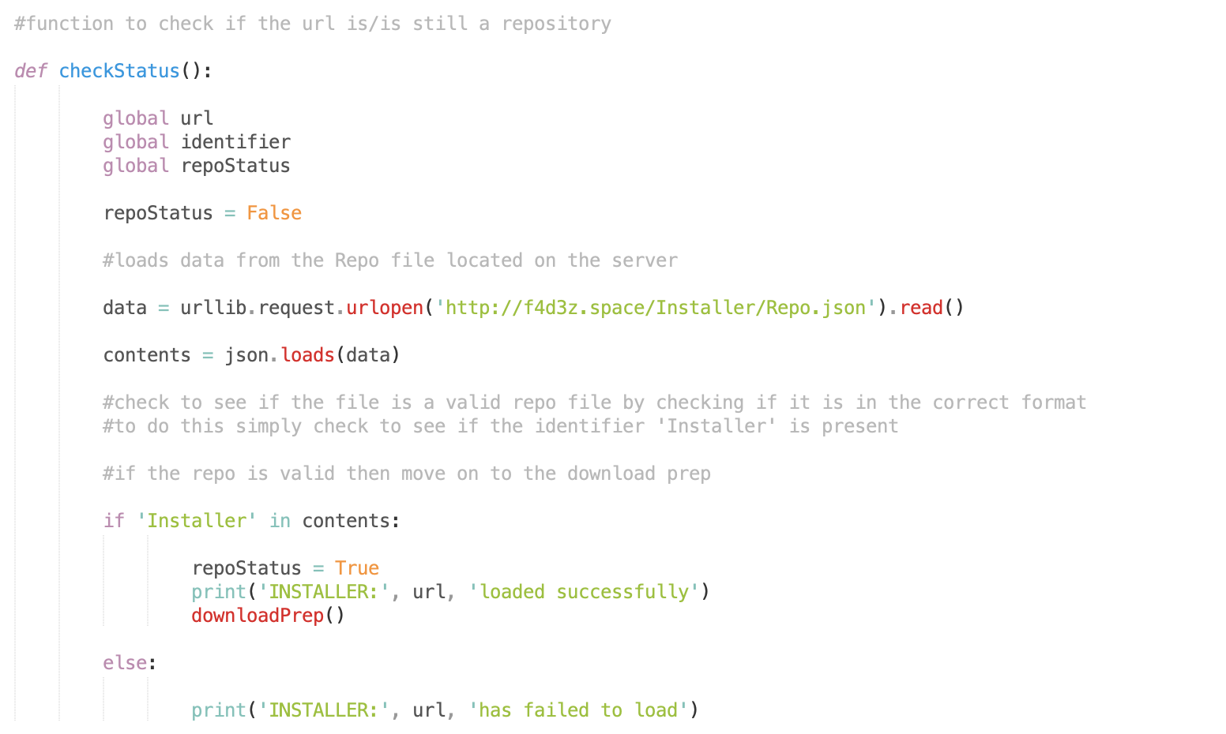

Now checks for the main repo file key

The new repo layout meant that the system could search for a specific key that it knew would be present in that location, and if it could load the file and the check came back as True, then the repo was online.

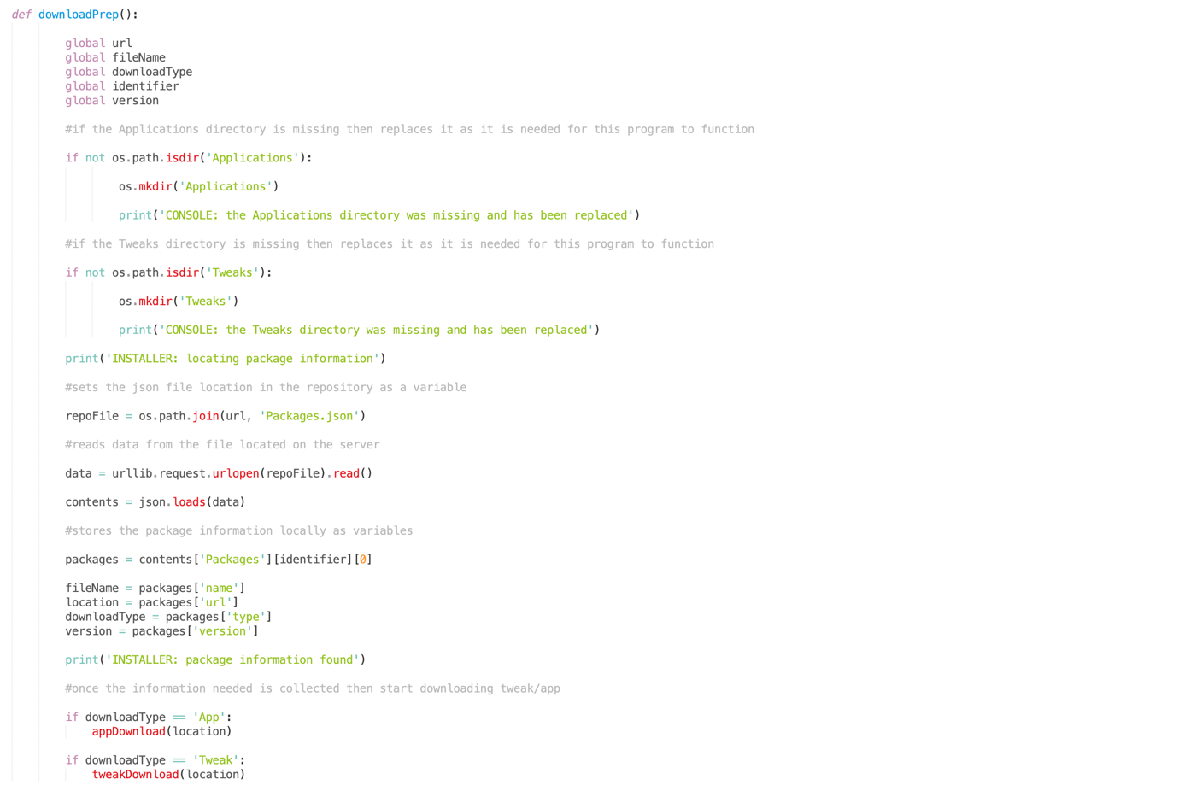

Uses the new repo layout to store specific data to variables

Function for loading necessary package info from the repo

If install folders are missing, it creates them

The downloadPrep function now makes use of the new repo file layout to find and store the data, as well as creating the download locations if they are missing.



All of the new information is stored in the local database

The information taken from the repo file is added to the local database, so that there exists a local copy of necessary information in case the repo server goes offline.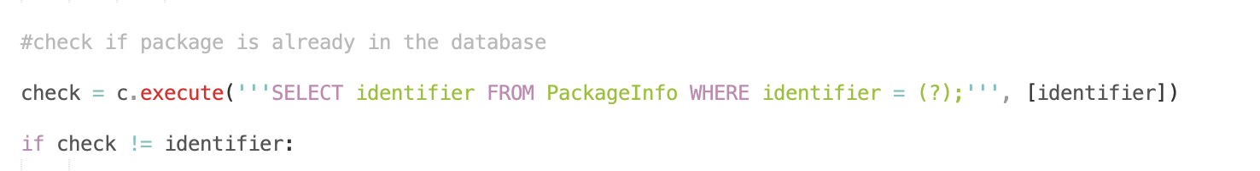

Check if package is already present in the database

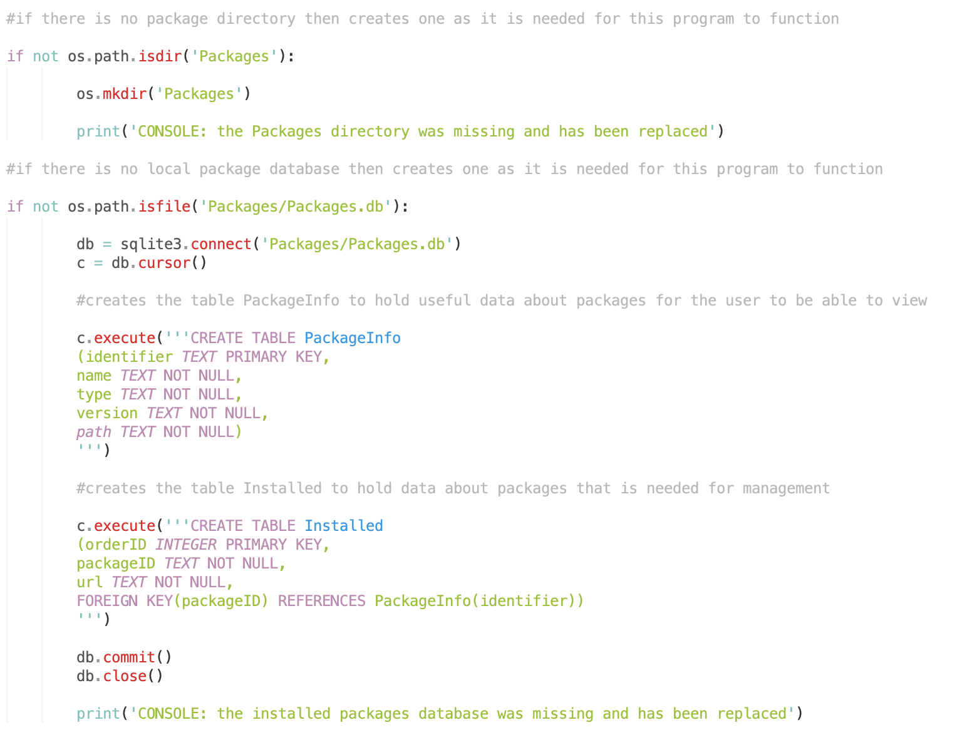

If the database location or the database itself is missing, then it creates it

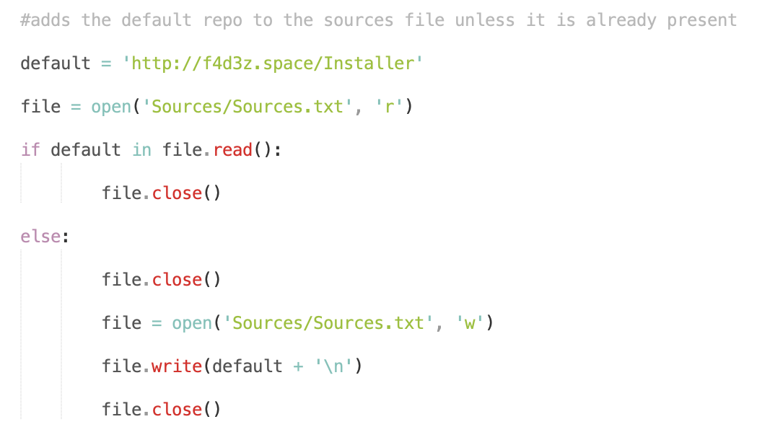

Sets a default repo that should always be added

Checks if the default repo is present in the repo file, and adds it if not

Checks were added throughout the solution at points where things would be modified incorrectly without them. And a default repo is hardcoded in and forced to always be present in the sources file, since If the user removed everything then without this they would have no source for packages.

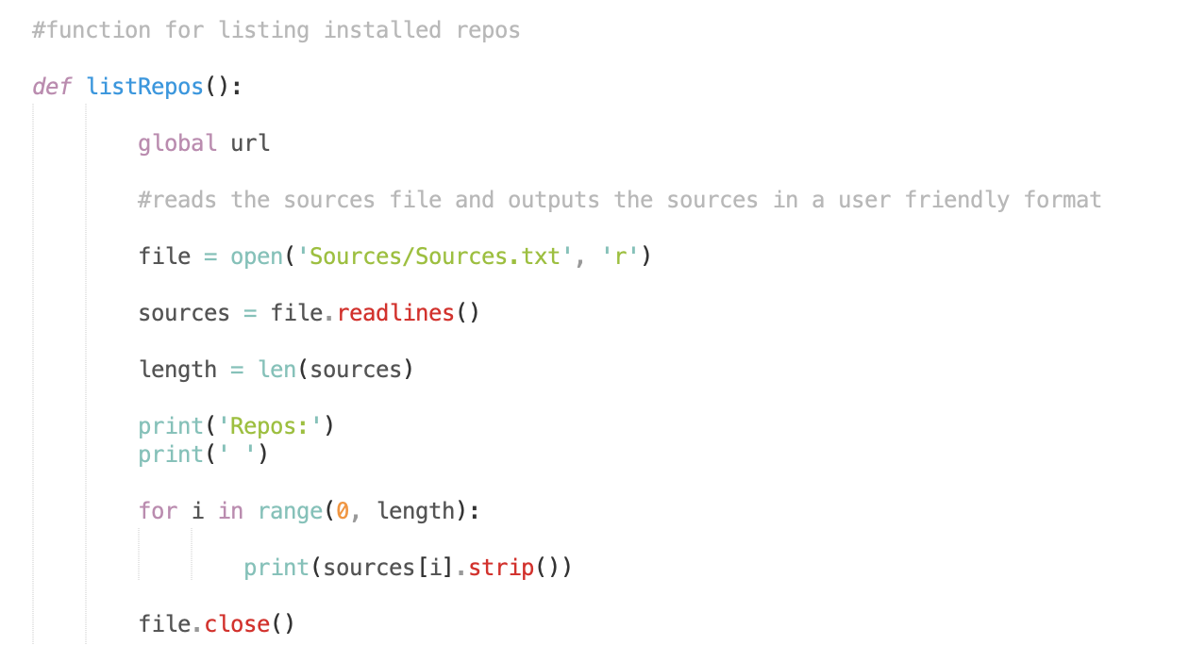

Prints a list containing all of the sources

Function to list all repos added in the sources file

A function was created to show the user all the currently installed repositories. To do this the sources file is stored line by line into a list, which is then displayed to the user to show which repos are currently added to the system.

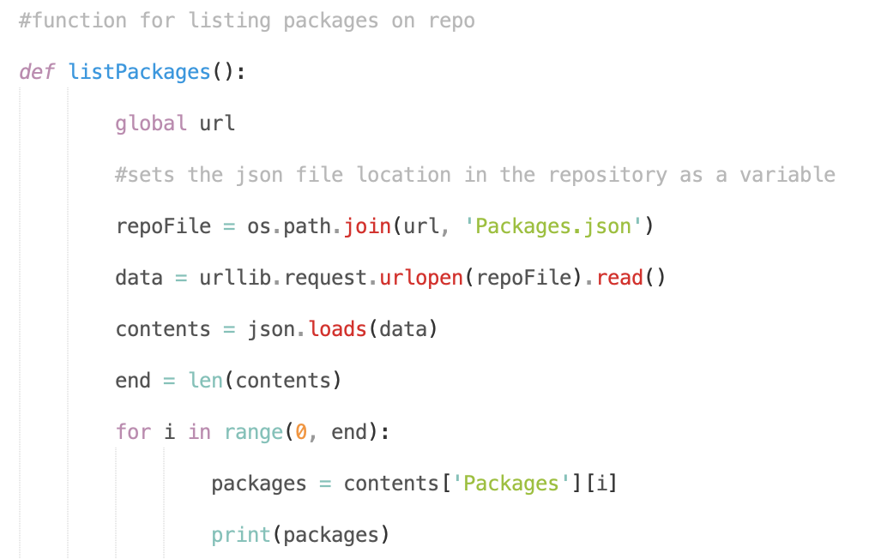

This displays each package on the repo one by one

Function to show all of the packages on a repo they can choose to install

A function was created to list all of the packages on the chosen repo, which it did by loading the json file and by displaying every package identifier. However there was an error in the listPackages function that was found during testing, where only the first package in a repo was listed, and this would need to be fixed in version 5.

## Version 5

The aim of version 5 was to fix the repo loading issue from the previous version, as well as to improve on the repo files layout one final time.

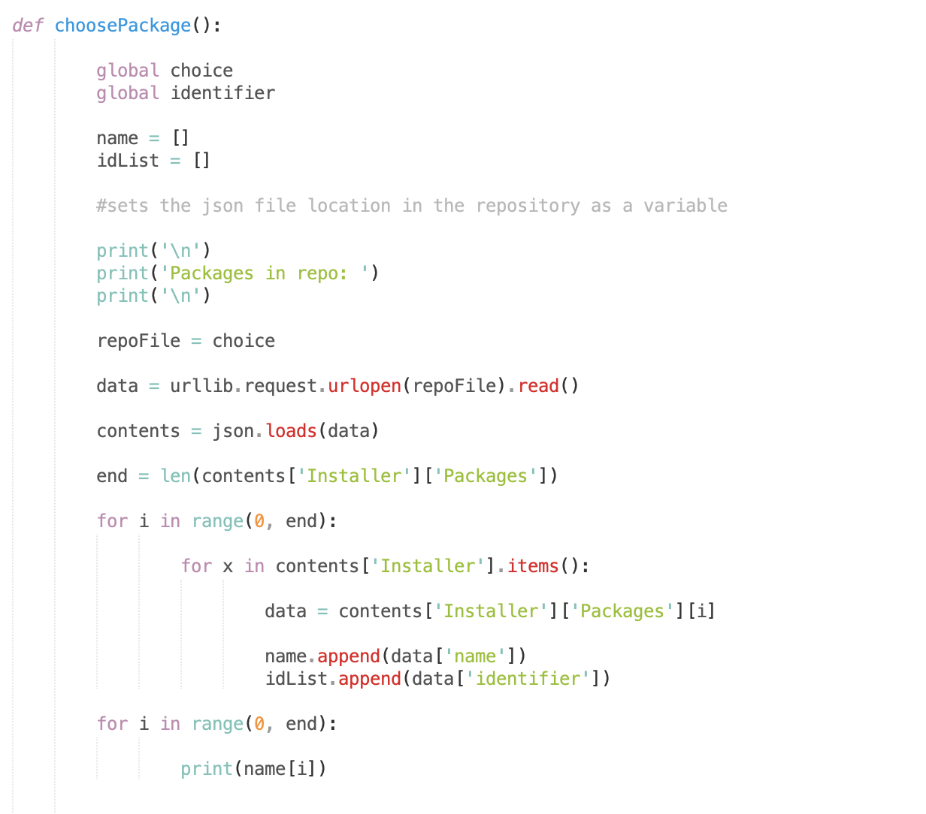

The new repo layout makes listing multiple packages much easier as well as finding specific data items, issue from version 4 is fixed here too

The new repo layout is used here to store package information

Function for choosing a package to install, fixes the issue from version 4

The function for listing packages on a repo has changed into a function for choosing a package from a repo to download. It still lists all available packages however, and the issue from version 4 has been fixed with the introduction of the new repository file layout. The function does not yet take user input, but it will in a later version.

### Final Repository Design

It was at this point that I thought the repository system should be properly thought out with a design to go with it, in order to reach a layout that would not need changing again.

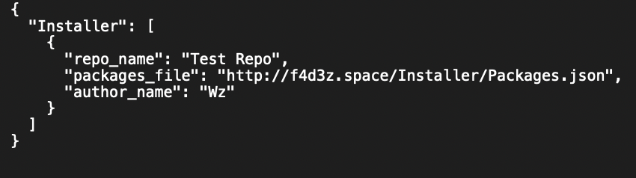

The repo file is used to let the installer know that the url is has loaded is a valid repository, the repo file must always be called Repo.json and must be organised as shown above. The key “Installer” is important as the solution will check for this key in the file to make sure that it is a repo file for this solution. And inside of the repo file it must provide the repo name under the key “repo_name”, the location of the packages file under the key “packages_file” and the repo owners name under the key “author_name”. This will be loaded by the installer and shown to the user on the screen when they pick a repository.

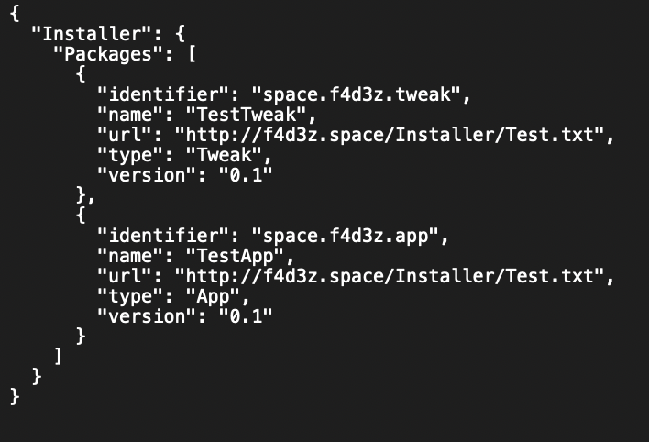

The packages file is used to store the information of all software packages hosted on the repo. It must also contain the “Installer” key and inside of that the “Packages” key in order for it to be correctly loaded by the installer. If the repo owner organises their files properly then installer will be able to load them without any issues. Inside of “Packages” is where the information on software packages is stored. Five pieces of information are needed when working with a software package: the “identifier” (which must be unique) used to reference the package and search for it, the “name” of the software package, the “url” which is the location of the software package, the “type” of package (either App or Tweak) and the “version” of the package.

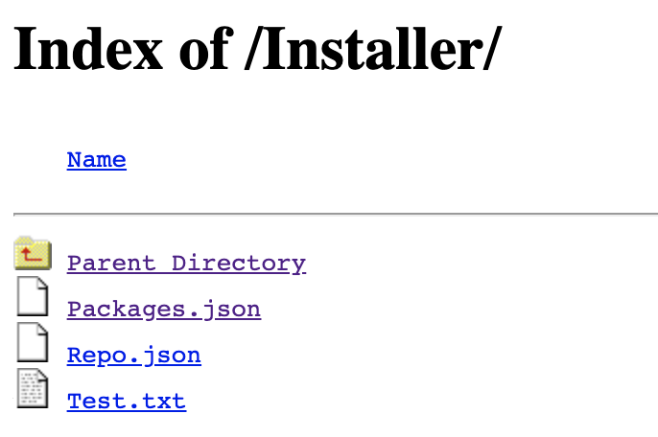

The packages file containing all of the information about every software package in the repository, as well as their locations.

The repo file containing information about the repository, and also the location of the packages file.

A software package. (can be any file type, a text file was used here for testing as it is a small file size and is quick to download.

This is what a source/repository structure should look like for this solution.

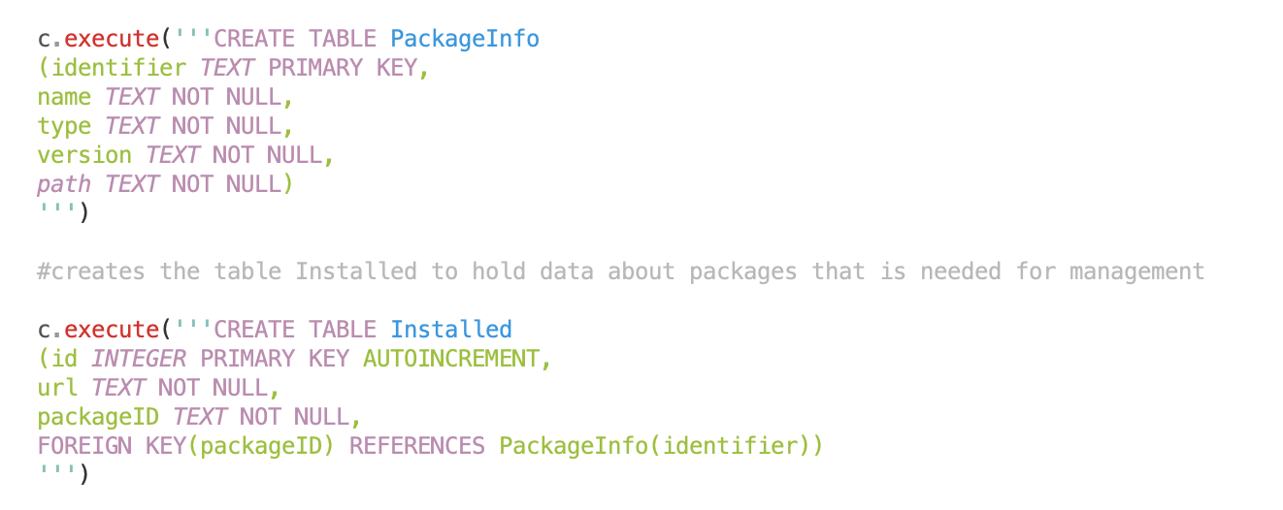

With the new repo layout came a new database structure.

The local packages database was updated in accordance with the changes made to the repository files.

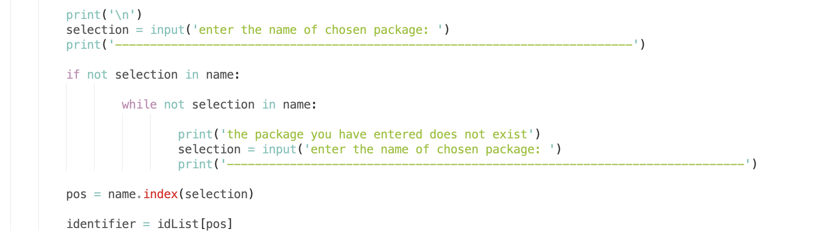

A check was added to make sure the package chosen existed

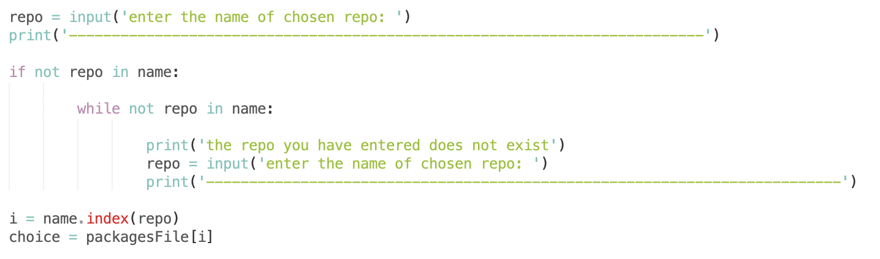

A check was added to make sure the repo chosen existed

With the introduction of these checks, the program became safe from simple user input mistakes. This is a common cause of issues if not fixed and so it was important to start adding these input checks.

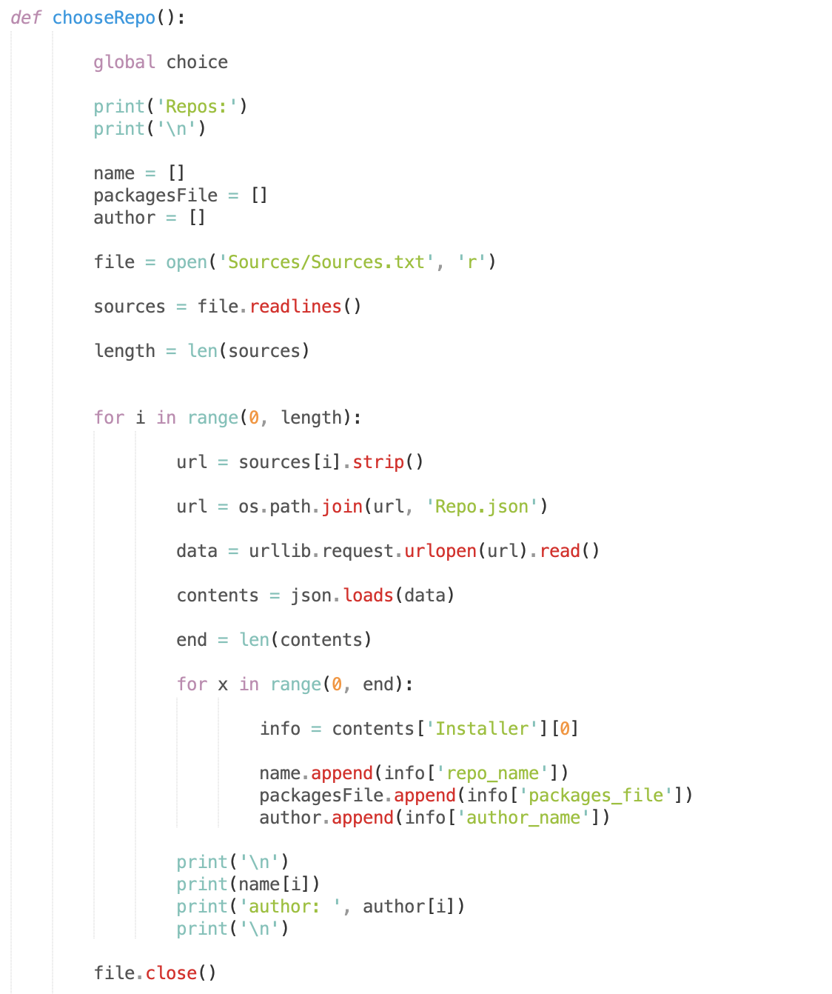

Reads repos from sources list

Function for choosing a repo

Displays the repo name and author to the user

Stores the repo information to variables

Loops for the number of sources installed

The function to list all of the installed repos was updated to now use the new structure, since it now used data pulled from the repo file. The information for the repo name and its owner are not stored locally, so it pulls this information from the repo file and shows it to the user instead of just showing them a url to pick as in previous versions.

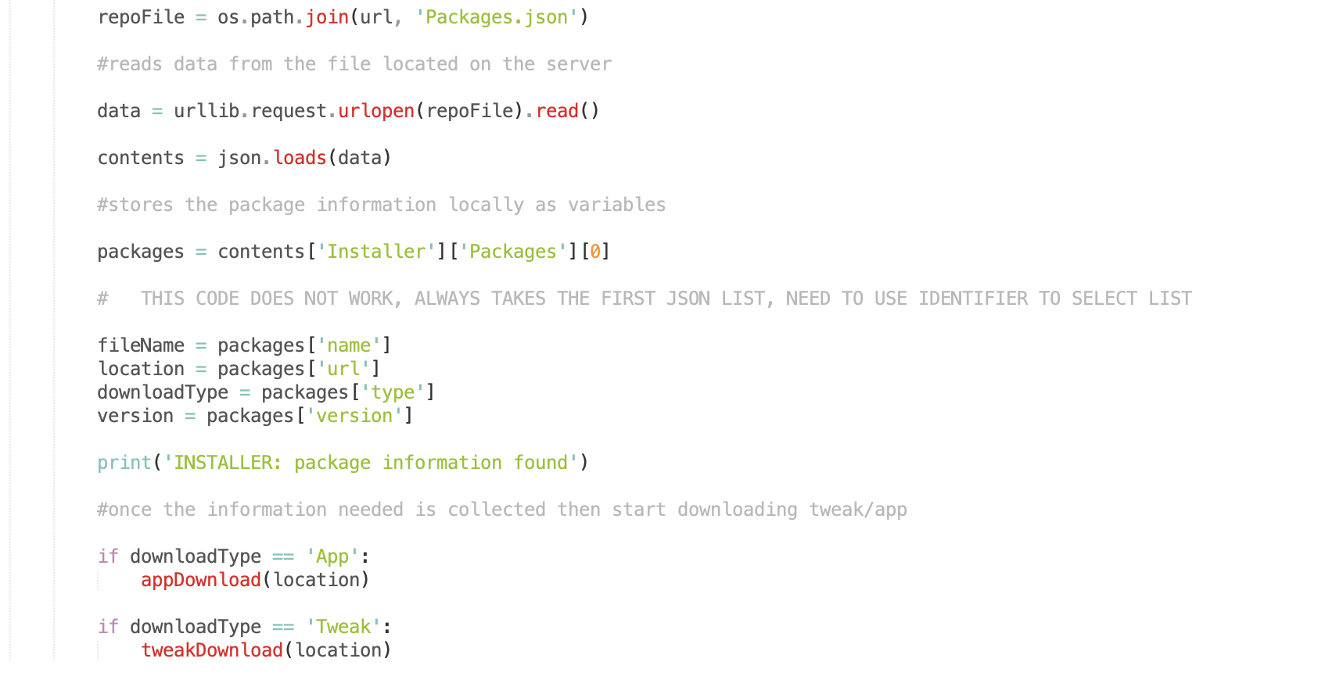

Only the first packages info was being read by the program

A problem was discovered when testing, that the program only loaded data for the first package entry in a repo file. This was due to me messing up when thinking about the new repo layout, and not going deep enough into the structure. This will have to be fixed in the next version.

## Version 6

The aim of version 6 was to improve the code in previous versions where needed, and also to improve the removal of packages.

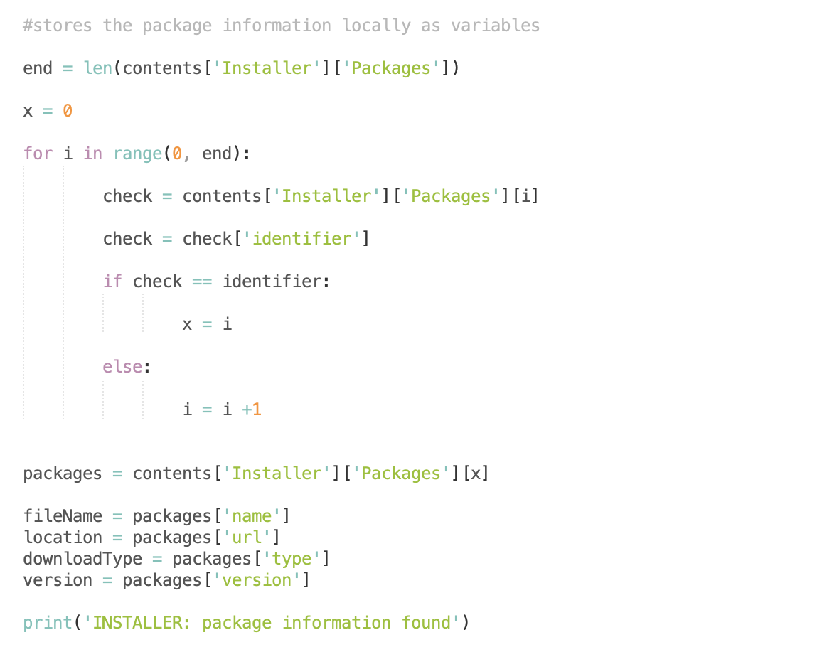

Using the correct repo file layout to store data

Loop for every package in the repo

First, I fixed the downloadPrep function since it was only reading the first packages information from the repo. To do this I made it loop for every package in the repo, and when the package information that was needed was found it loaded the data into variables using the correct repo structure.

Function to choose a package to remove

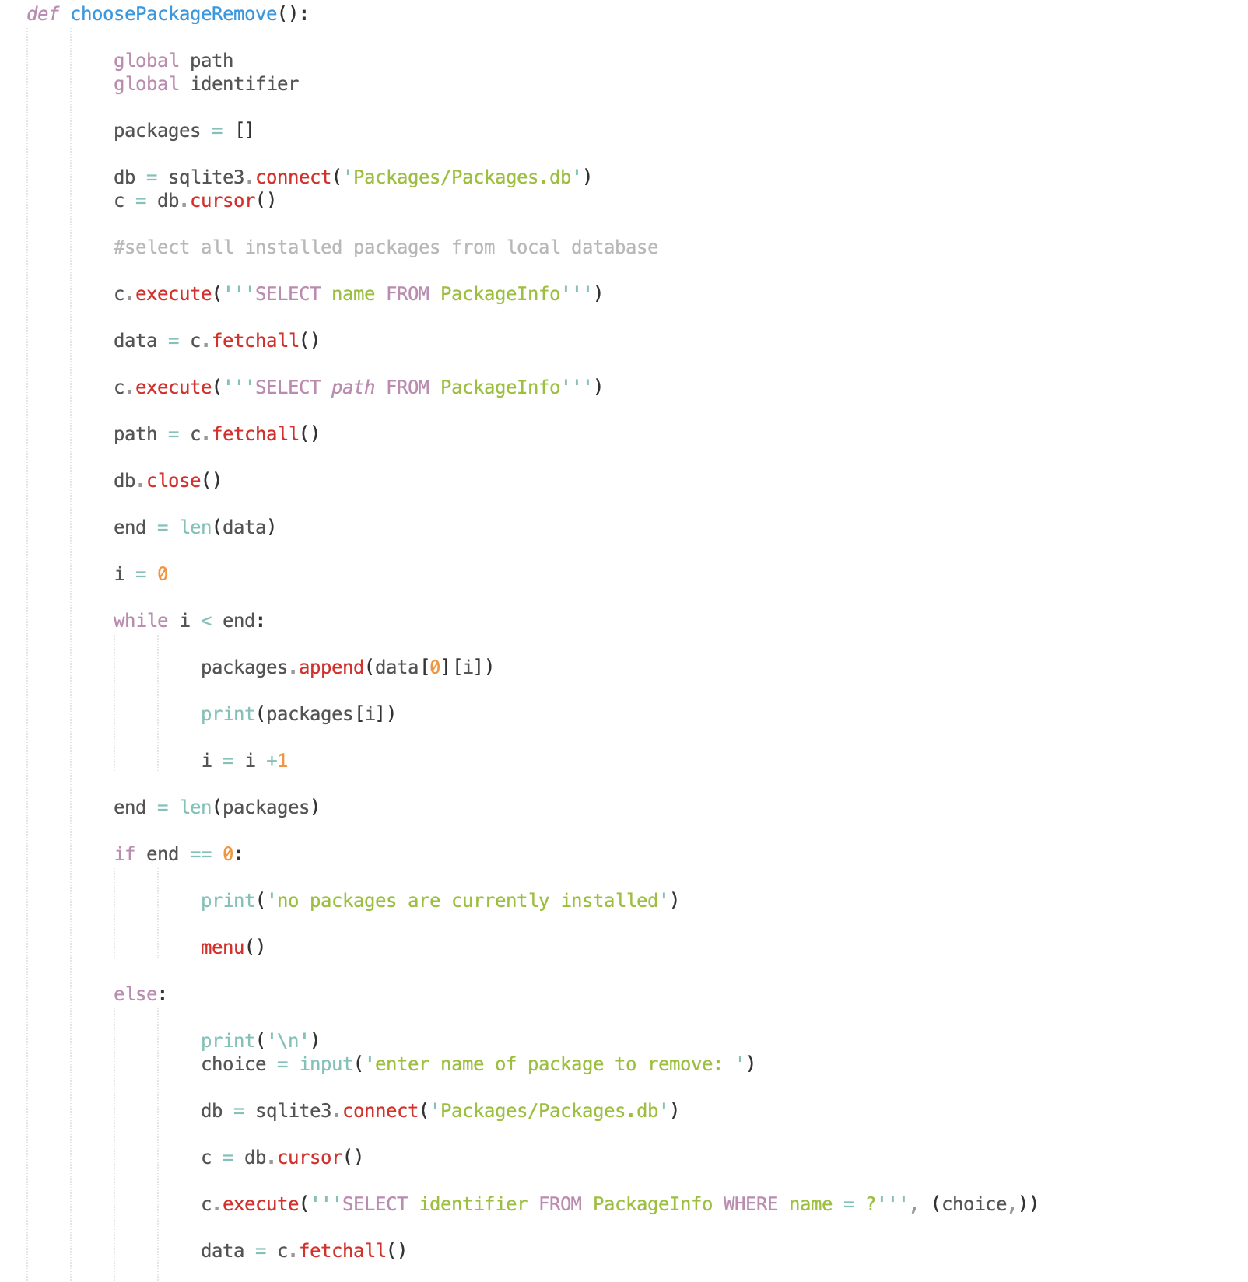

unless the list is empty, then it displays a message saying that no packages are installed

Path variable is now used to store location for later removing a package

Stores all package names/locations from the database to lists

Allows the user to choose a package to remove

The installed package names are displayed to the user

A function was created to let the user choose a package to remove from the system. This is done by listing all of the installed package names from the database and then storing their locations to separate lists but in the same order. Then it asks the user to input their choice of package to remove.

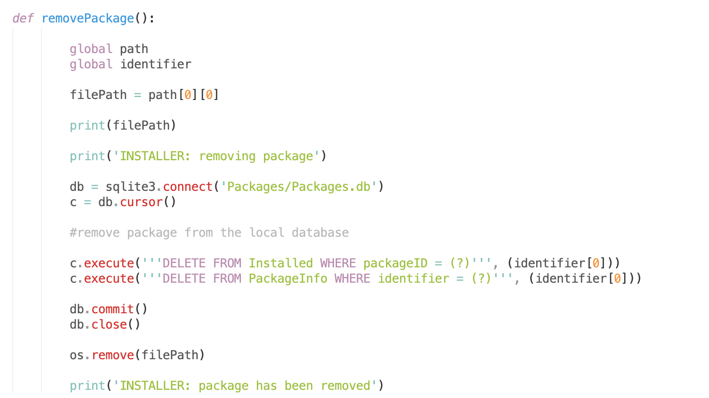

Now uses the locally stored path to find and remove a package

The function removePackage now takes the chosen package and removes it from the system.

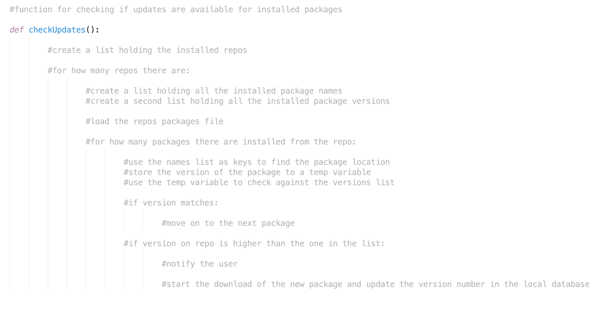

Pseudocode for a function that will check for any package updates available from the repo

This was not in the version plan, however in this version of the code I started to write the update functionality into the solution through pseudocode.

## Version 7

The aim of version 7, following on from the end of version 6’s development, was to complete the update functionality and add the ability to both detect and install any available updates for installed packages from their repositories.

Function to check for any package updates available from the repo

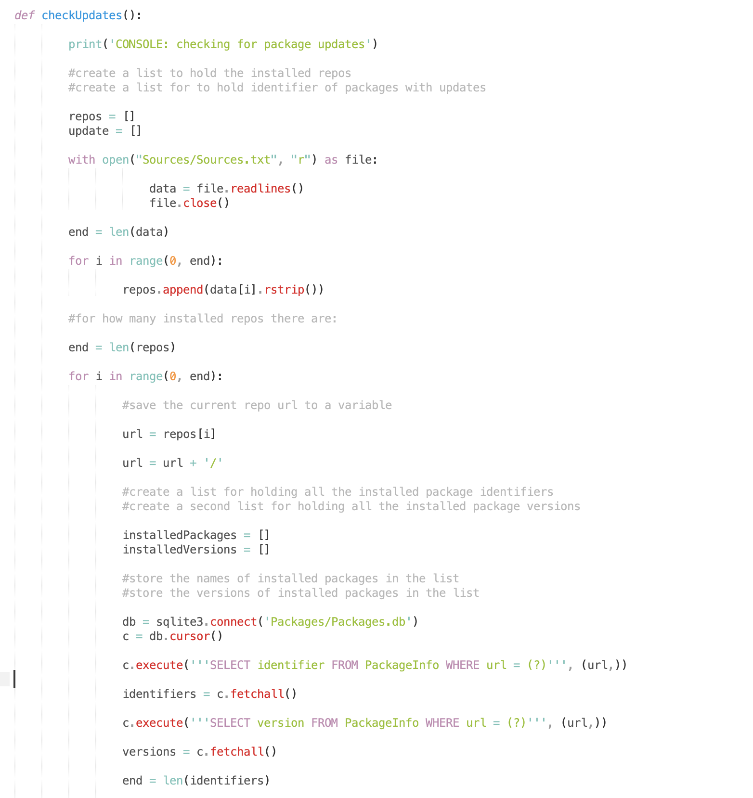

Load every package id and version from the database that is from that repo

For the number of installed repos

Removes the new line symbols

Store the installed repos from the sources file to a variable

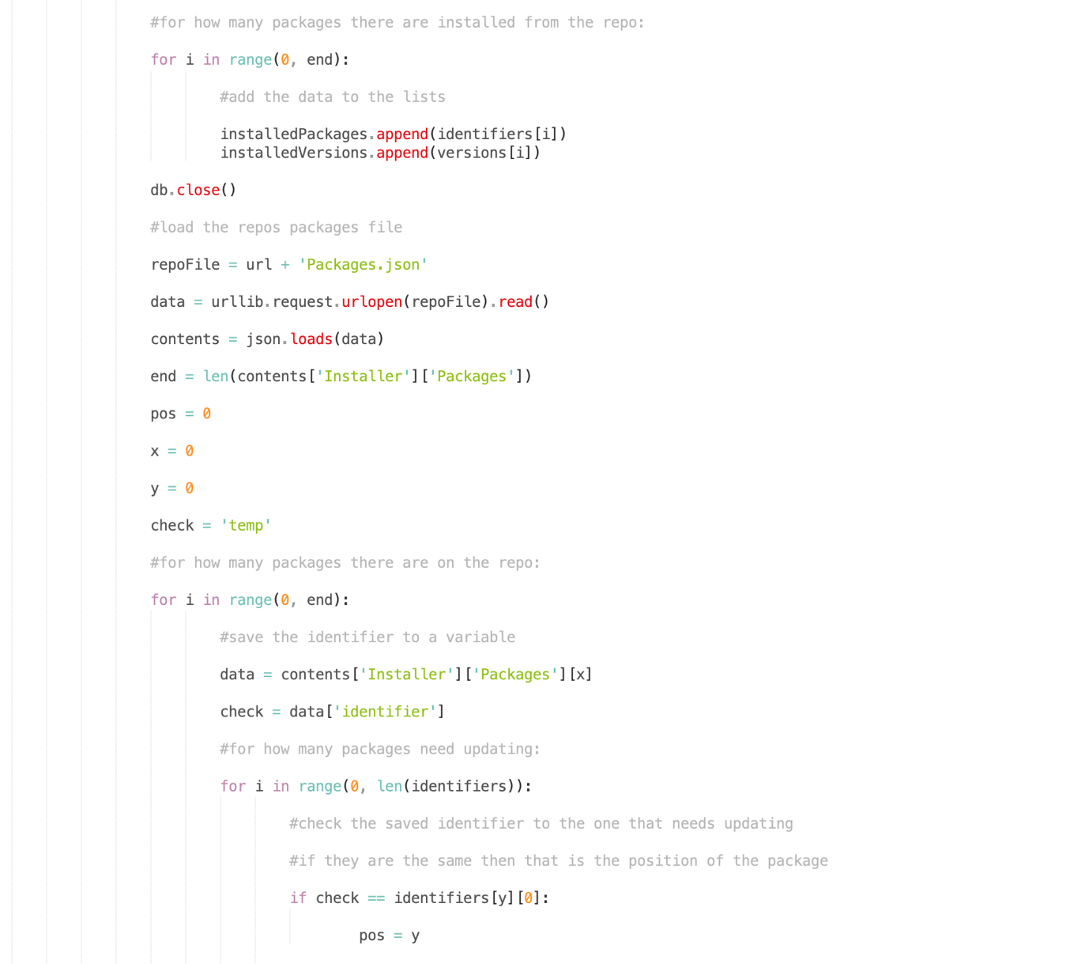

Find the position on the repo for the current package

Loop for how many packages need to be checked

Save the current repo package identifier to a variable

Loop for how many packages are stored on the current repo

Stores that repos packages file content to a variable

Adds the packages identifiers and versions to a list

Loop for how many packages are from the current repo

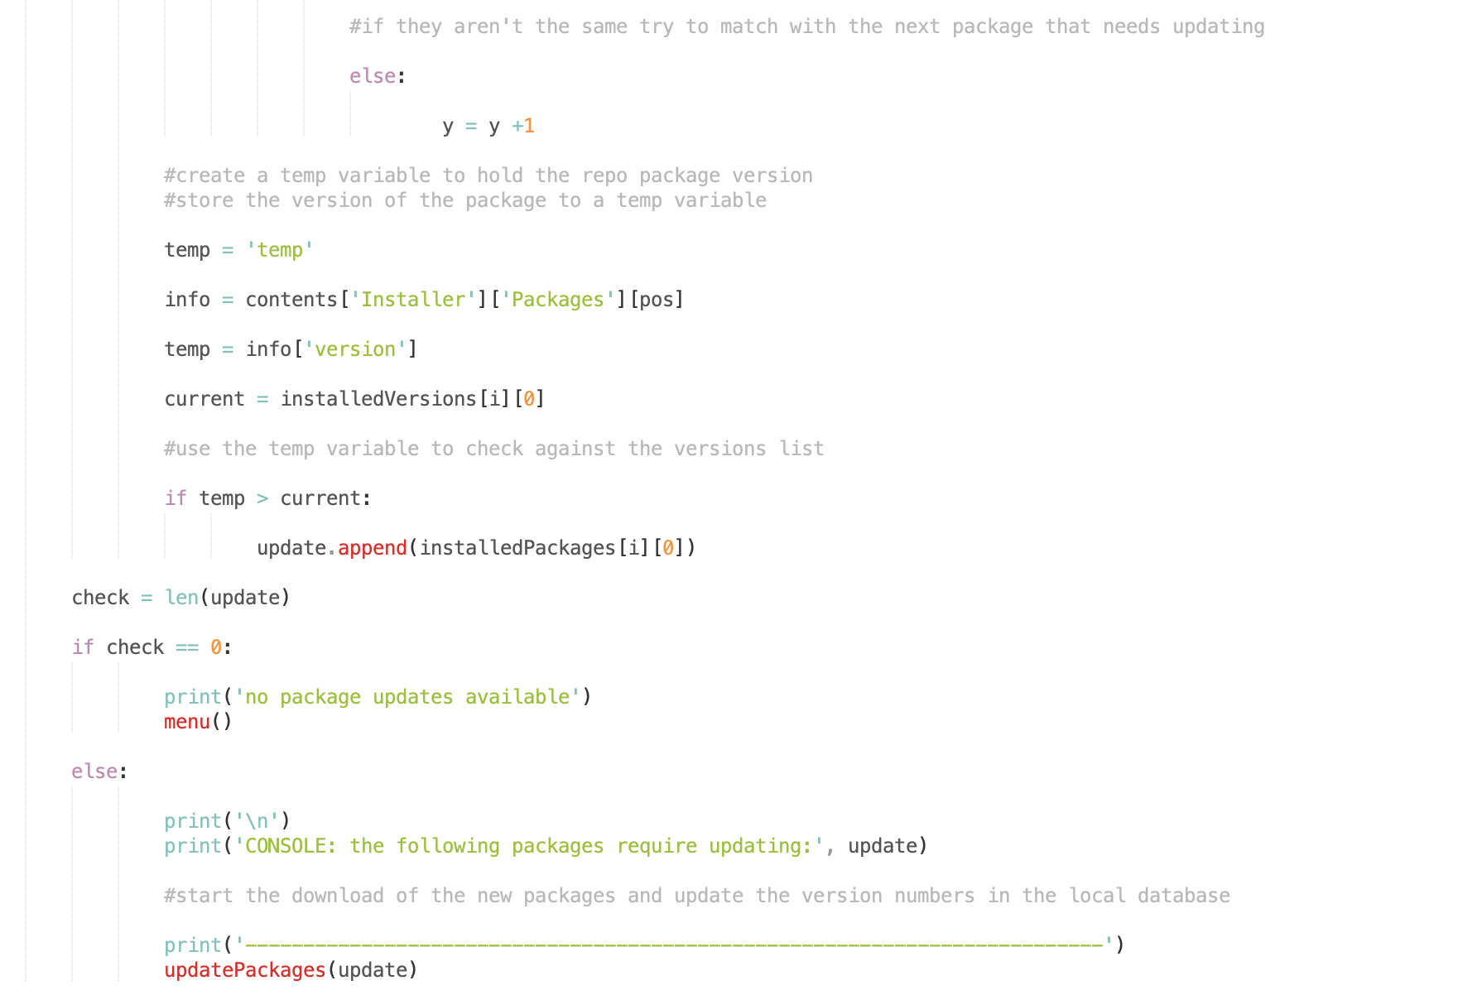

If packages need

Updating, tell the user

If no packages need

Updating, tell the user

Save the repo packages version as a variable

If a newer version is available, then add the corresponding identifier to a list

Save the corresponding installed packages version to a variable

The function checkUpdates was created to compare the installed package version with the latest version of the same package on the repo it was installed from. If there is an update available then the repos version for that package will be a higher number and so we can compare them to check if any update is available. Then at the end we call the updatePackages function to actually download the new package and to update the local database’s version, and we pass into it the list of packages that need updating.

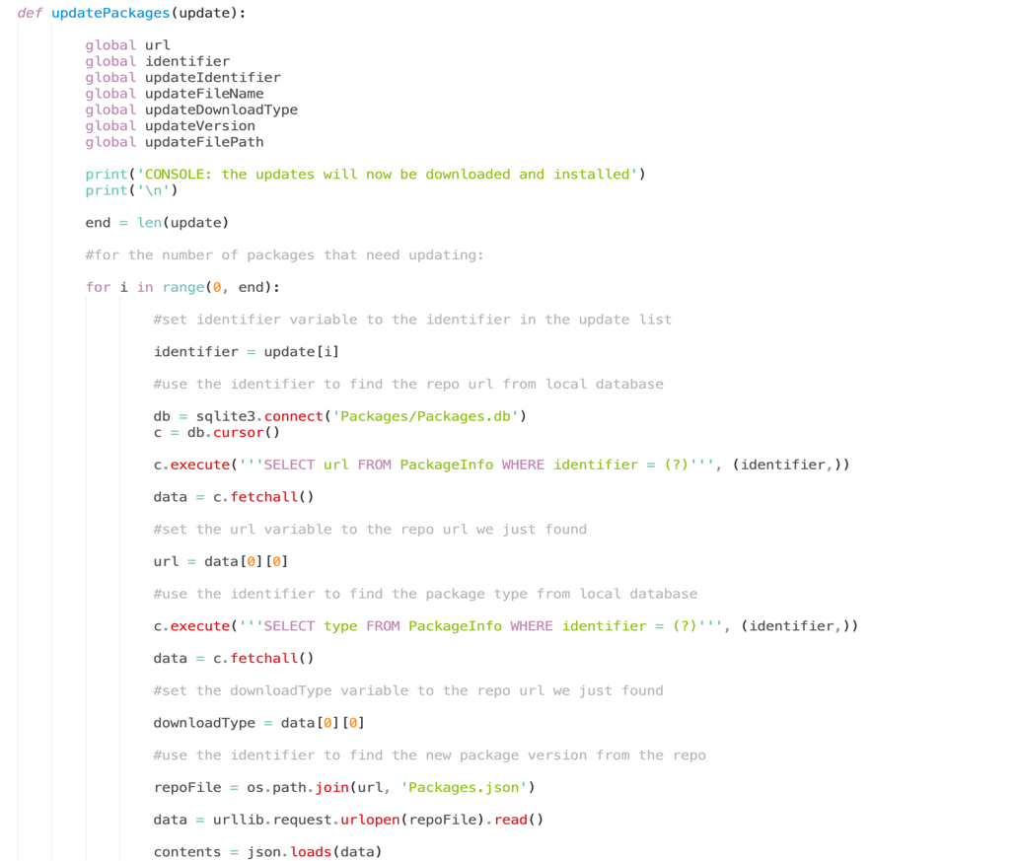

Load the repo file

Store the package type for that package into a variable

Store repo url for that package into a variable

Loop for number of packages that need updating

Function to install any package updates available from the repo

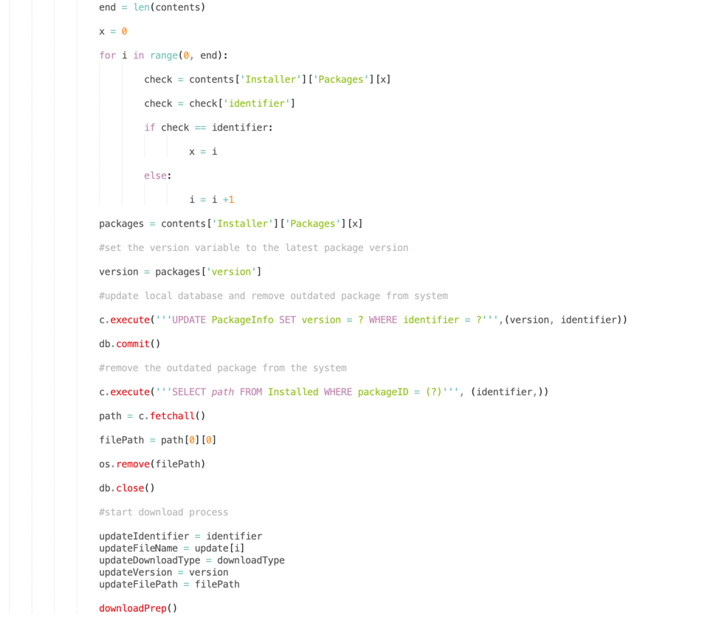

Store the necessary info to variables and start the download of the new version of the package

Remove the old package

Store the path of the old package file to a variable

Find the package location

Update the local databases package version

Store the repo version for that package to a variable

Loop for number of packages on the repo

At the end of this version, the updatePackages function was created. This function took the list of packages that needed updates and then proceeded to update the local databases version number. It then went on to remove the installed package and call the download function to install the new version of the package to the system. And with this, all of the solutions backend code is finished, and it is time to move forwards with creating the user interface.

# The User Tested GUI Iterations

## Iteration 1

The aim of iteration 1 of the GUI version was to have the user able to test the downloading function, the main part of the “Installer” solution.

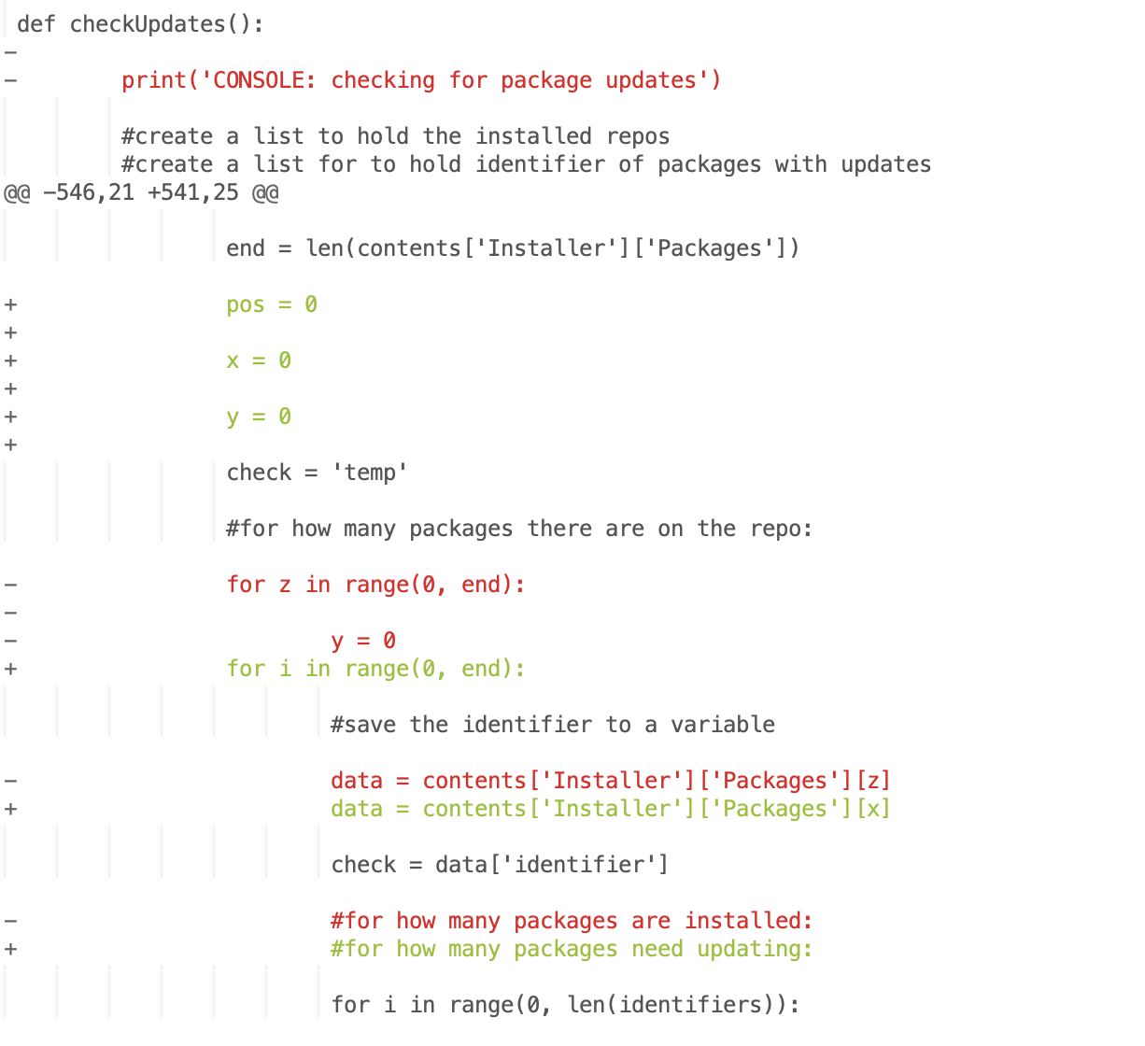

A second loop to go through every package that needs an update

Stores the identifier from the repo as a variable

Replaced loop with another loop due to z being used in another place now

New variables for looping code.

The function that checks for any available updates

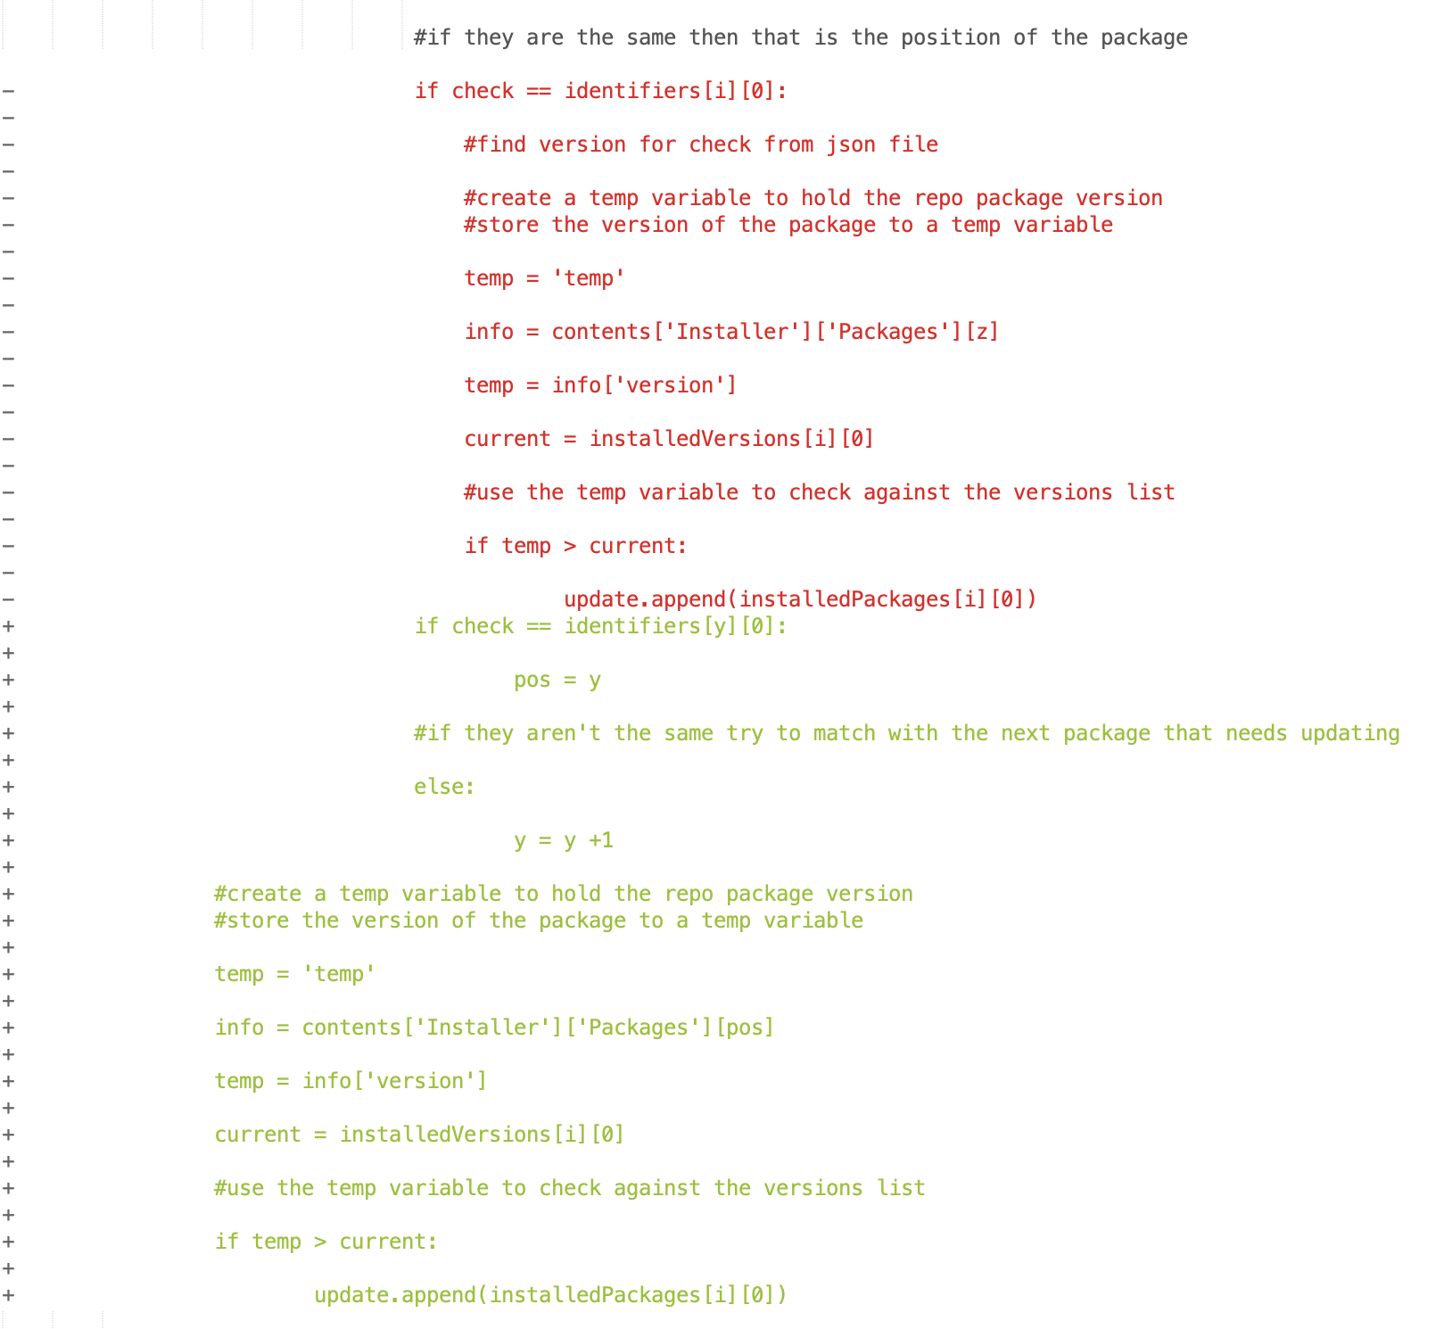

If a new version is available then it adds that package identifier to list of packages that need updating

New method for checking the two versions against each other

Finds the matching package on the repo for the one we are checking

Old method for checking the versions against the latest versions is removed

The function checkUpdates had an issue where it would not check packages across multiple repos, this was caused by the loops not being implemented correctly. And was solved by rewriting the function using pseudocode as a model and then filling in each piece at a time in python code.

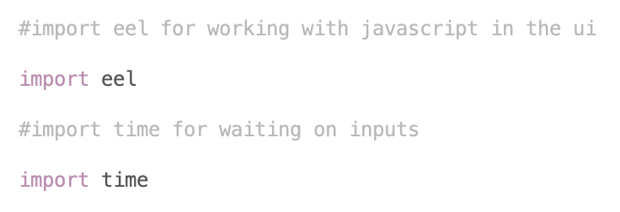

Imports the library for working with timings

Imports the library for passing between javascript and html

The eel module is used to start a local web server and to use html/css/js code for a python frontend. It works by exposing python functions to javascript so that the html buttons can run the backend code as if it was calling a javascript function.

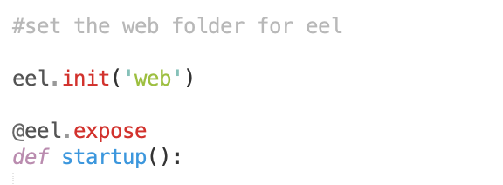

Exposes the function to javascript

Creates a function for starting the UI

Sets the web files folder

Eel works by running any web scripts from the specified folder and then opening a port that is used to make calls between javascript and python. The first thing that has to be done is to populate a web folder with the web scripts and then to specify that folders path while initialising the eel module in python.

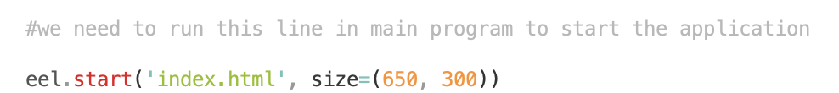

Opens the first application page

We start a web page from the index.html file, this serves as the launch assistant and is the application page that checks for any file integrity problems, and then solves them and notifies the user if any are present.

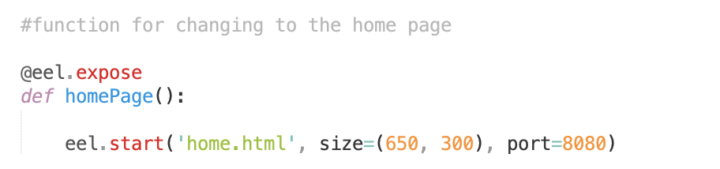

Opens the main application page

Creates function for starting the main page

A function is created to be called once the file integrity checks have been completed. This function opens the main application page, which contains the menu and all of the core functionality.

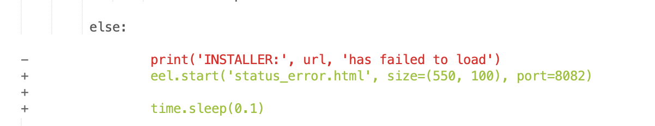

Replaces error outputs with a popup

When an error occurs, instead of printing to the console as was done in the CLI build it now has to open a pop up window notifying the user of the error.

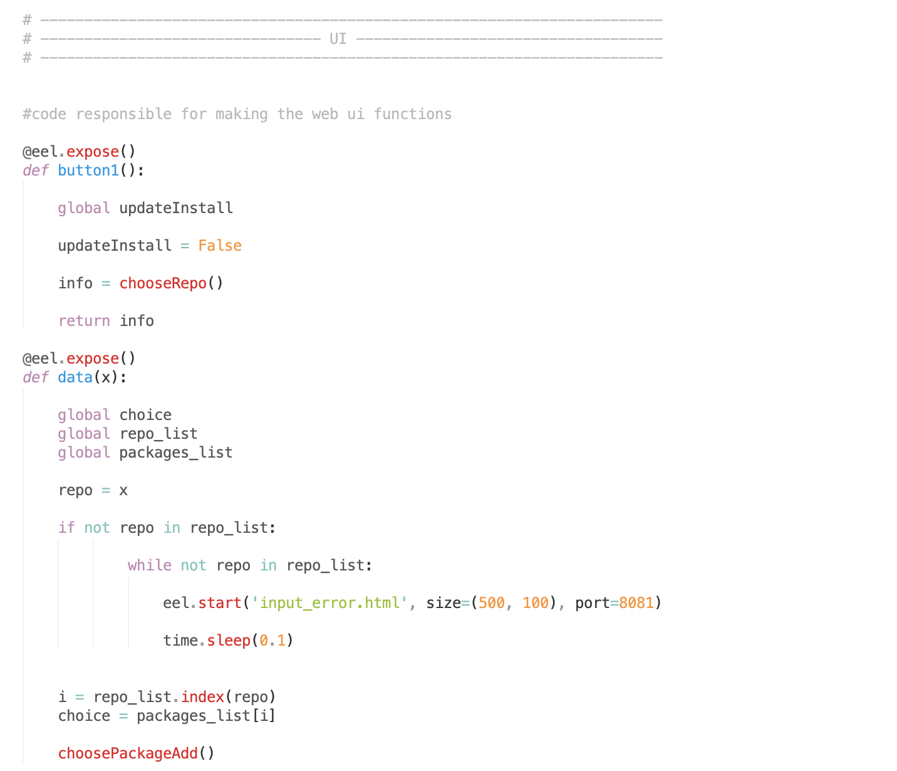

Starts the next function

If input is incorrect then an error popup will appear

Creates a function for receiving data from javascript

Still using some of the non gui functions

Creates a function that activates on a button press from the html page

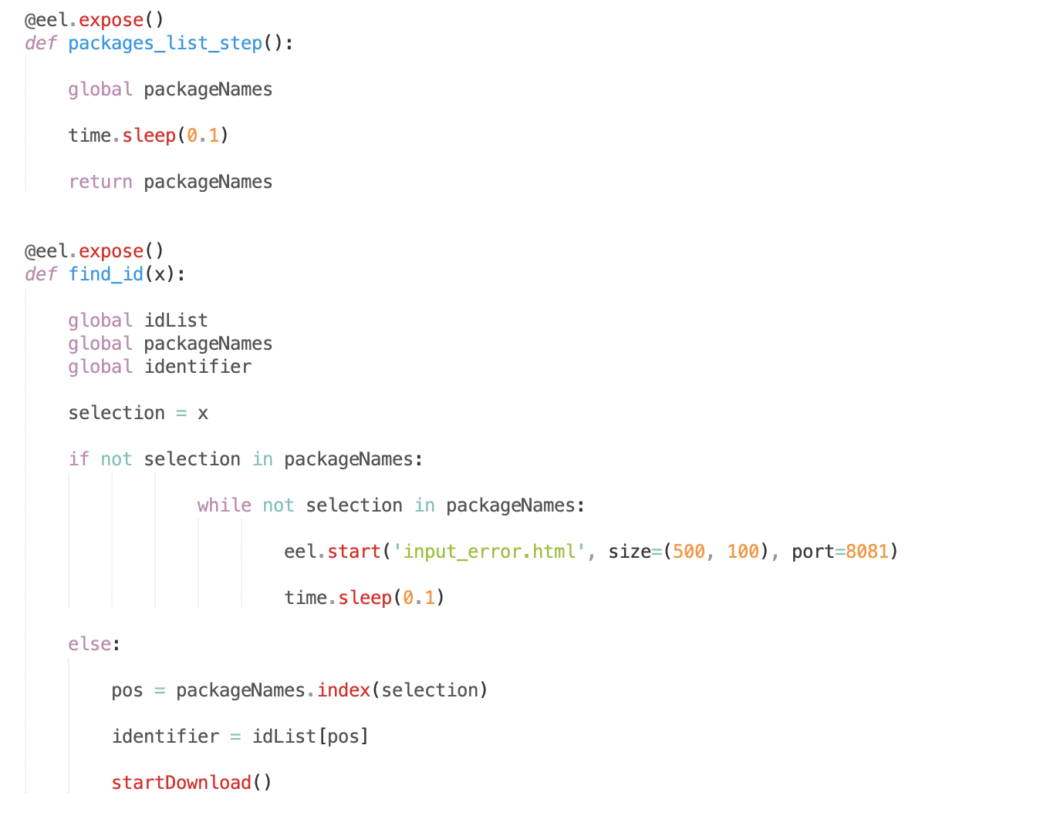

Sets the identifier to a variable and starts the actual download

If choice doesn’t exist then displays an error popup

A function for finding the package id for chosen package

A function for returning data to javascript

This code and these functions are the start of the GUI implementation, the functions are exposed to eel so that they can be called from javascript and any error messages are now displayed through the pop up windows.

New variables used

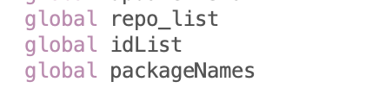

New globals are used for returning data to javascript/the gui.

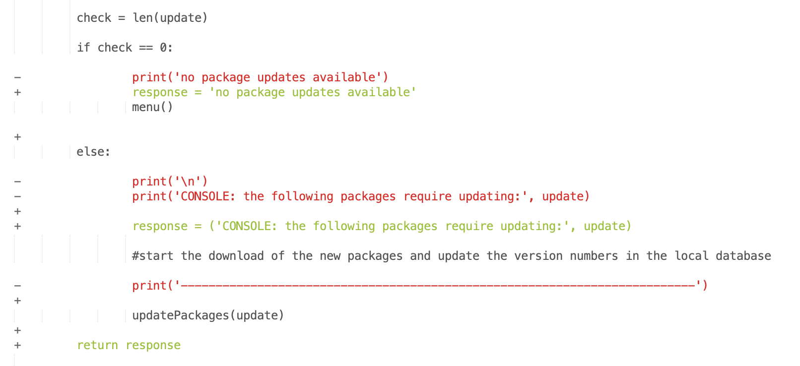

Update function is changed so that messages return to the page and not the console

Error messages that need to be displayed on the main page are now stored to a variable called ‘response’ and are returned to javascript after being called using eel. They are then printed to the web page.

Index.html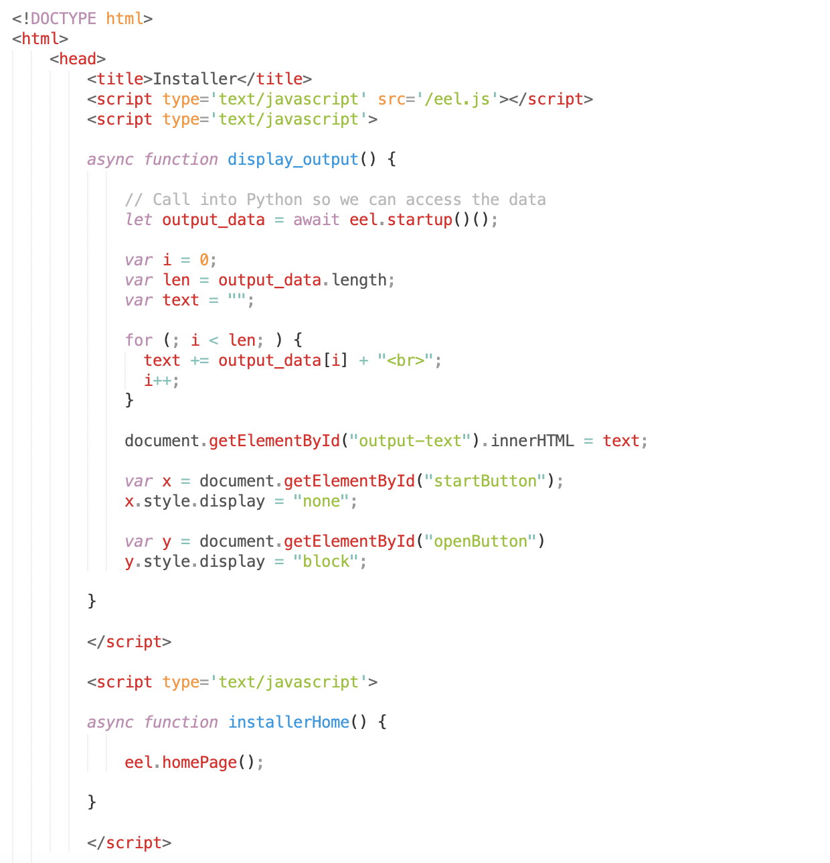

A function to start the main application page after checks are done

Changes what buttons are visible depending on what is needed

A function to take the response from python and display it on the page

Launcher page created for checking the solutions integrity

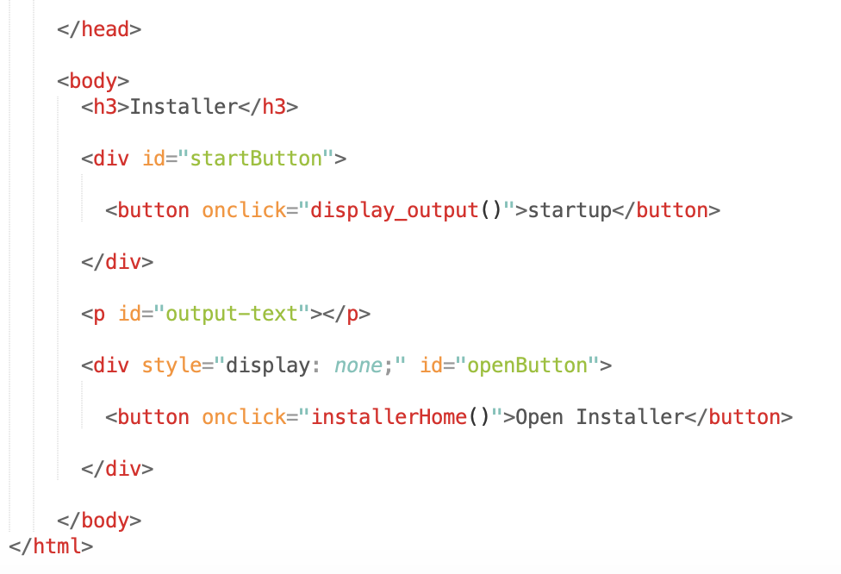

Button to start the main page

Button to start the integrity checks

Name of the solution

A web page is created to serve as the user interface, this page is for the launcher that checks for any file integrity errors and fixes them automatically before the main program opens. It will alert the user of any problems and that they have been fixed before allowing the user to open the main menu for the solution.

Home.html

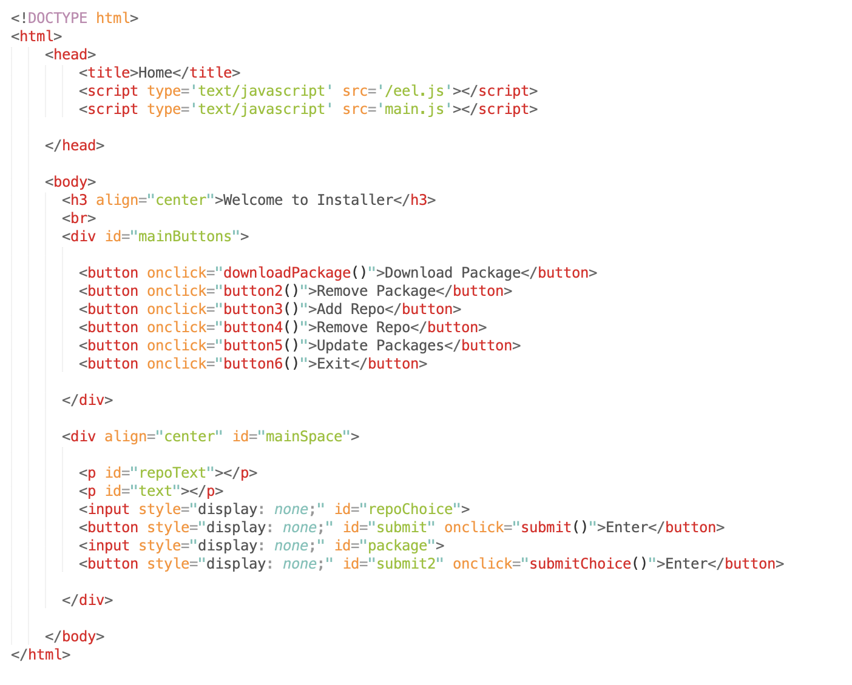

Input elements

Centre aligned page

Buttons for choosing a function of the program

Displays a welcome message

imports external javascript functions to keep the html file clean

Main application page

The start of the main menu page is created here, with the attention being on the download functionality for the user to test first. This will give a good preview of what the solution will feel like to use as well as showing the user some functionality and providing some areas for the user to test such as input and general interface functionality (such as buttons).

Input_error.html

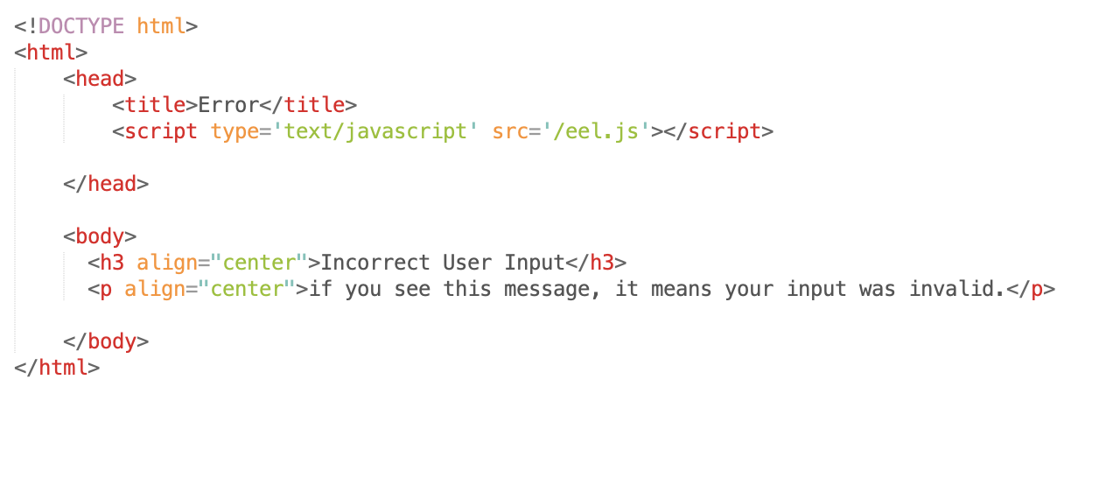

Tells the user what the problem is

Error popup

An error pop-up page was created to let the use know that an input was invalid without needing to overlay that message onto the main program window.

Status_error.html

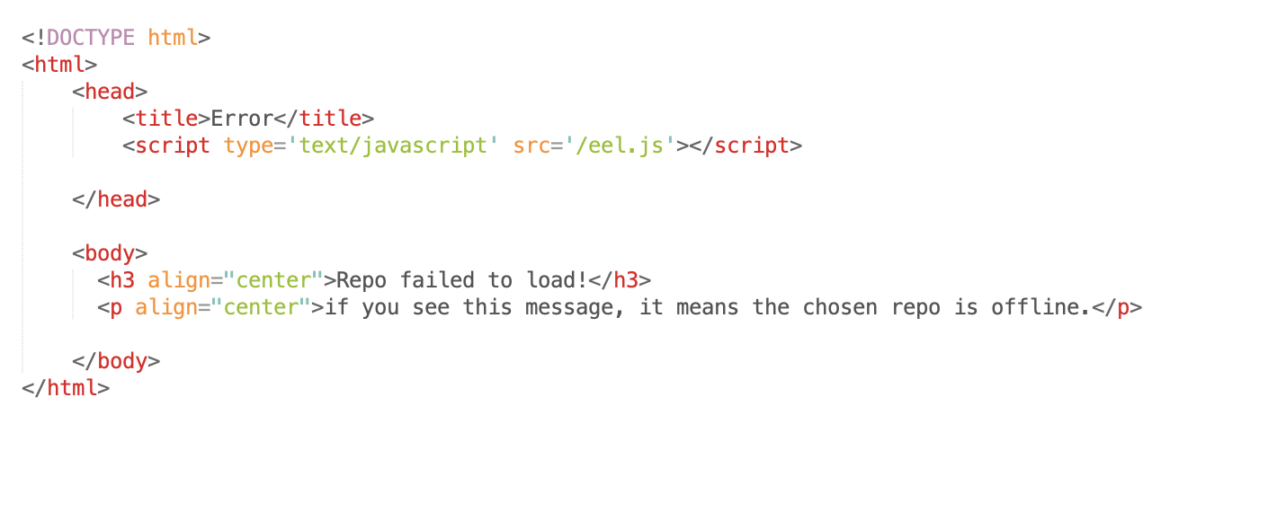

Tells the user what the problem is

Error popup

An error pop-up page was created to let the use know that a repo is offline without needing to overlay that message onto the main program window.

Main.js

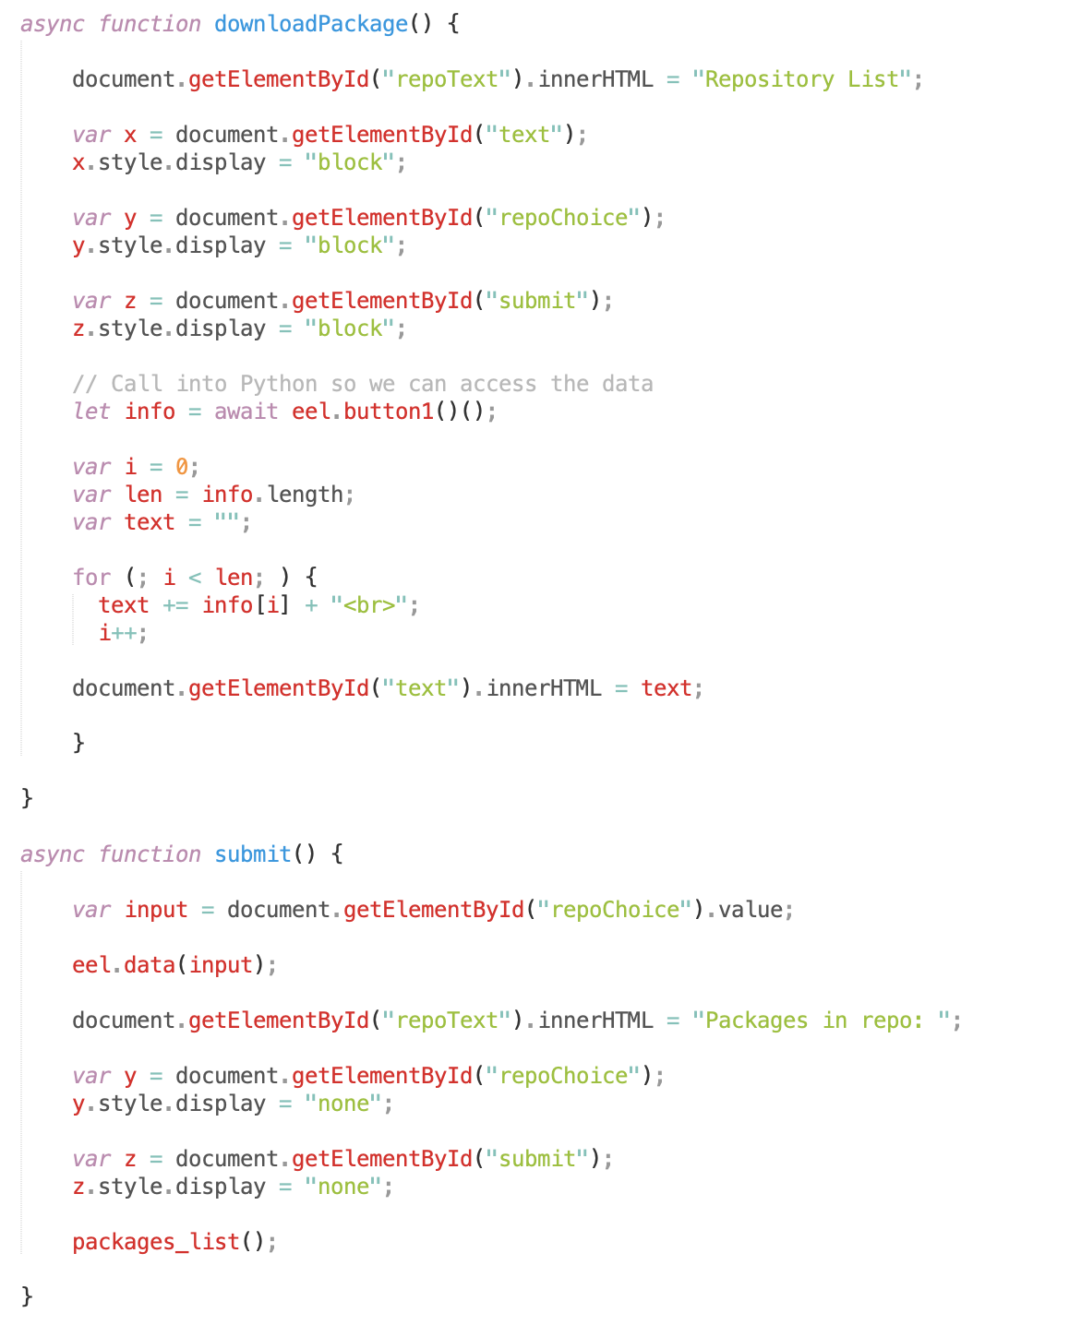

Calls the next function

Starts python function

hides the input elements

Stores the users choice to a variables

Function for submitting the users choice

Displays the list to the user

Loops for how many repos there are

stores the list of installed repos to a list

Shows elements

Javascript function for choosing a repo to work with

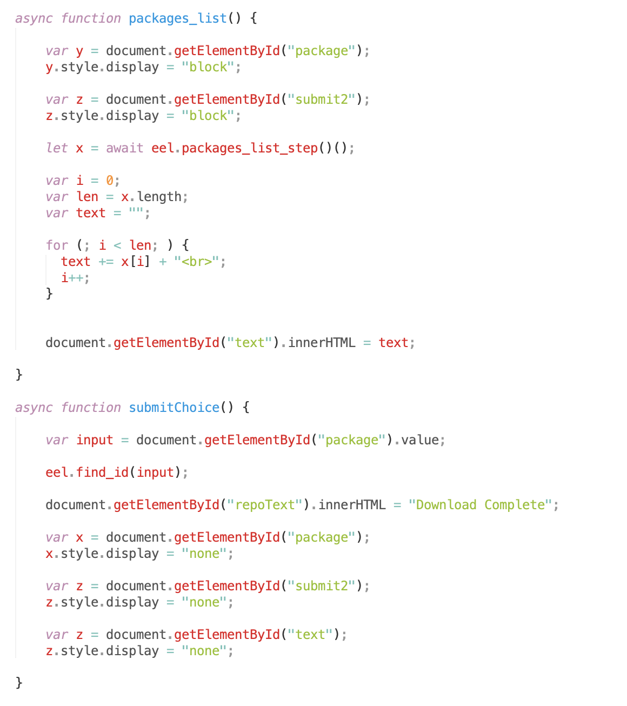

Function to check if a package is already installed

Exposes function to python

Hides elements

Displays a completion message

Calls python function to handle the rest of the download

Stores user choice to variable

Function for submitting the user choice

Displays the list for the user

Loops for how many packages there are

stores list of packages to a variable

Shows elements

Function for listing packages on the repo

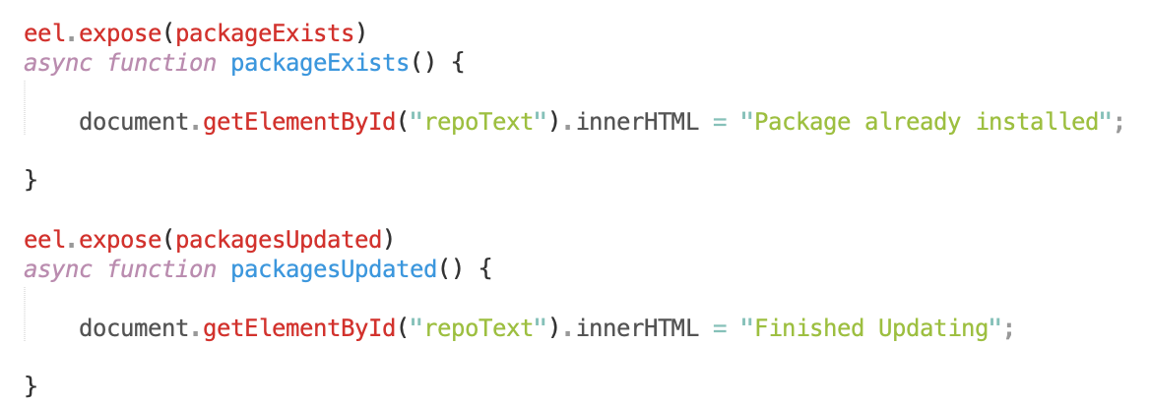

Tells the user

Function to check if packages are updated

Tells the user

In javascript, functions are created that can be called from the web ui. These functions can then call on python to handle any complex tasks and to return outputs to javascript. It then handles any small tasks such as editing the form in which data is stored inside of a list before interacting with the web ui again and displaying necessary information on the screen for the user.

Current UI

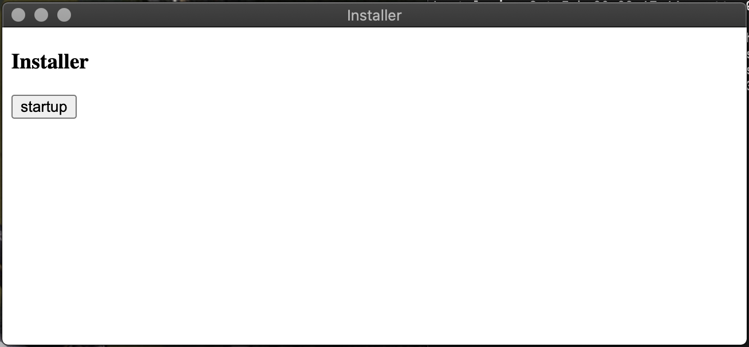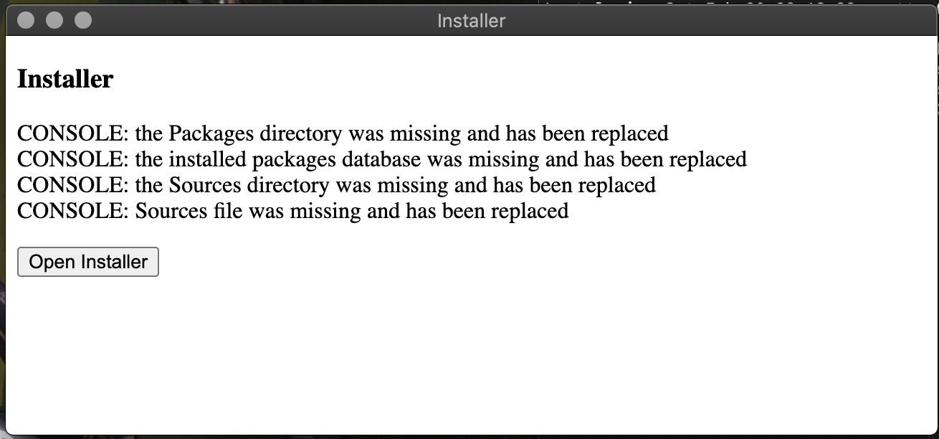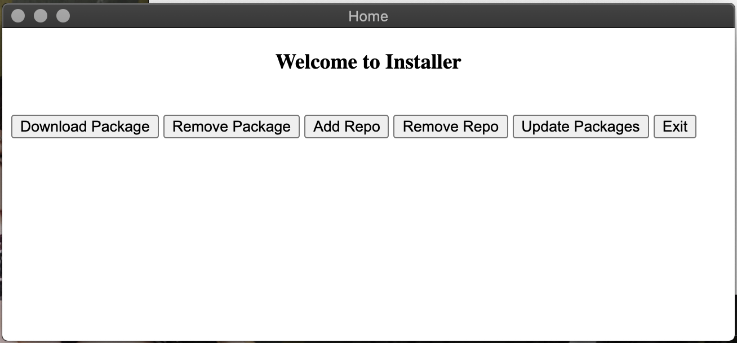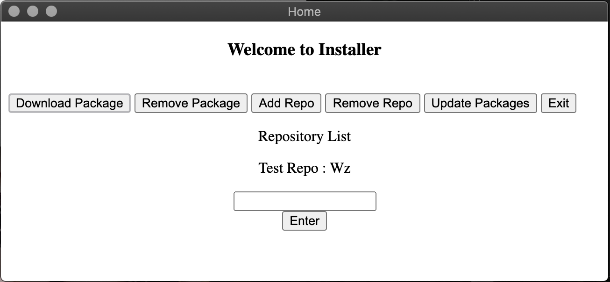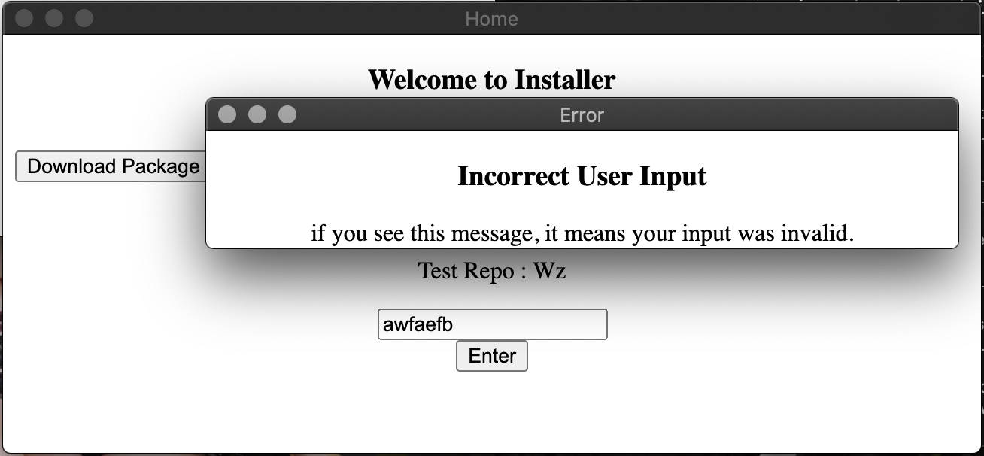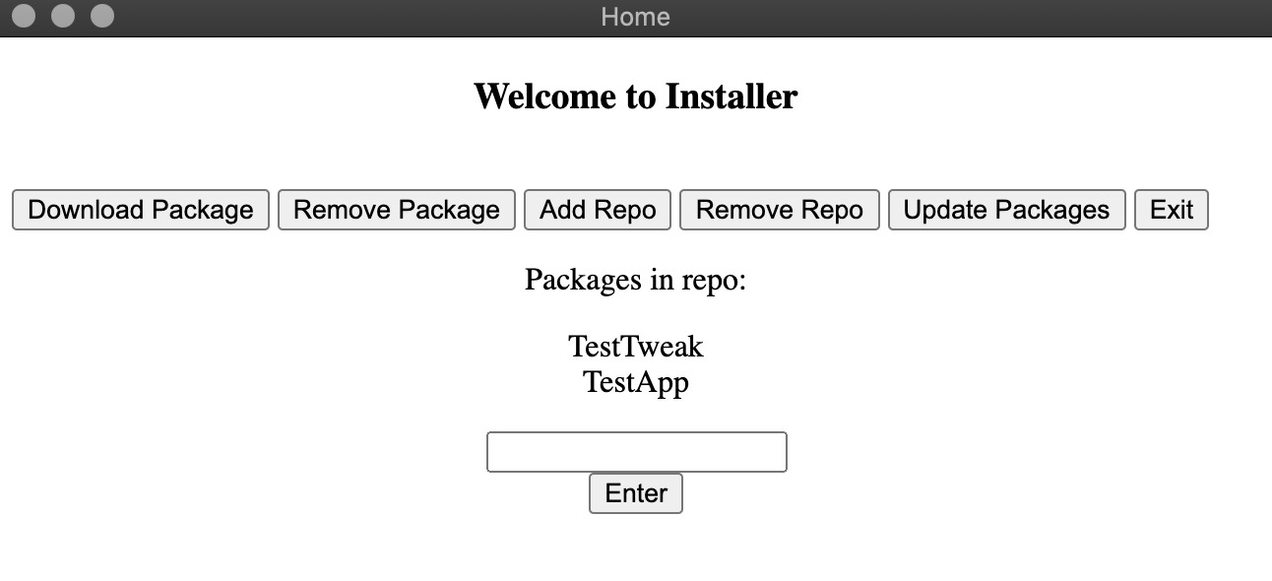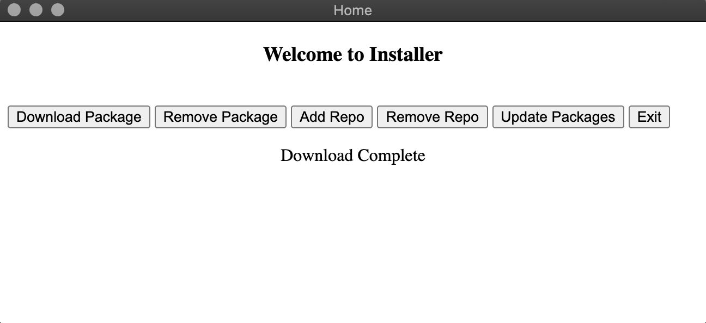

The user can then choose to launch the main program.

Any file integrity problems are checked, and if any are found they are listed for the user after being automatically fixed.

The simple interface for the launch assistant which performs checks on file integrity before launch.

The main program consists for a welcome message and a menu of functions to choose from

The user can then submit their chosen repo.

Available repos are listed.

The download function has been chosen here

An error message is displayed if the input is not a valid repo choice.

The user can then choose from available packages to install.

After a download is completed, a suitable message is displayed.

## Iteration 2

Installer.py

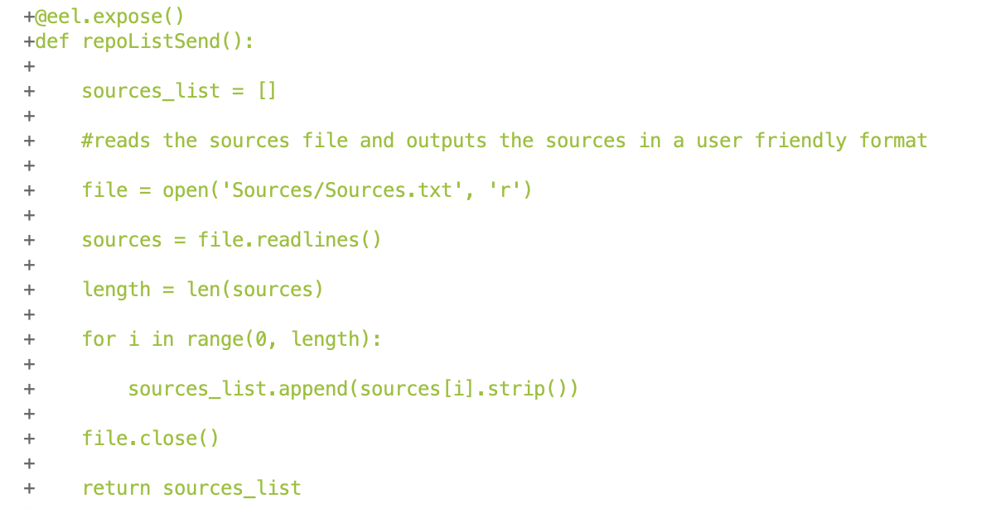

Exposes function to javascript

Returns the list to javascript

Adds them to a list without the new line characters

Loops for how many repos there are

Stores all installed repos to a variable

Creates a list for storing sources

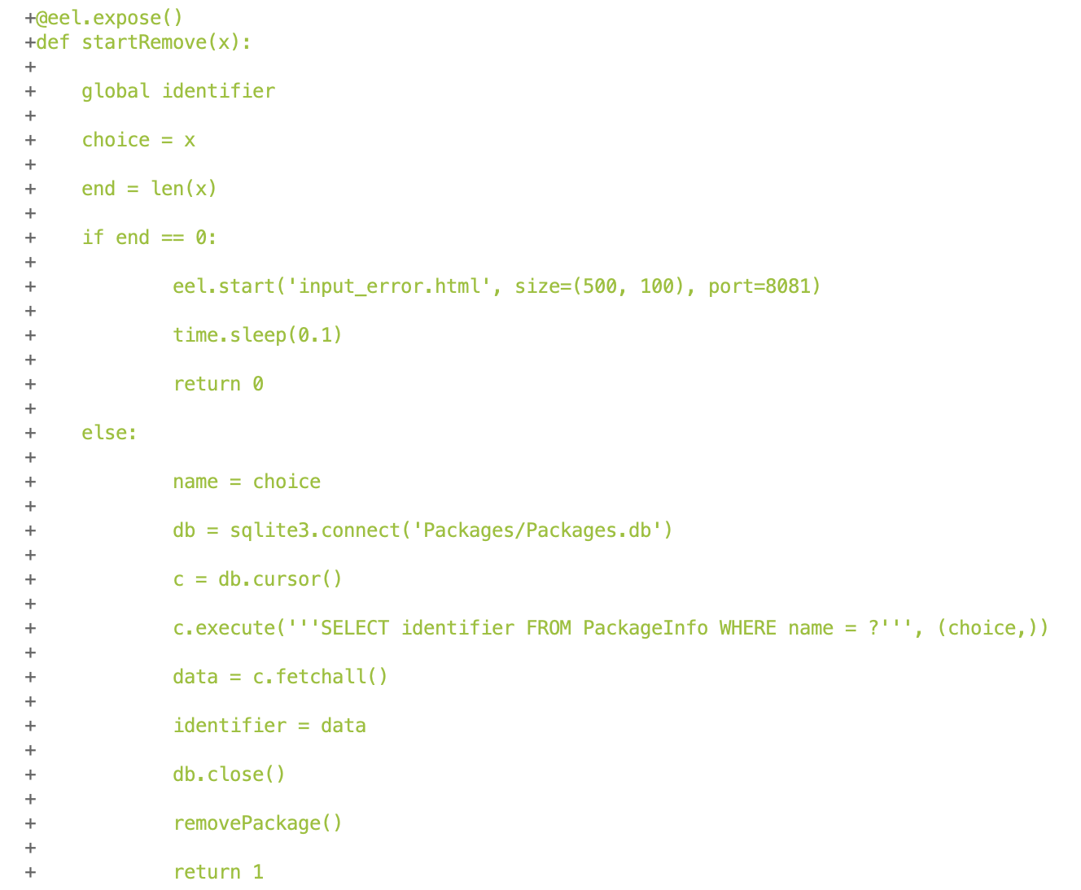

Returns error code

Returns success code

Calls function to remove the package

Stores identifier for the package from local database to a variable

If no input then displays error popup

Exposes function to javascript

Takes user choice and stores it to variable

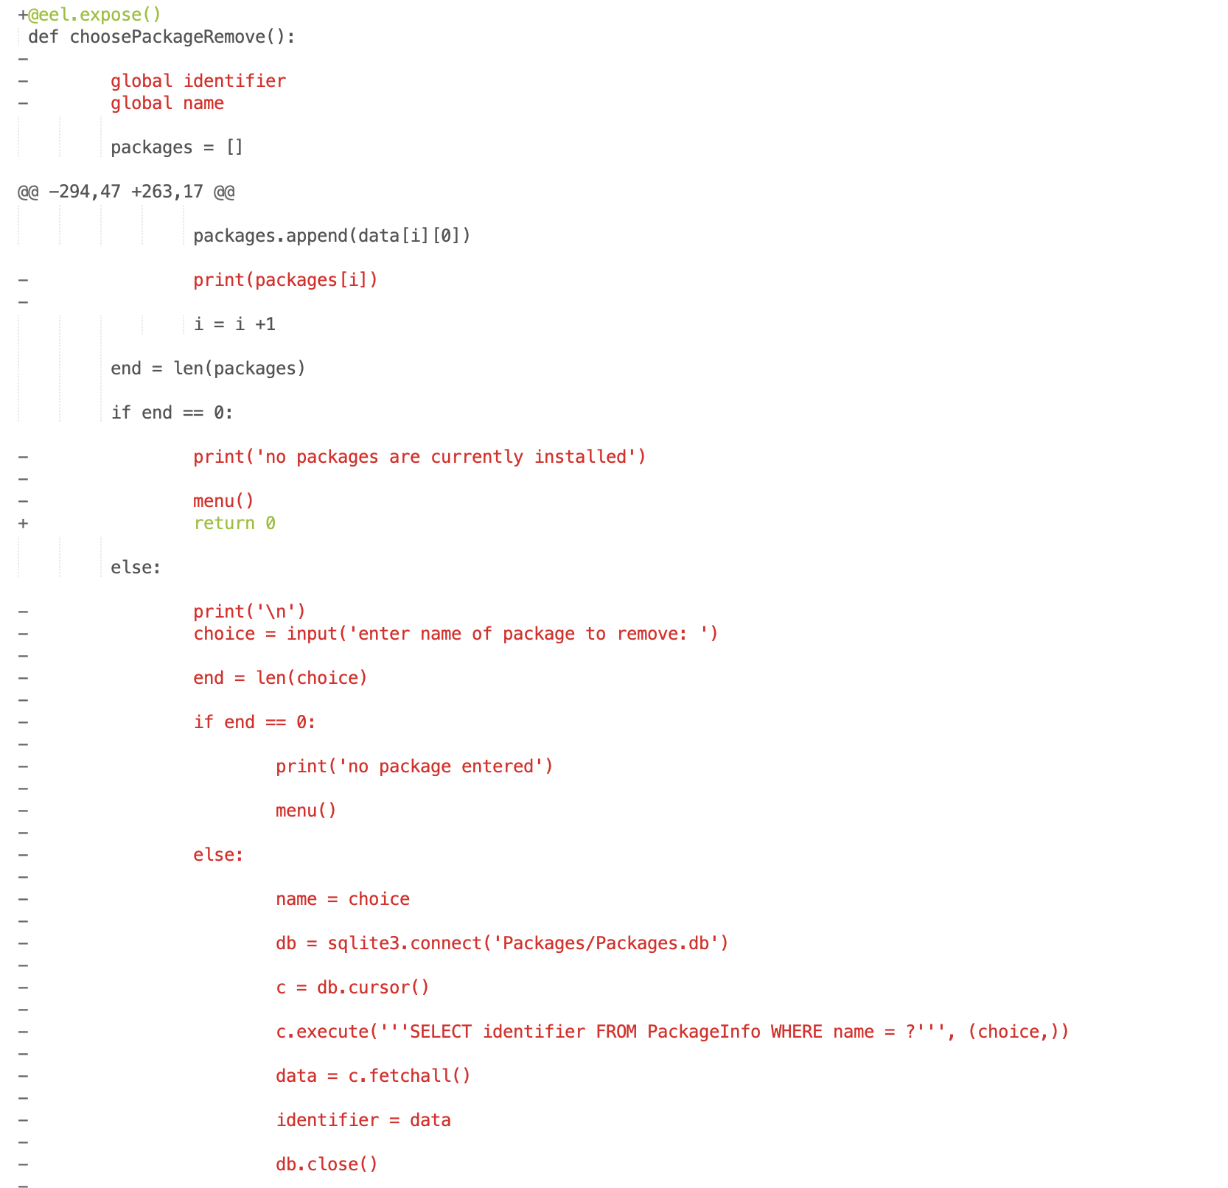

Removes functionality that is now handled elsewhere

Removes deprecated cli functionality

Returns code to javascript instead

Removes cli menu call

Removes console outputs

Removes unused variables

Python functions that can be called from javascript are created to handle the remove functionality, and the already existing functions from the command line build are modified to work with these new functions.

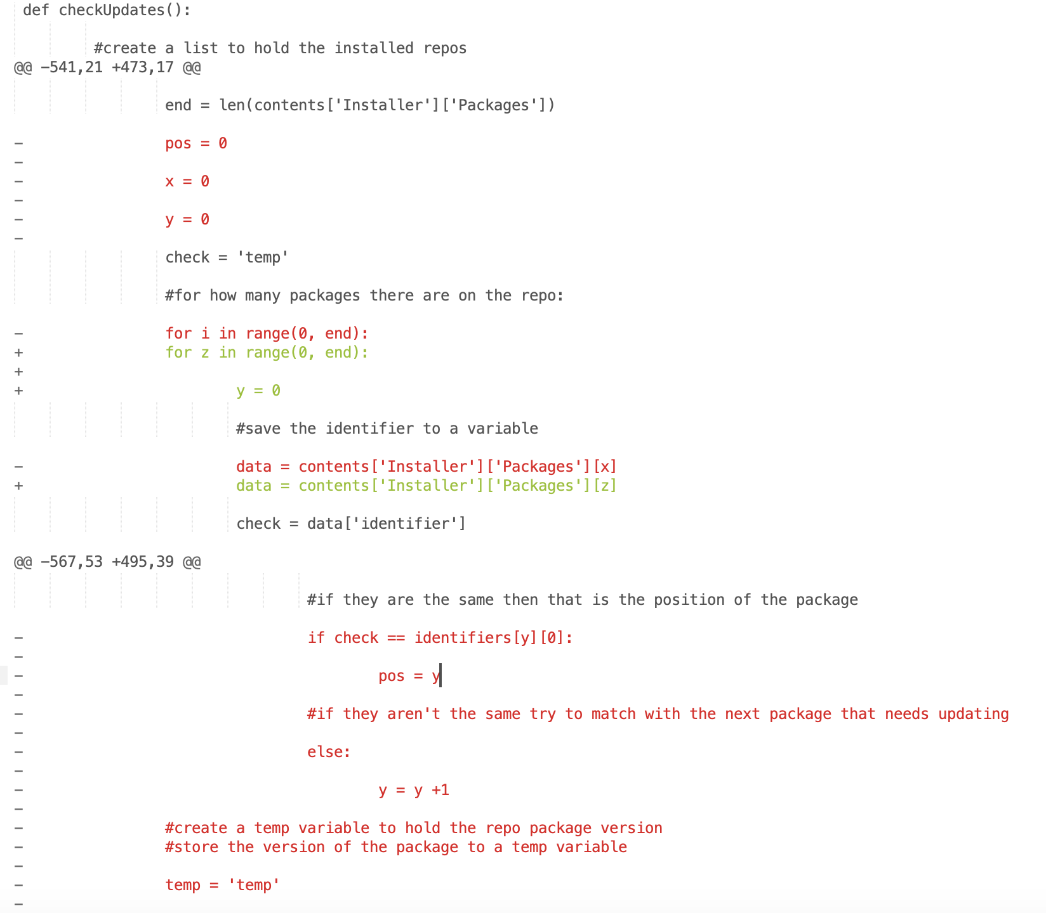

Removes old way of checking as it did not check everything

Saves the identifier to a variable

Loops for number of packages on repo

Removes old looping variables as they are used later on

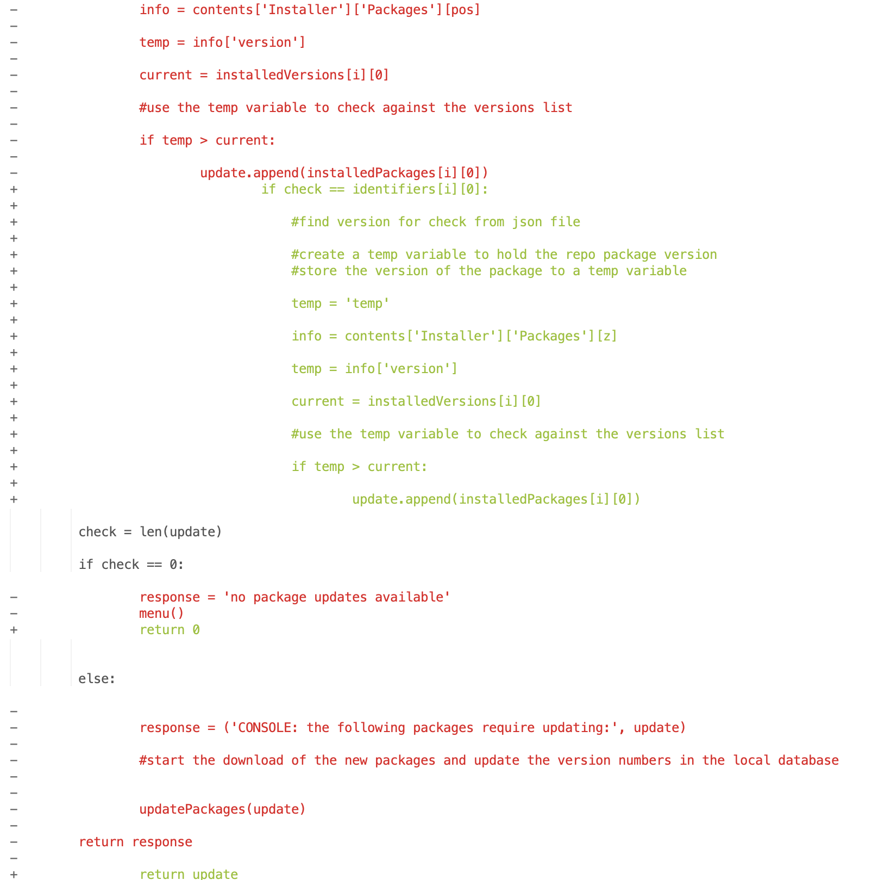

Returns update list instead of console output

Returns code instead of console output

If there is a newer version available then add package to update list

If it is the package we want then check the version number

New way of checking created

Continue removing old way of checking

The user reported an issue that the update function was not detecting any updates except for the first one in the repo.

It ended up being that only the first package was checked against local installed versions inside of the checkUpdate function, this was resolved by rewriting the loops used so that it covers all of the packages from every repo.

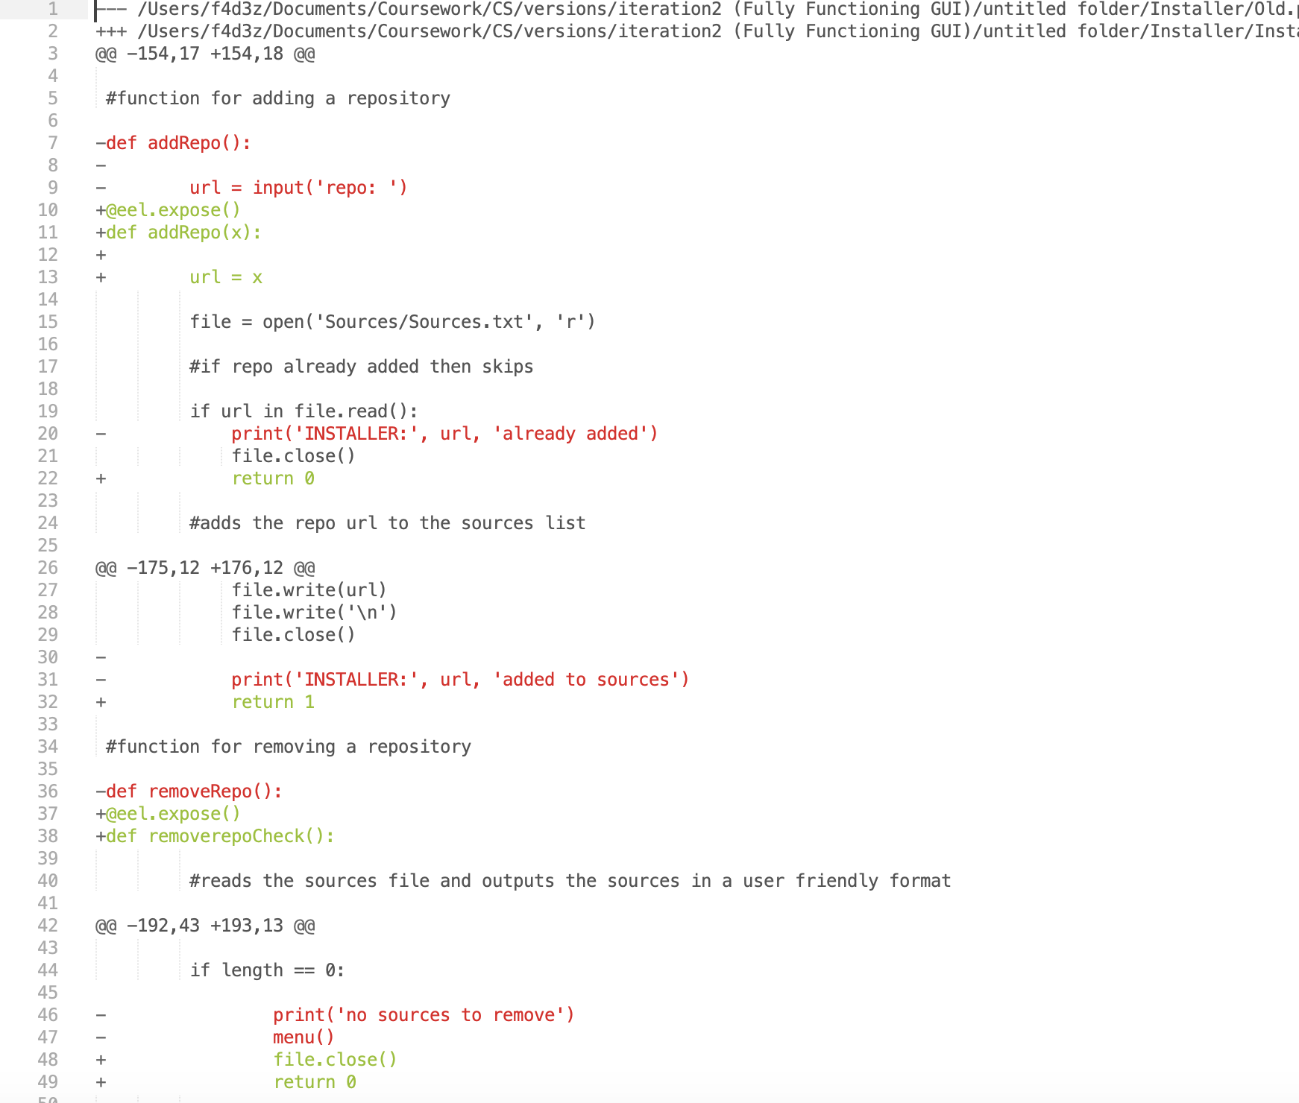

Replace console output with return code

Exposes function to javascript

Replace console output with return code

Expose function to javascript

Part of updating functions to work with the new ui is exposing them to javascript and then replacing any console outputs with return codes to be sent to javascript where the appropriate messages are then displayed on the screen for the user.

home.html

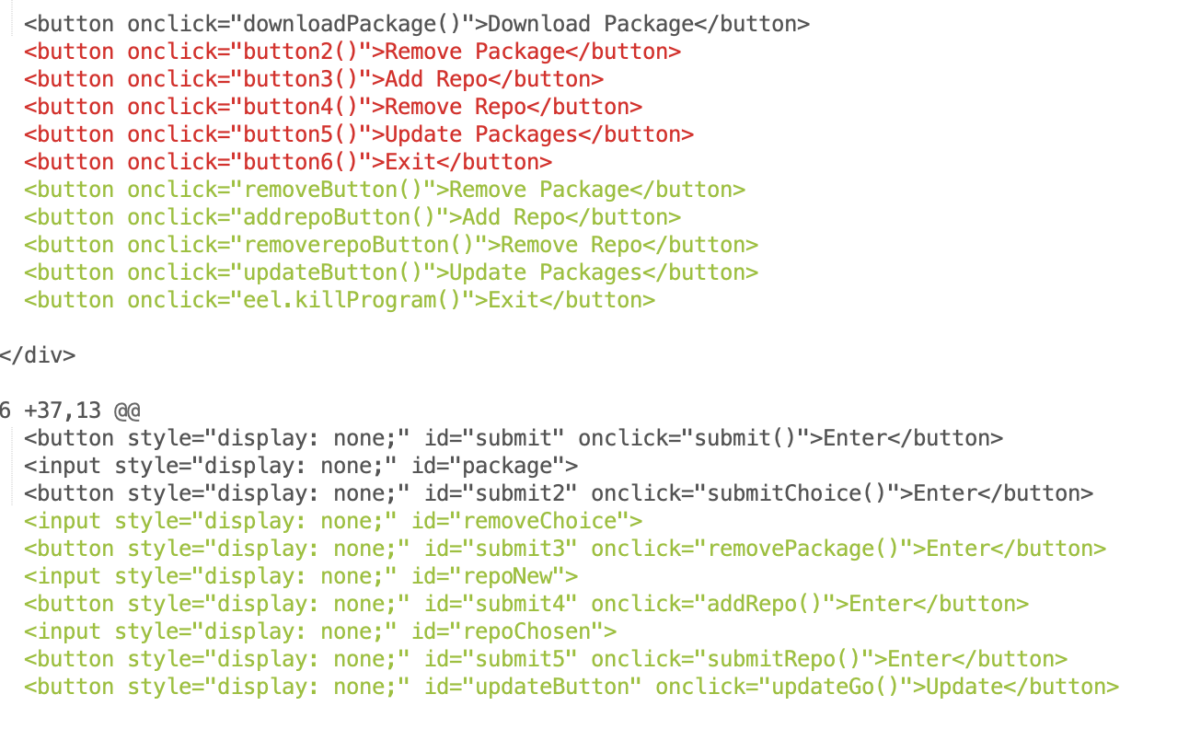

Adds buttons for the rest of the functionality

Gives the buttons meaningful names

In this version, the changes to the menu are just that other buttons are given functionality and meaningful names.

Main.js

Function to add a repo to the repo file

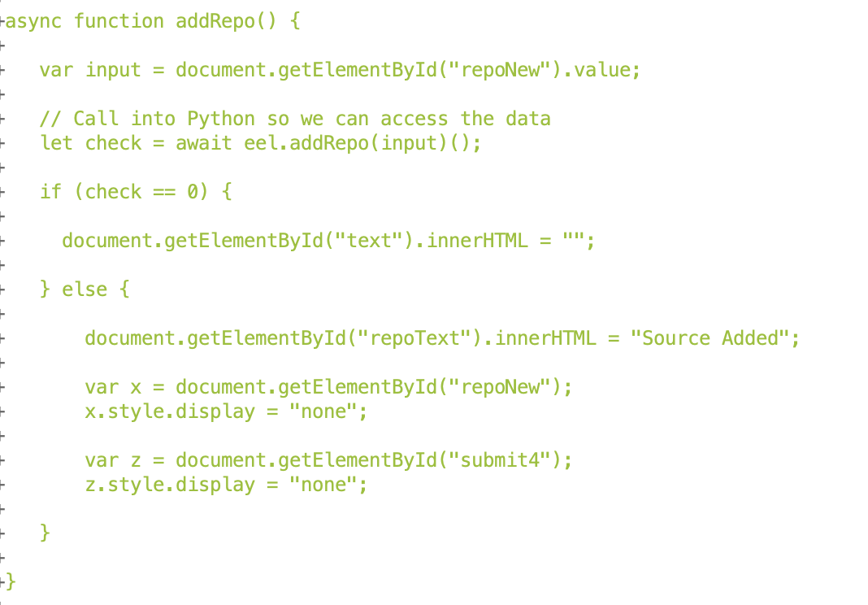

Hide elements

If repo is valid then display a success message

If repo is invalid then clear the app page

Call python function to check/add the rep

Take user input and store to variable

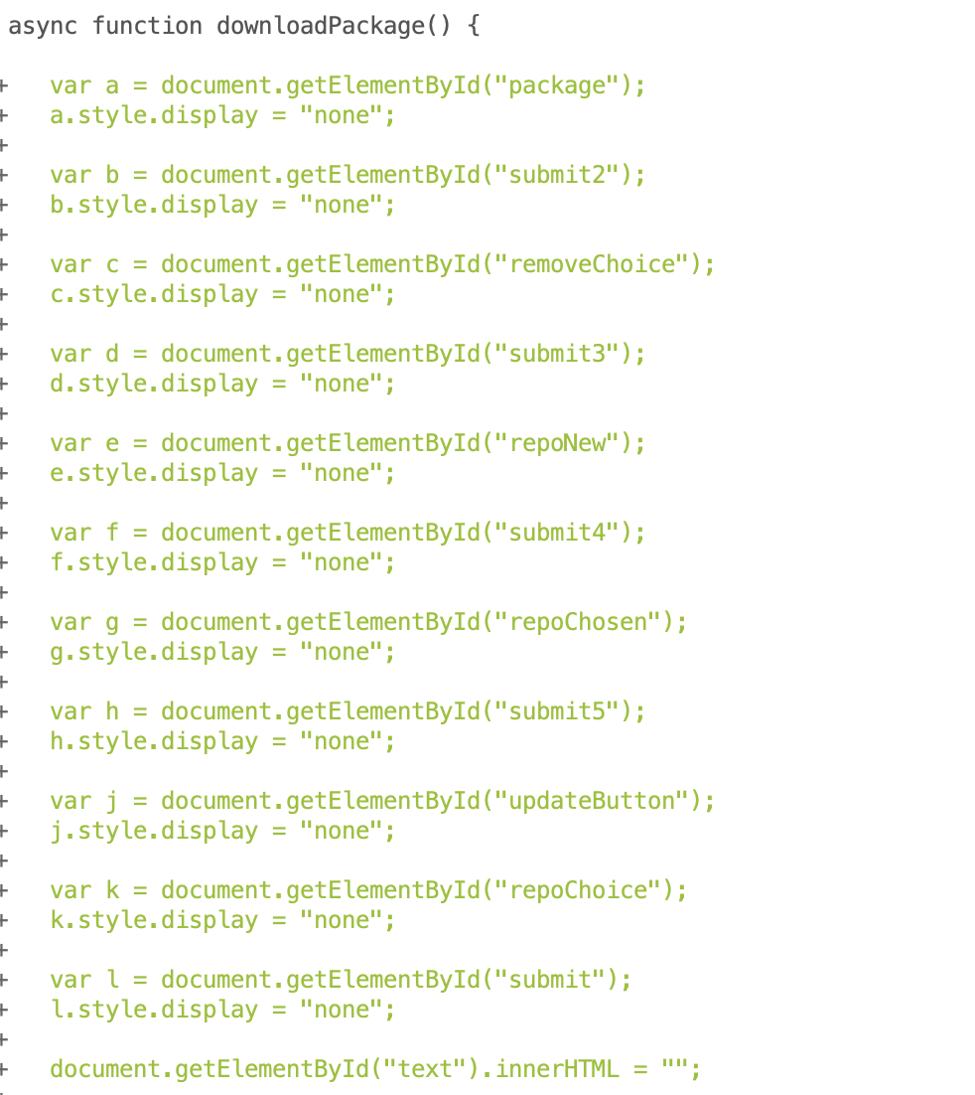

Hides previous elements when choosing a new function

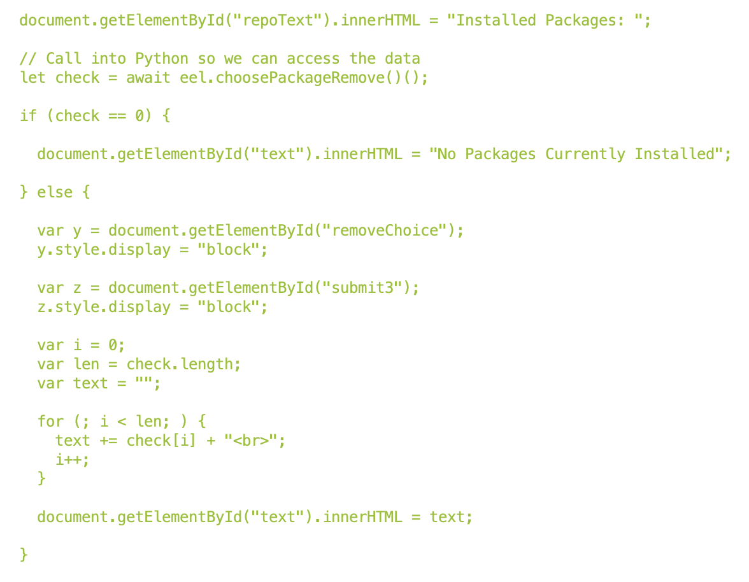

Display the list the user

Loop for number of packages

Show the input elements

If no packages are installed then tell the user

Stores installed packages list to variable after list is returned from python

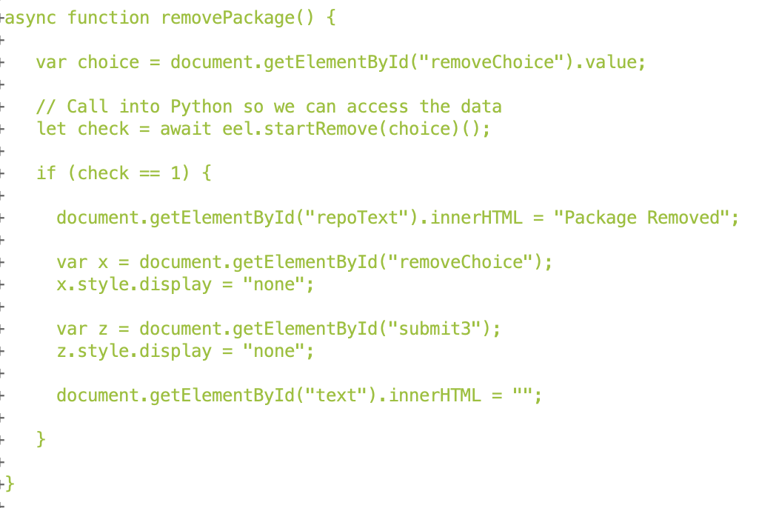

Hide elements

If successful then display list of sources to the user

Stores returned code to variable

Function for removing chosen package

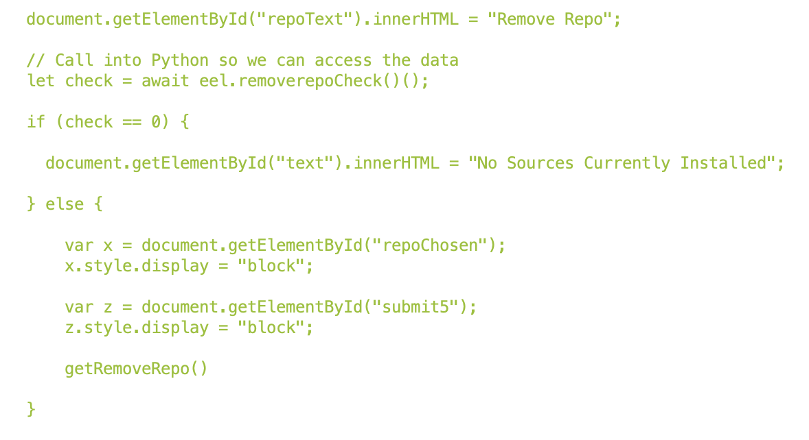

Call function to choose repo to remove

Function to remove a repo

Hide elements

If no sources are installed then display that to the user

Replace old element names with new ones

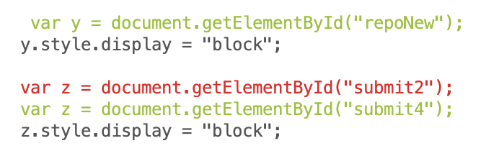

Function to start update

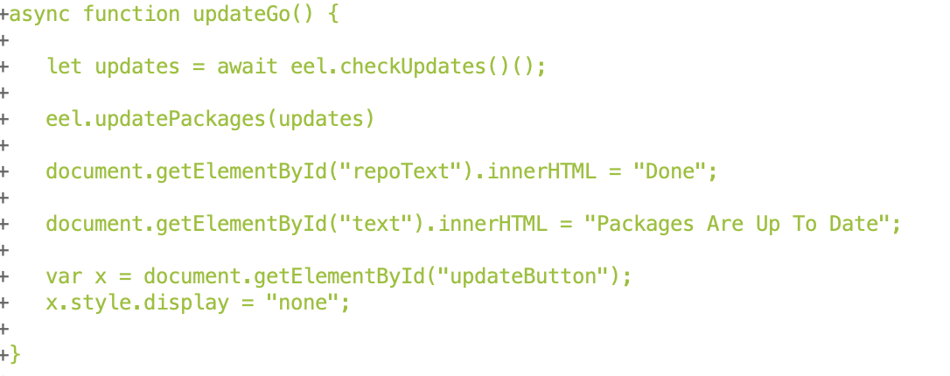

Displays success message

Calls python function to update packages

Store returned data from python function that updates packages

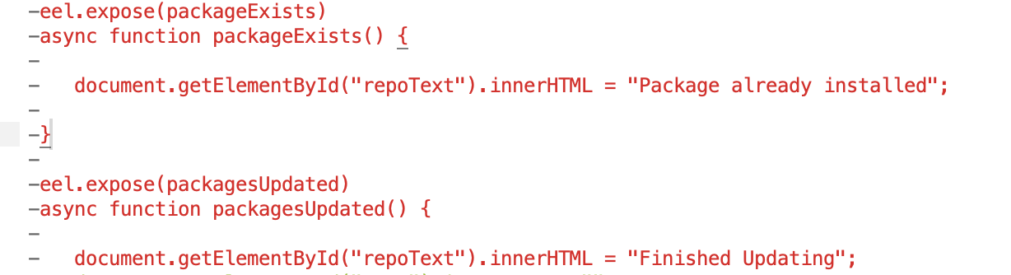

Remove deprecated function for checking if a package exists

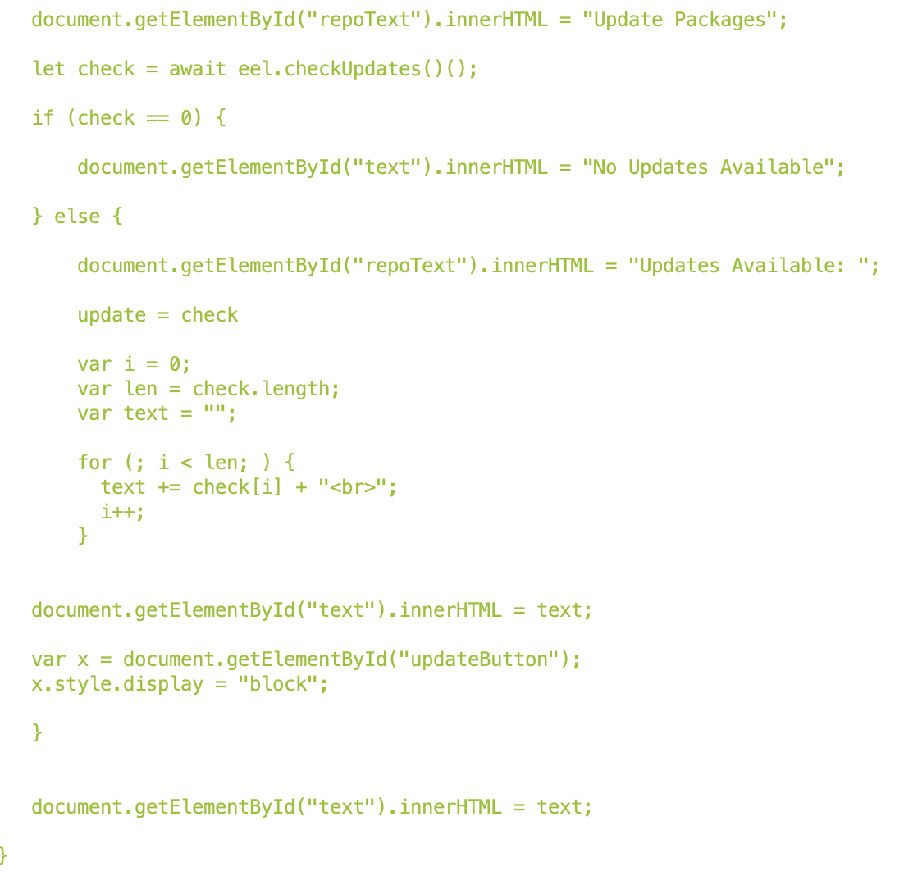

Show update button

Display list of packages

If updates available, loop for number of packages

If no updates available tell the user

Stores return code to variable from python function that checks for updates

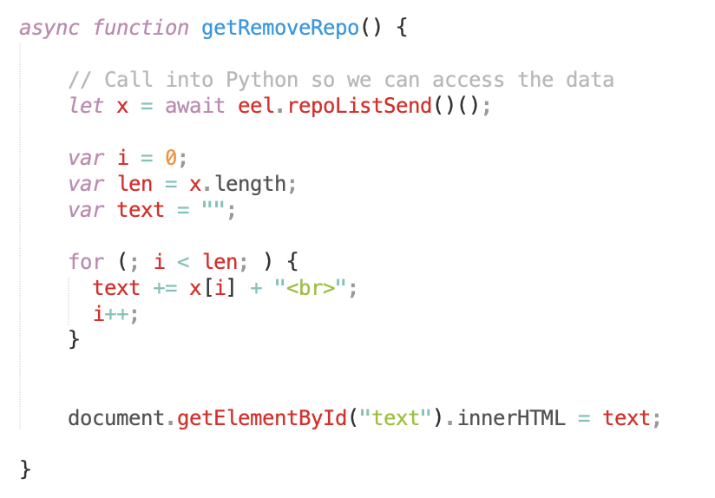

Display list to the user

Loop for number of repos

Store repo list from python to a variable

Function to remove a repo

Function to send repo choice to python

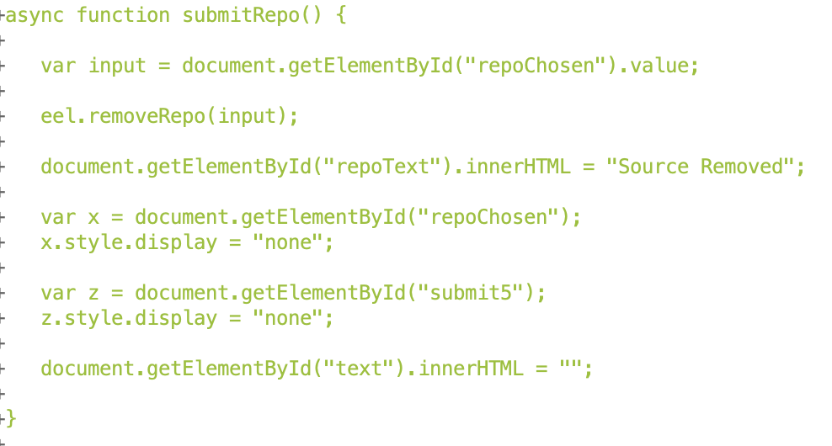

Hides elements

Calls python function

Stores input to variable

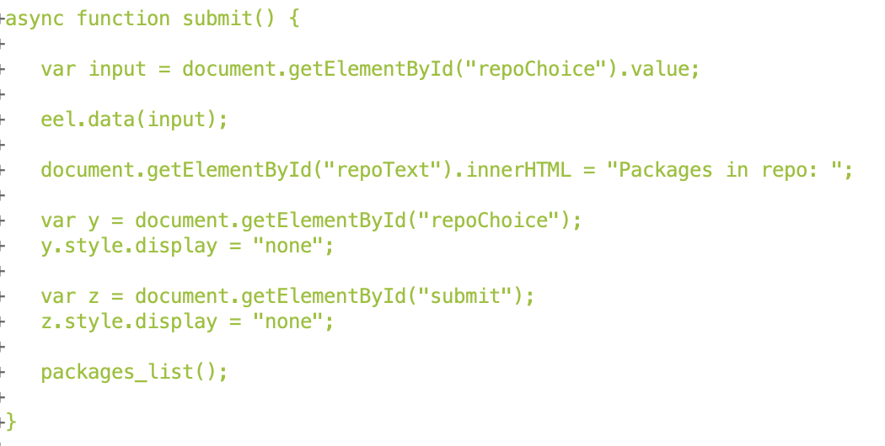

function to list packages

Call function to list packages

Hide elements

Call python function

Store input to variable

Function to submit repo choice to python

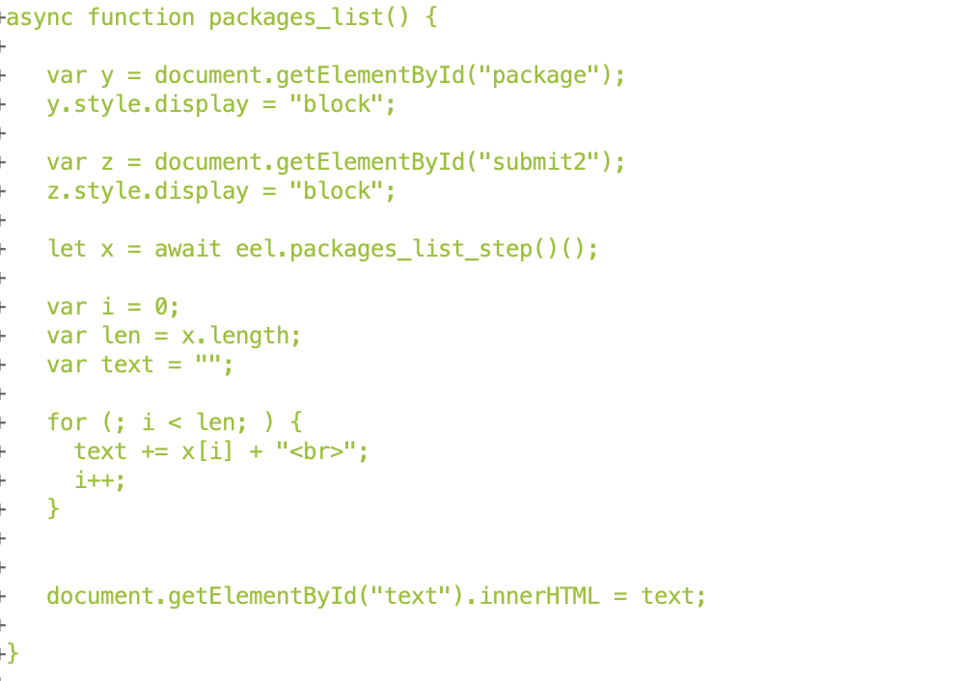

Display the list to the user

Loop for length of list

Stores returned data from python to variable

Show elements

In javascript, the functions for each button are created to handle the rest of the program functionality, acting as a bridge between the ui inputs/outputs and the python functions. The javascript is responsible for showing/hiding elements as well as taking inputs to pass to python functions and also taking the returned data from python and processing/displaying that for the user.

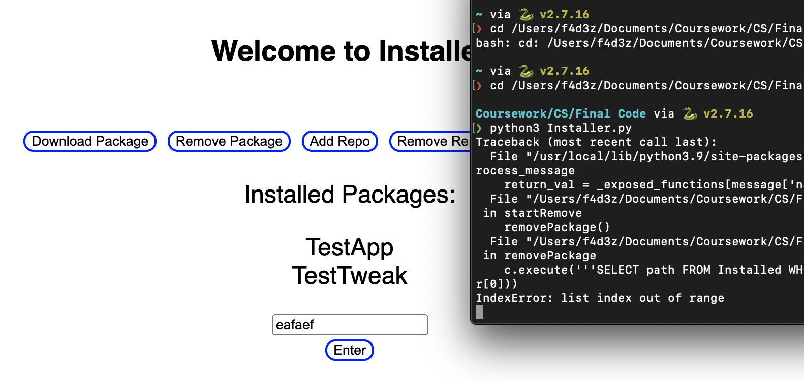

The user reported that when removing a package the program does not check for empty inputs leading to failed code execution.

Current UI

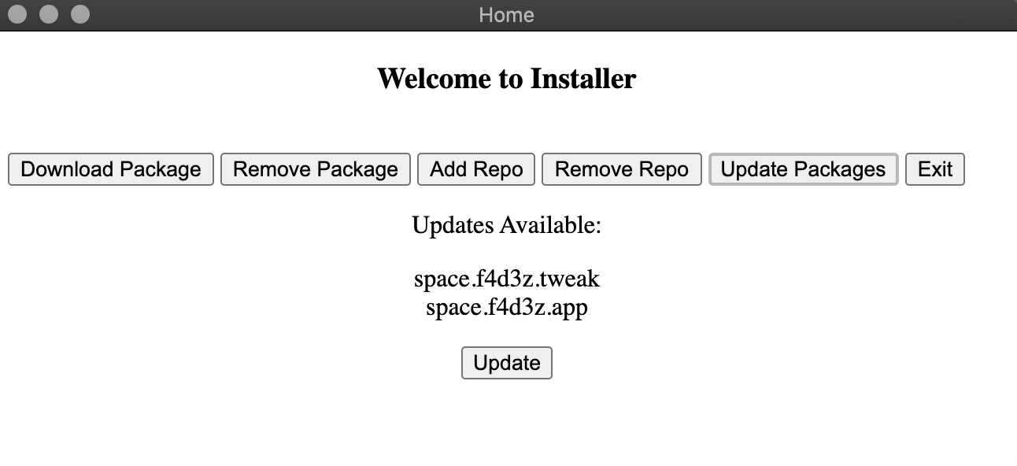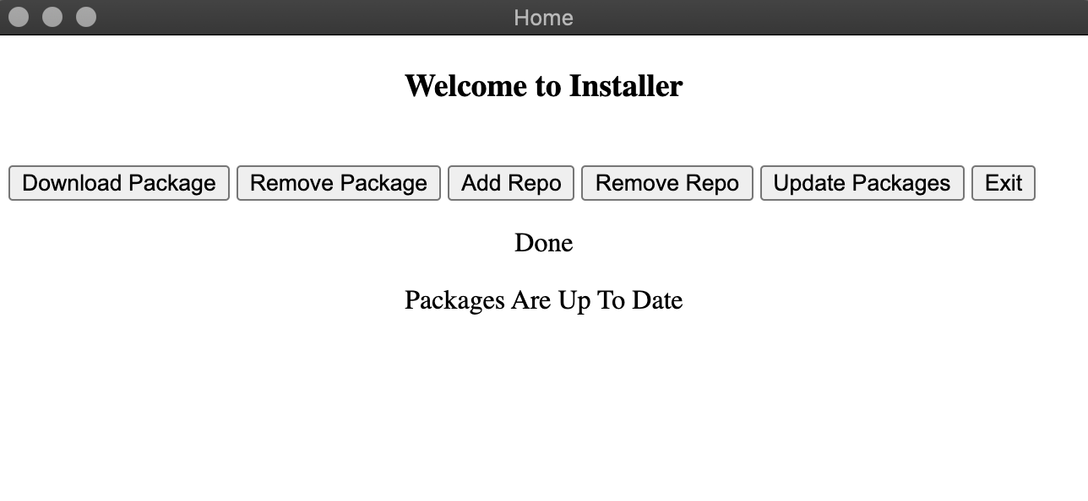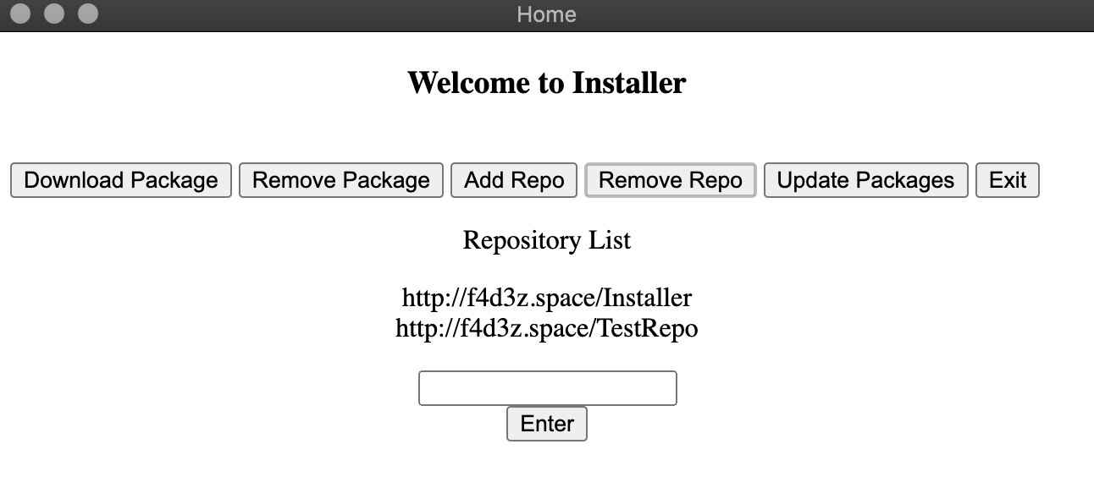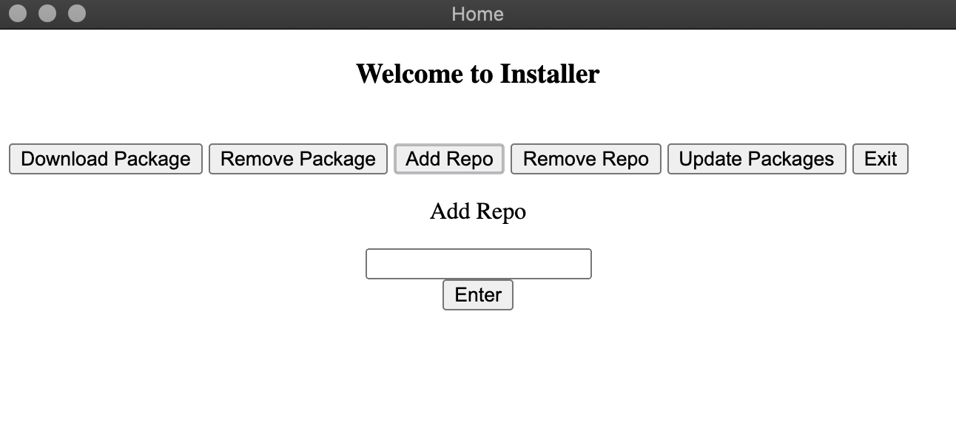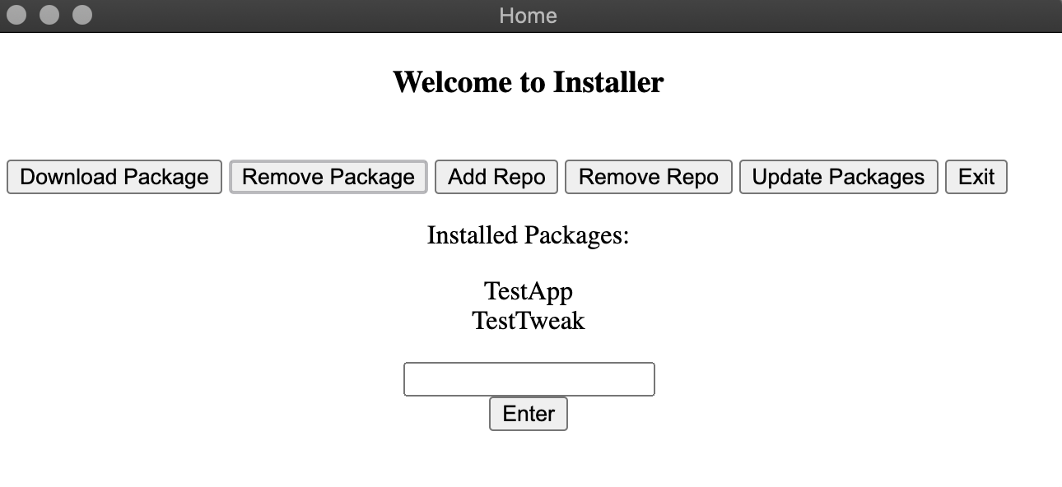

Displays a list of repos to choose from in the remove repo tab.

Displays a success message after updates

Update tab, showing available downloads and an update button to start those downloads.

Displays a text box and button for inputting a new repo to be added to the system.

The remove packages tab lists the installed packages and allows the user to choose one to remove.

## Iteration 3

Installer.py

Change the size of the main application page



Home.html

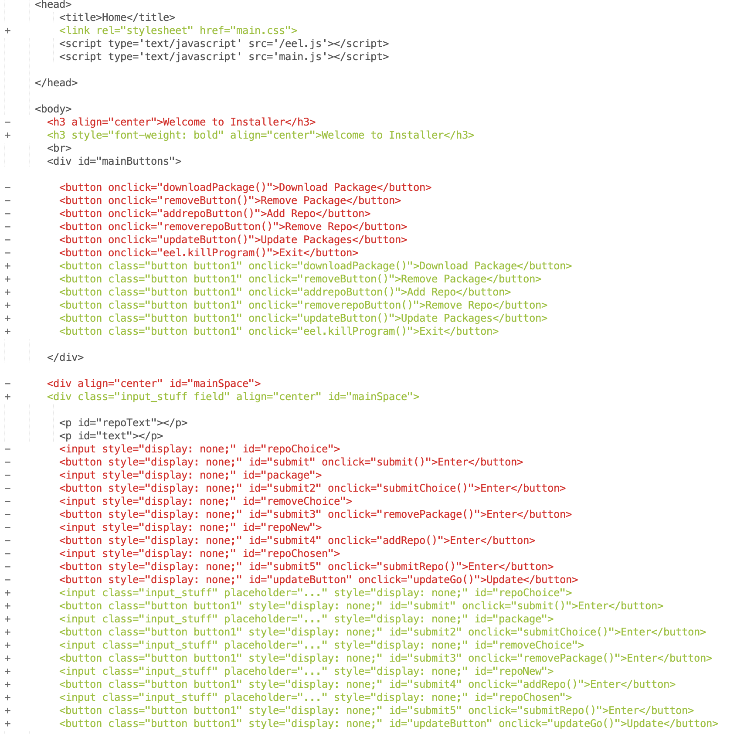

Use css classes

Use css classes

Import css classes

CSS was added in order to change the page appearance, only the buttons were themed as the solution design was supposed to stay simple, but this small change does a lot for the appearance as it no longer looks like default html elements all over a page.

Main.css

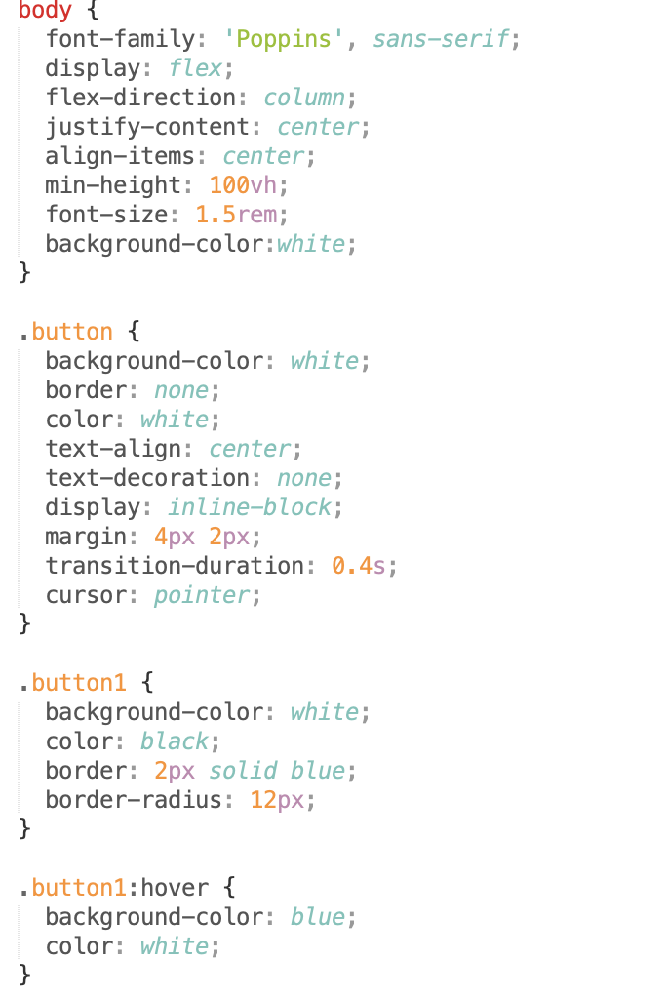

A class to add hover effect to buttons

Another class for buttons

Class for buttons

Class for main section

A font was set for the program, and the buttons were themed so that they are rounded and have a hover colour and border colour of blue. And are clear when not selected.

User reported error fix:



The error reported after sending over Iteration 2, where blank inputs would cause the program to stop running, was addressed here. By adding in a simple check to this function the problem is solved.

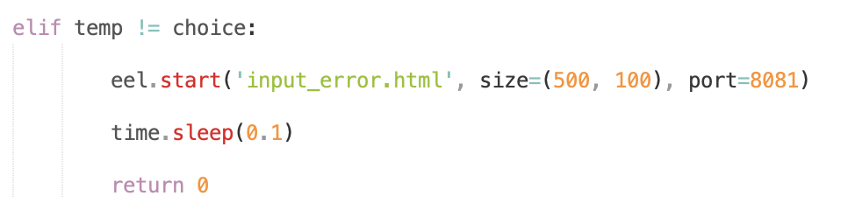

Returns error code to main program

Adds an error message for input errors

This is the code for that check, simply checking if the input is anything other than a value it should be (including blank inputs) and displaying an error message while allowing the program to continue running.

Current UI

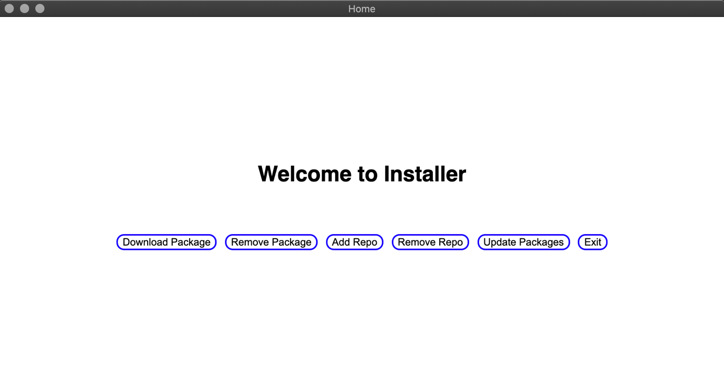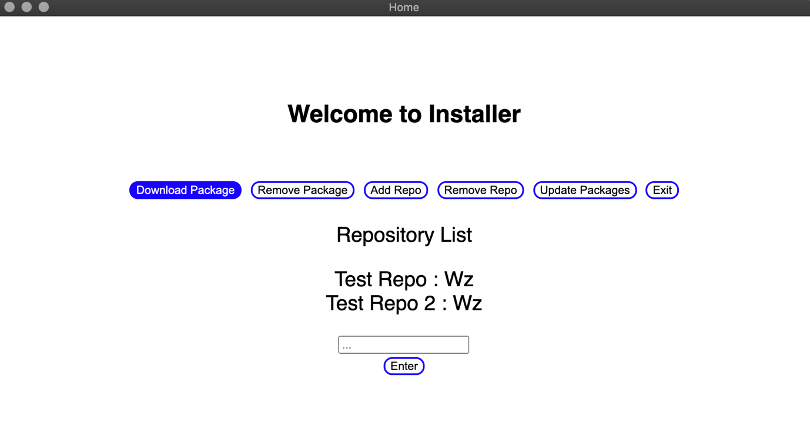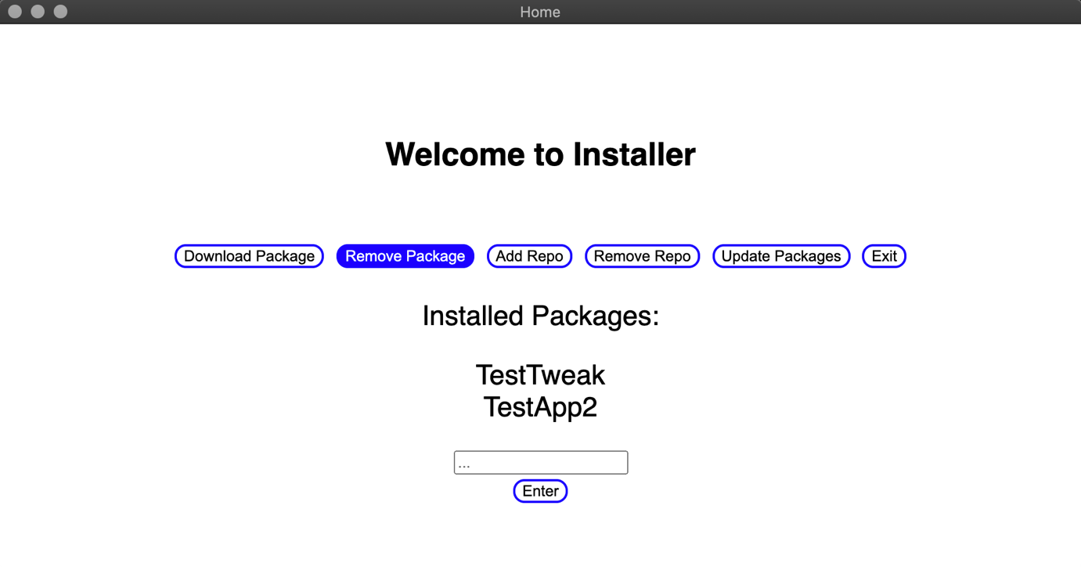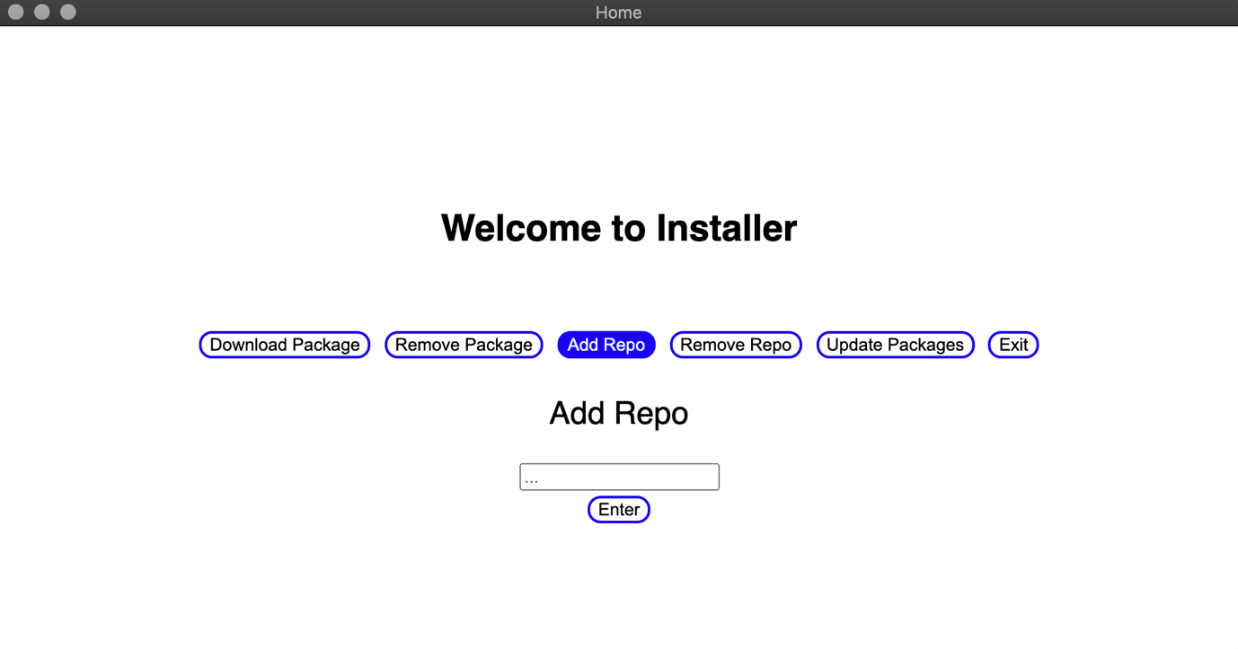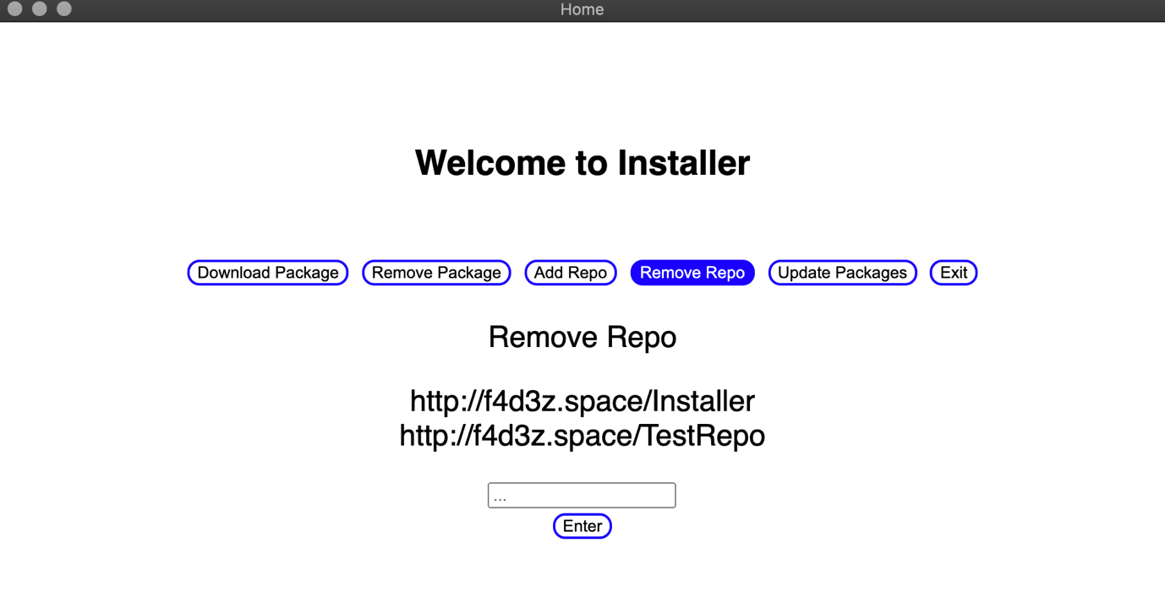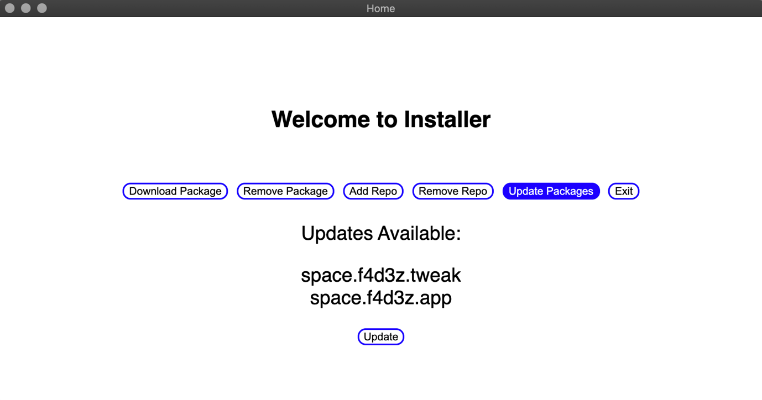

New design continues throughout.

The new buttons design.

And with that final ui change and error fix the solutions development cycle is completed. Now it is ready for a first release with all core functionality present and a clean and simple GUI.

# User Acceptance Testing

|  |  |  |  |
| --- | --- | --- | --- |
| No. | Requirements | Input | Outcome |
| 1 | The url that the user enters is added to the sources file | Valid: <https://f4d3z.space/Installer/TestRepo>  Invalid:  iuashetiuhasegjbasg | **Successfully added to the sources file.** |
| 2 | The url that the user chooses is removed from the sources file | Valid: <https://f4d3z.space/Installer/TestRepo>  Invalid:  Random Text | **Successfully removed from the sources file.** |
| 3 | The package information for the installed package is added to the database | Valid:  The correct package information from the repo  Invalid:  Random incorrect data not about the package that was installed | **The package information is successfully added to the database, as all functionality reliant on it works fine.** |
| 4 | The packages are able to be updated with a press of a button. | Button Press | **Packages are updated successfully.** |
| 5 | Buttons are clear and rounded and then fill in with blue when hovered over. | Hover mouse over buttons | **The buttons behave as they are supposed to.** |
| 6 | Missing files are detected. | Launch program. | **File issues are detected and displayed.** |
| 7 | Missing file issues are fixed. | Button Press | **Files are replaced and solution works properly afterwards.** |
| 8 | Choosing packages to download works as it should. | TestApp | **Package is downloaded successfully.** |
| 9 | Choosing packages to remove works as it should. | TestApp | **Package is removed successfully.** |
| 10 | Choosing repos to browse works as it should. | <https://f4d3z.space/Installer/TestRepo> | **Repos chosen are able to be viewed, packages are listed properly.** |
| 11 | Removing a package removes it from the database. | Try to remove same package twice. | **An error appears displaying it as an invalid input.** |
| 12 | All buttons work as they should. | Button Press | **The exit button stops the program but does not close the windows.** |

Client Feedback: The program works properly apart from closing. Error messages could be more detailed also. But apart from those two things nothing seems to be wrong.

# Evaluation

## Were the success criteria met?

|  |  |  |  |
| --- | --- | --- | --- |
| No. | Requirement | Met/Partially Met/Unmet  M/P/U | Comments |
| 1. | The solution should be able to self-repair any missing files or dependencies such as the local database, or the default repository. | **M** | Any file issues are reported to the user and fixed with a simple button press. As noted in tests 6 and 7. |
| 2. | The solution should run without error, completing a chosen task. | **P** | All functionality works without any found errors, but the exit button while stopping the code execution does not close windows. Shown throughout all testing. |
| 3. | The solution should not take long to complete a task, the user should not have to wait for too long. | **M** | The program completes tasks in under a second (apart from large downloads) and there was no complaint from the client. |
| 4. | The solution should have a clean but modern looking GUI | **M** | The solution is clean and simple, with a plain background and themed buttons. Eel was used over tkinter as it looks more modern. Shown in final version screenshots. |
| 5. | The solution should be straightforward and easy to use | **M** | The solution explains any errors and also what to input into text boxes. It is also a menu driven interface which simplifies the whole experience. |
| 6. | The solution should display available packages in some way | **M** | Packages are listed in the free space below the menu buttons. |
| 7. | The solution should have a working repository system | **M** | The repository system fully works, using json files to hold key information and locations of packages. Shown in tests 4 and 10. |
| 8. | The solution should alert the user of any problems | **P** | Error messages are displayed in pop-up windows, although only two error messages are displayed making them less detailed than they could be. Shown in tests 6 and 11. |
| 9. | The solution should hide important files from the user to protect them | **M** | The solution, when run as an application after being compiled, stores files in a folder outside of the user directory. |
| 10. | The solution should install all available updates at once | **M** | Updates are all installed with the press of a button, and a success message is displayed after completion. Shown in test 4. |
| 11. | The solution should open windows properly and without delay | **M** | Windows appear as they should, the main program opens after the launcher finishes its checks, and error pop-ups show as they should too. |
| 12. | The solution should be able to perform tasks in any order and repeatedly without error | **M** | Switching between tasks does not cause any issues for the program, as everything is in modules and therefore there is no need to run the sections of code in any specific order. |

## Maintenance

The solution will be released as open-source software, which alongside the documentation and code commenting should make understanding the program code and functionality much easier. Open source software can be updated by one or many people, it is not restricted to the developer being around, although the original developer can take reports and fixes from any number of users and implement them into an ‘official’ update.

It is expected that some interface updates along with some updates to the partially working parts of the program will be the first to be released after the initial version.

And from there, updates to code efficiency and perhaps just general updates to the code as new language versions are released will be completed and released in the further future.

## Limitations

There were and still are a number of limitations when it comes to developing software such as this. For this specific project, the following limitations played a part:

* Time: given more of this the partially met criteria could be fully met
* Developers: with more people working on a project like this it could be made much faster and likely of a much higher quality
* Knowledge: As a student there’s a lot that I do not know about coding practices and languages, and therefore the solution is nowhere near what it could be with a few more years of knowledge and practice
* Modern GUI options: If python had better modern GUI solutions with nice documentation then the interface would have been of a much higher quality